How to install Cygwin
Oussama Hammami 2010-08-02
Switzernet
This tutorial will show you how to install Cygwin.
Files you’ll need:
Cygwin http://www.cygwin.com/setup.exe

To begin, let’s install Cygwin. Download the setup.exe and run it. You will see this screen:

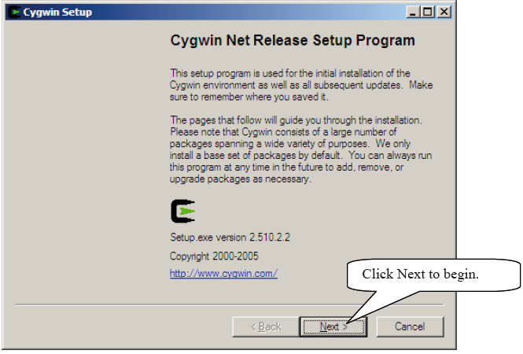

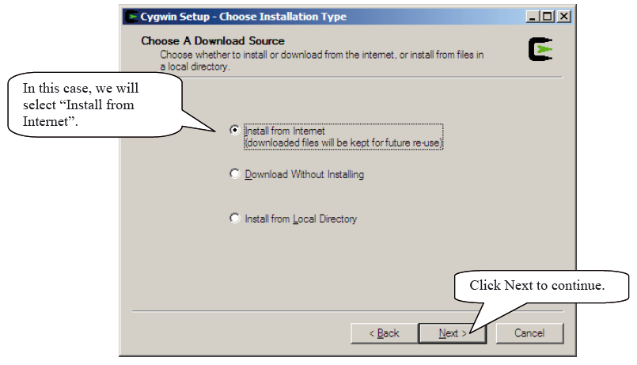

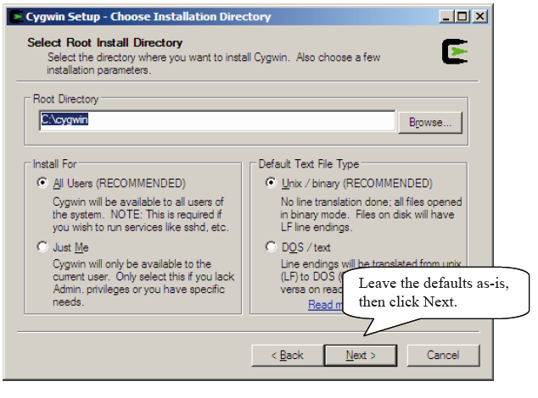

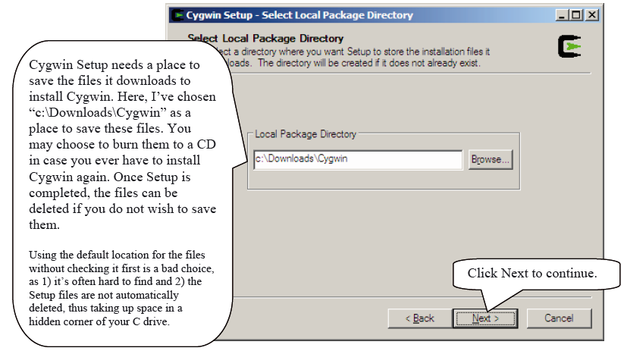

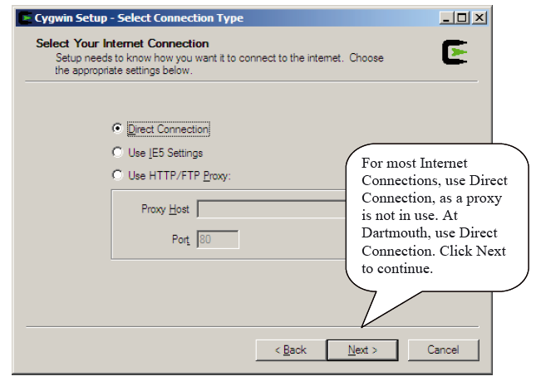

Cygwin Setup will now download the list of mirrors. If you have a personal firewall, click “Allow” if it asks you whether or not setup.exe should connect to the Internet. Select a mirror, then click Next to continue.

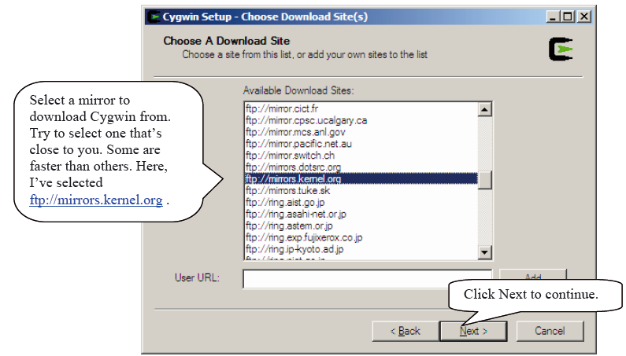

Setup will now download the list of packages to choose from.

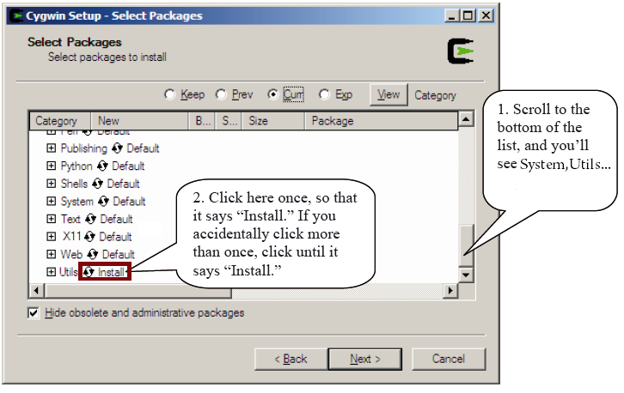

You may install any packages you like. For now, we’ll leave it at the default, except for a slight change: let’s tell Cygwin to install all of System, Utils, Shells and Accessibility.

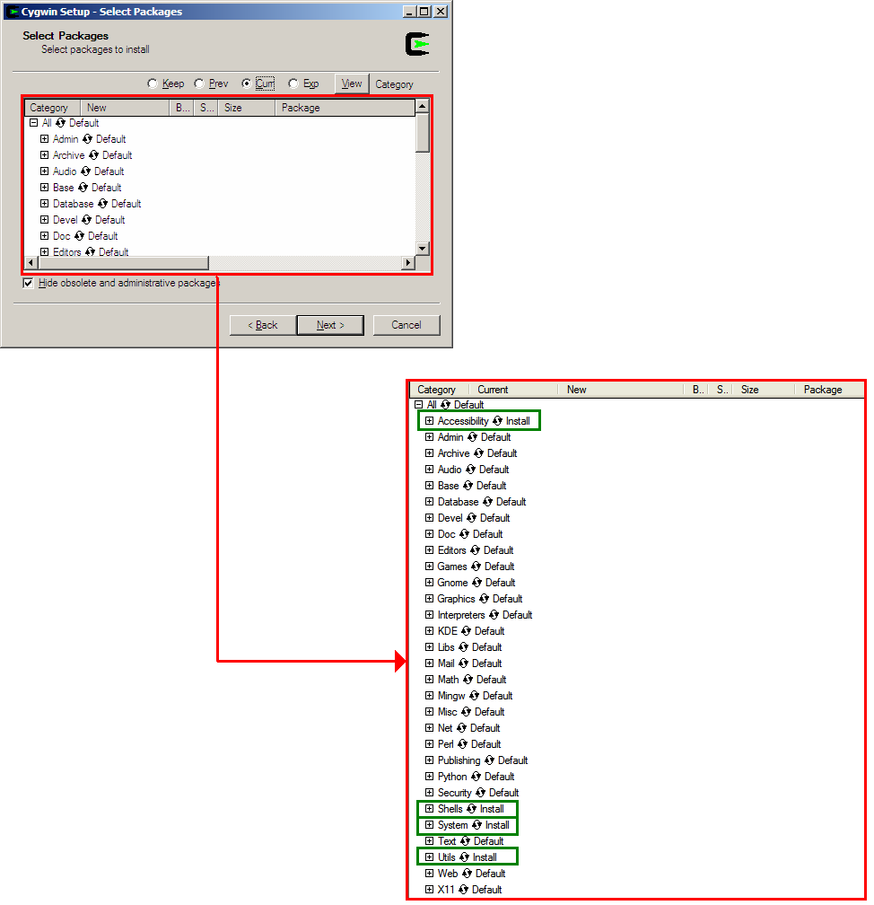

When you’re finished, click Next to continue. Cygwin will now download and install the selected packages.
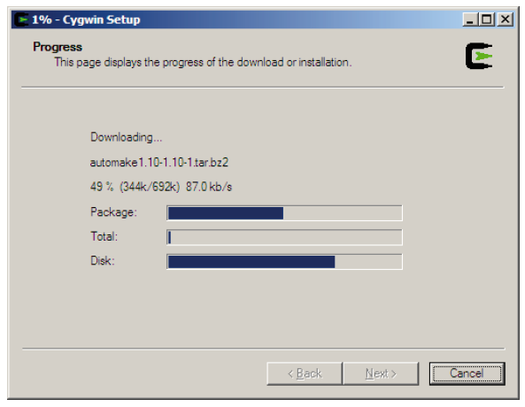

The Cygwin download and installation can take an extremely long time, especially if you’re off-campus or on a slow Internet connection, or if you’re installing a lot of packages.

Question: Cygport.sh (or some other shell script) seems to be taking forever! Setup has been working on this one script for over 20 minutes!
When this is the case, it may mean that the script (or a component called by the script) entered an infinite loop. You’ll need to close the appropriate process, so that the installation can continue.
Press CTRL-ALT-DELETE on your keyboard, and click “Task Manager”. Go to the Processes tab.
Click the “CPU” column twice, so that processes are sorted in descending CPU Usage order. Now find the process that’s using all of the CPU (most likely bash.exe or similar), select it, and end it by clicking “End Process.”
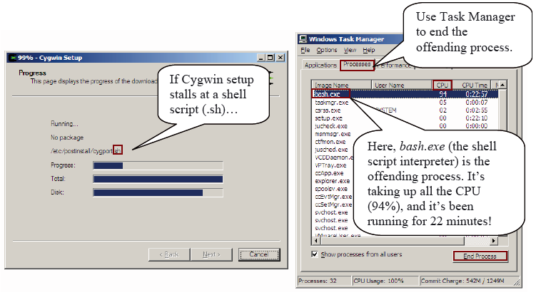

N.B.: System Idle Process is a normal part of the system, and should not be terminated, regardless of the amount of CPU it’s using or its “CPU Time”. The System Idle Process is simply an accounting mechanism Windows uses to track unused CPU time. It doesn’t actually “consume” CPU time.

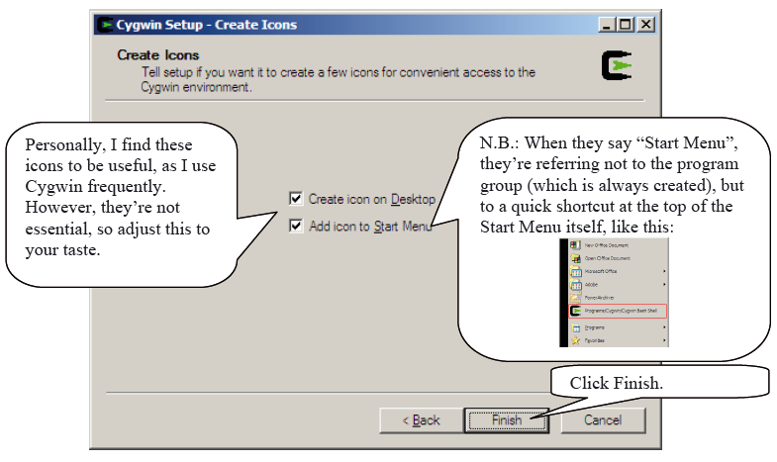

Congratulations! You’ve installed Cygwin!

