[1'cbq'1 mr24 import]

**UploadING MR18 customers to  
 the new MR24 database**

*Created on 2013-03-05  
Nicolas Bondier*

[[pdf](index.pdf)][[html](index.htm)][[docx](index.docx)]

* * *

Switzernet logo

Copyright © 2013 by Switzernet

**Contents**

**Introduction** 3

**How-to use** 3

**Import customers** 3

**Import accounts** 8

**Import old i_customer fields** 17

**Import customer sites** 18

**Import follow me** 22

**Imports subscriptions** 27

**References** 29

**Introduction**

This document is a how-to upload the customers using the scripts of migration to the new billing.

**How-to use**

In this how-to, we will only take a sample account. The procedure is the same for large number of accounts.

**Import customers**

On pbs1 go to /root/120822-customer-download/ and execute the following commands:

|  |
| --- |
| pbs1:~/120822-customer-download# ./customers_download.pl  Select a range of i_customer to import.  First i_customer:  11252  Last i_customer:  [...] |

The new excel file will be created. As output, you will see the correspondences between column name and letters (A, B, C …) as the example bellow shows:

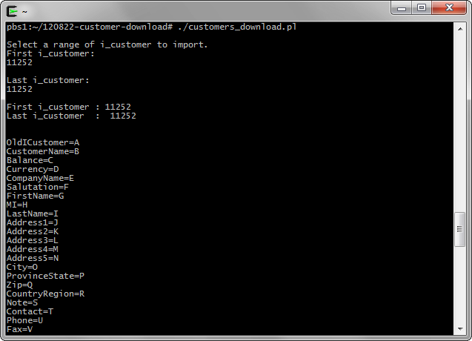

And next steps to execute:

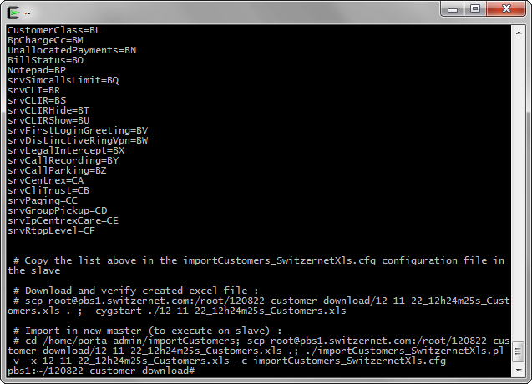

Connect through SSH to the new slave server and go to */home/porta-admin/importCustomers*. Open *importCustomers_SwitzernetXls.cfg* and past the list of correspondences under *[Columns]*.

|  |
| --- |
| Nicolas Bondier@NicolasBondier ~  $ ssh switz@slave.switzernet.com  Last login: Thu Nov 22 11:35:39 2012 from 212.147.8.99  [switz@slave ~]$ su -  Password:  [root@slave ~]# cd /home/porta-admin/importCustomers/  [root@slave importCustomers]# nano importCustomers_SwitzernetXls.cfg |

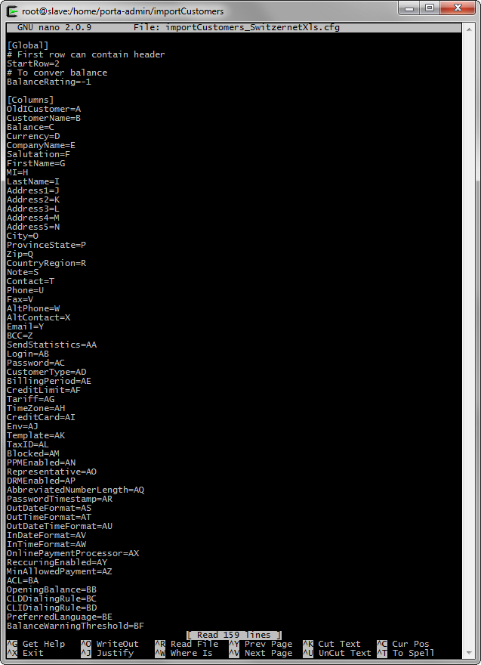

This is the only changes you have to make to *importCustomers_SwitzernetXls.cfg*.

From Cygwin on your local computer, execute the command provided by the script:

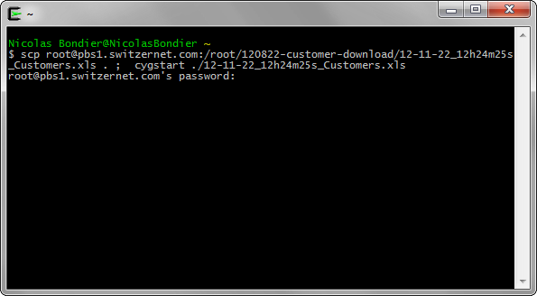

This will locally download and open the new excel file. Check the values seem ok. The values must correspond to the column names, the first and last column must be the same as the first and last line of the list of *importCustomers_SwitzernetXls.cfg*, all customers should be in the file, etc.

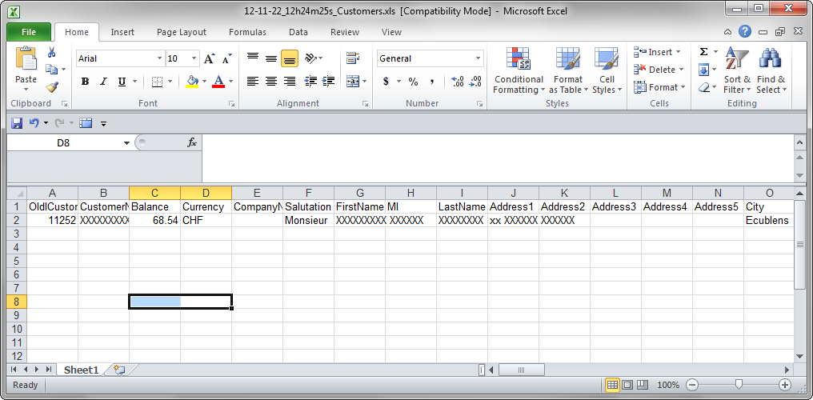

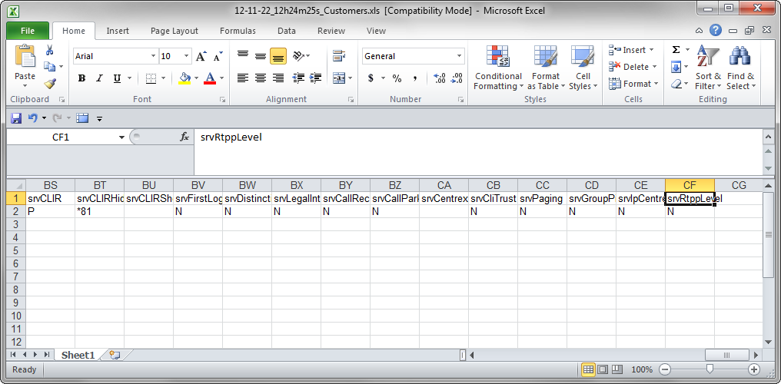

Once verified, go back to the slave in your working folder and execute the second command given as output of the downloading script in order to get the new excel file and uploading it.

|  |
| --- |
| [root@slave importCustomers]# cd /home/porta-admin/importCustomers;  scp root@pbs1.switzernet.com:/root/120822-customer-download/12-11-22_12h24m25s_Customers.xls .;  ./importCustomers_SwitzernetXls.pl -v -x 12-11-22_12h24m25s_Customers.xls -c importCustomers_SwitzernetXls.cfg |

If everything has gone fine, the *importCustomers_SwitzernetXls.pl* should have imported all customers of the *12-11-22_12h24m25s_Customers.xls* and created a new file ‘*i_cust_corr.csv*’.

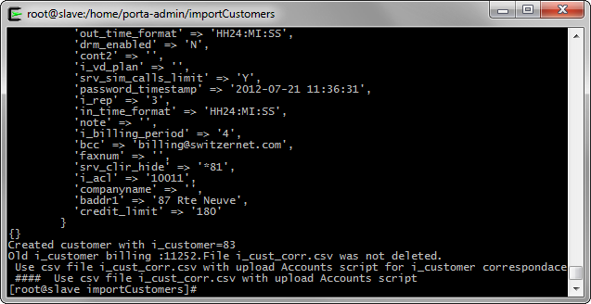

The ‘*i_cust_corr.csv*’ file is the link between the old *i_customer* and new *i_customer* in the two billings. It is essential for the next steps. Only one line is present in the sample file, as we only have one customer.

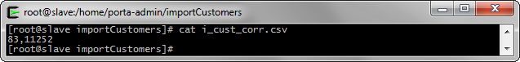

In the new porta-billig interface, you should now find the new customers you have created. In our example, the name of the customer has a suffix with a timestamp for testing.

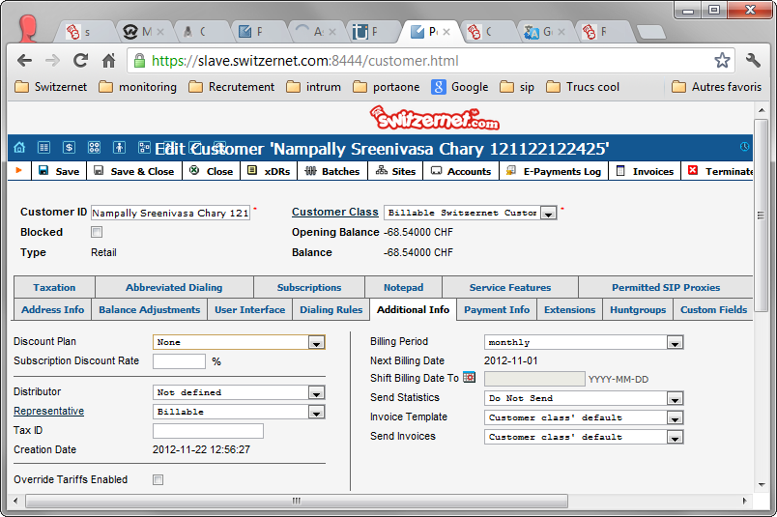

Verify the data from the web interface is the same as the old billing (with some exceptions in Service Features). If everything seems good, let’s upload the accounts for these customers.

**Import accounts**

Go to your working folder on pbs1 and download the new created ‘*i_cust_corr.csv*’ at this place.

|  |
| --- |
| pbs1:~/120822-customer-download# scp switz@slave.switzernet.com:/home/porta-admin/importCustomers/i_cust_corr.csv .  switz@slave.switzernet.com's password:  i_cust_corr.csv 100% 9 0.0KB/s 00:00  pbs1:~/120822-customer-download# |

This is the list of files you should have in you working folder.

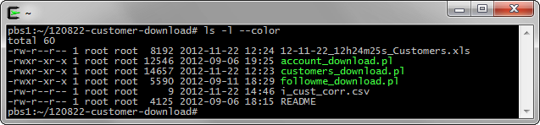

Once ‘*i_cust_corr.csv*’ copied, simply run the ‘*./account_download.pl*’. It will read our new file, get all accounts data for the customers of ‘*i_cust_corr.csv*’ and create the new excel.

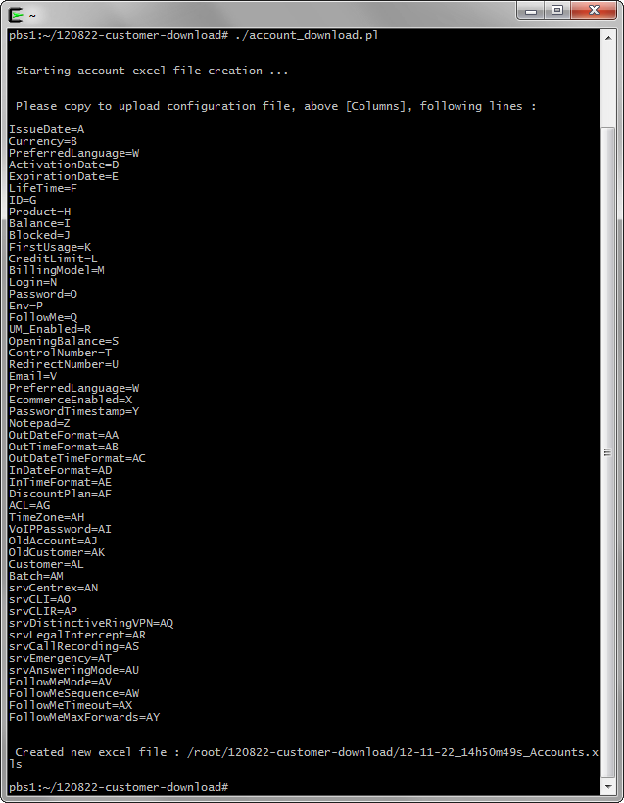

The file path is provided. Simply download to your desktop, open and verify if the excel is correct.

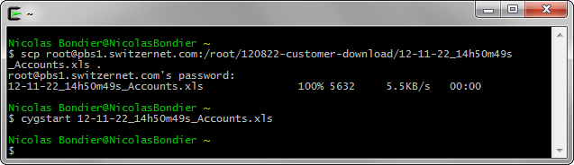

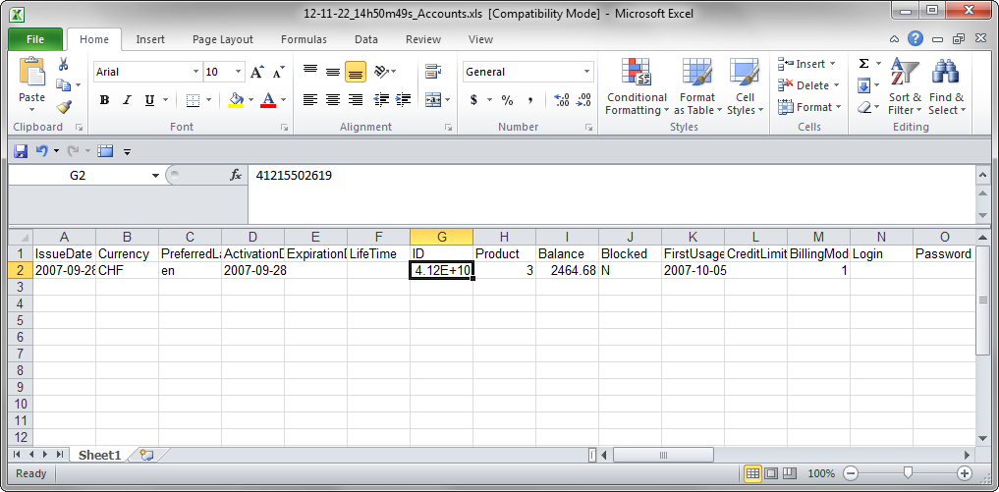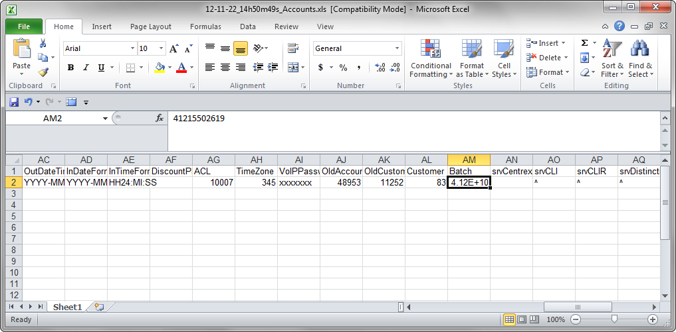

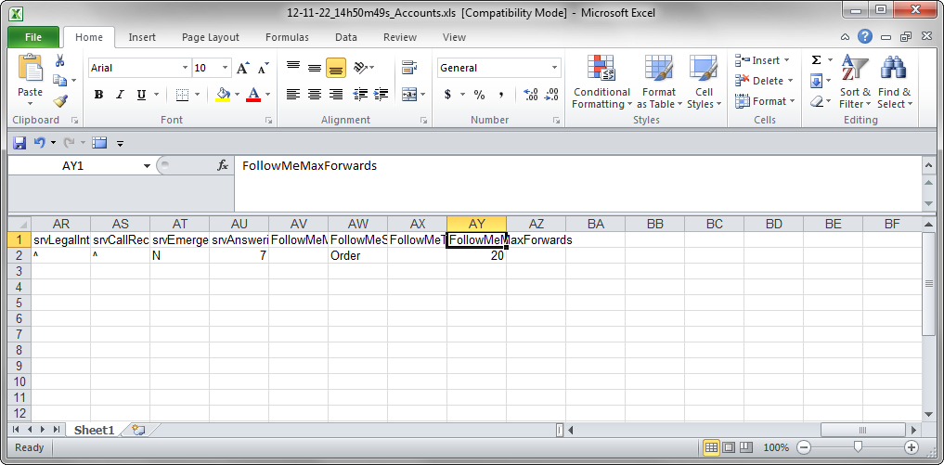

If the data seems correct, go to the slave and edit ‘*importAccounts_SwitzernetXls.cfg*’. Replace the list under [Columns] with the list of column names provided by ‘*./account_download.pl*’ script.

|  |
| --- |
| [root@slave importCustomers]# cd /home/porta-admin/importAccounts/  [root@slave importAccounts]# nano importAccounts_SwitzernetXls.cfg |

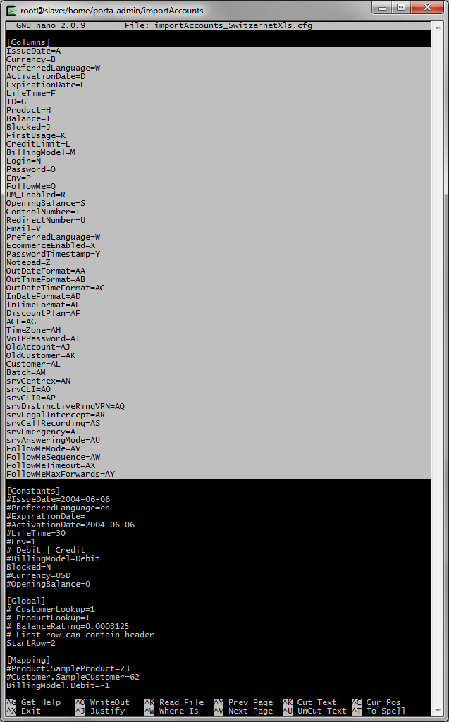

Download now the accounts excel file in our working directory.

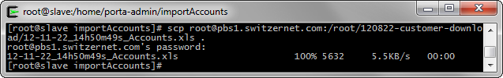

Here is a list of the files in the folder. We only use ‘*importAccounts_SwitzernetXls.cfg*’, ‘*importAccounts_SwitzernetXls.pl*’ and ‘*12-11-22_14h50m49s_Accounts.xls*’.

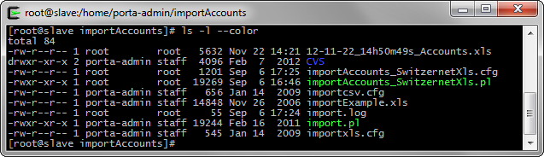

As you should have seen, the excel file contains all the data of accounts and the data for uploading, such as the new i_customer.

We only need to upload the new accounts. Run the following command with your new excel file :

|  |
| --- |
| ./importAccounts_SwitzernetXls.pl -v -x 12-11-22_14h50m49s_Accounts.xls -c importAccounts_SwitzernetXls.cfg |

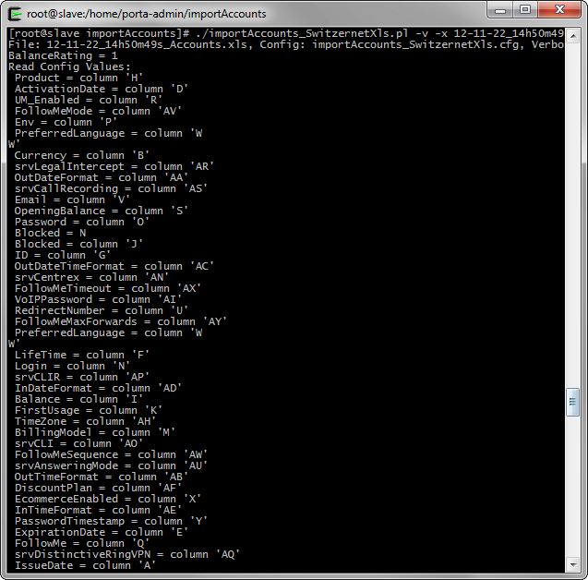

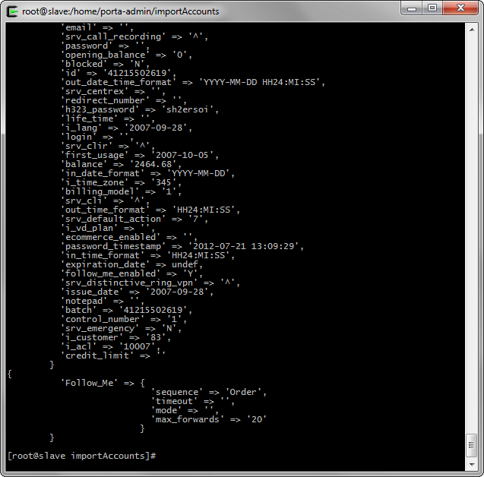

If no error occurs while importing the data, directly go to the new web interface and check all the data. Only Follow Me and Subscription should be missing.

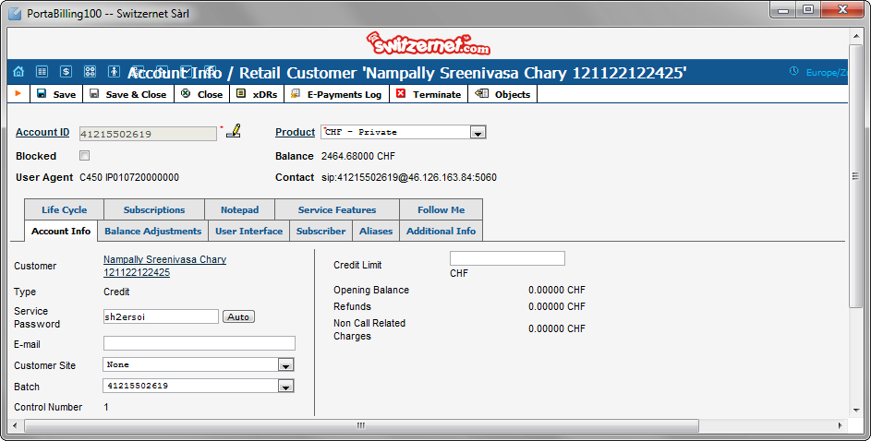

Note : On account creation on the new billing, if the account exist on both old and new billing, the dbas servers choose the new billing for authentication. The account has received a registration between the little interval I uploaded the account and the capture. This is why you can see the ‘*Contact*’ field is filled.

At this point the account is operational. We must continue the importation to provide other features like follow me, limit the maximum number of calls by account and add the subscriptions.

If you need to switch authorization and authentication from one billing to the other, use the following page:  
<http://switzernet.com/3/company/120820-acc-auth-to-billing/index.php>

Note also that accounting is send to the 2 billing masters if the account is on both. This way, no data is lost.

**Import old i_customer fields**

We decided to implement a custom field in the porta-billing web interface. This field is ‘*old i_customer*’. It will be the link between the old and new billing if we need it in the future. You can find it under any customer, under the ‘*Custom Fields*’ tab.

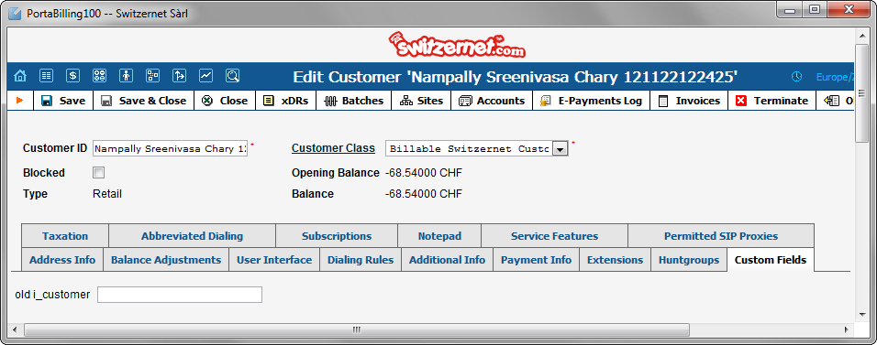

Go back to the ‘/home/porta-admin/importCustomers’ on the new slave. In this folder a script called ‘fill_old_i_customer.pl’ is present.

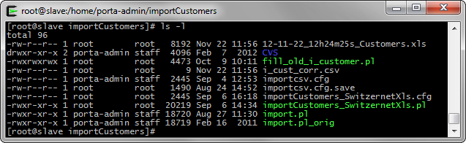

The script will use the ‘*i_cust_corr.csv*’ file and will upload the old *i_customer* value to the custom field we have created. This is done through SOAP connection.

Just run the script:

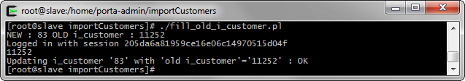

The old i_customer is now filled in the web interface:

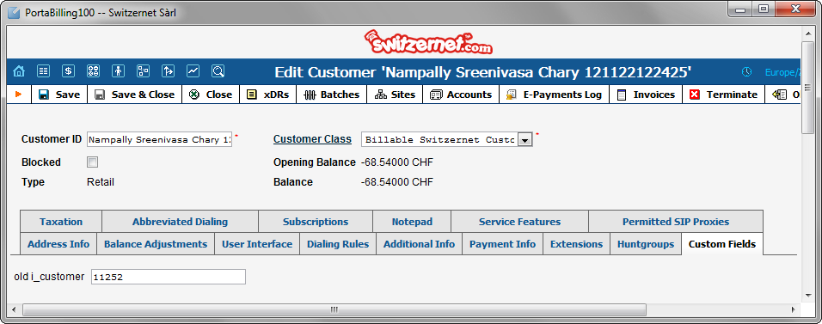

**Import customer sites**

For limiting maximum simultaneous calls for each account, we decided to use the new Customers Sites feature as the limit for each customer as disappeared. This point is essential for fraud prevention and for meeting our product restrictions.

Change directory on the slave to ‘*/home/porta-admin/importCustomerSites*’. Only one script is present: ‘*import.pl*’.

It does not need any input file. This script checks every account on the new billing master. If the account has no assigned site, it creates one with default values for the product used.

The advantage is that you can run this script every time you need to set a large quantity of customer’s sites to all accounts that do not have one, without looking for which accounts need to be updated with a new site. This script can be put in crontab if needed.

Here you can view the current state of our new customer’s sites:

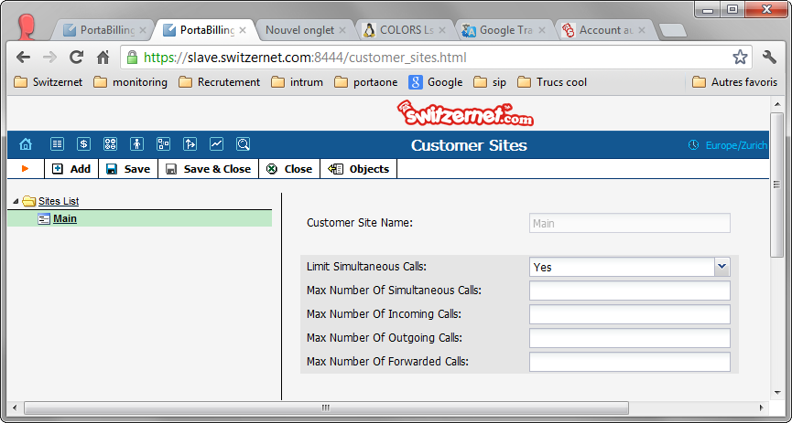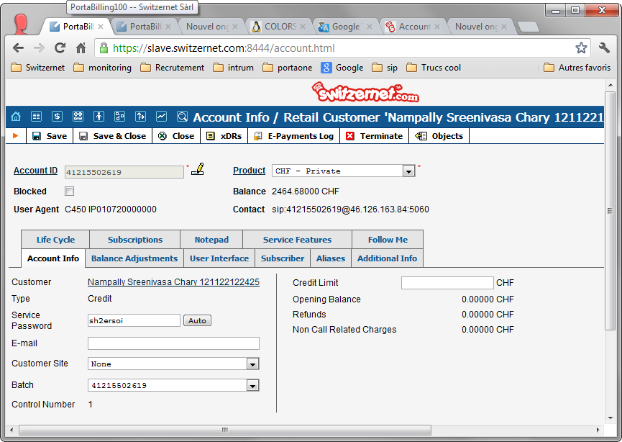

Launch the script ‘*import.pl*’:

|  |
| --- |
| [root@slave importCustomerSites]# cd /home/porta-admin/importCustomerSites  [root@slave importCustomerSites]# ./import.pl |

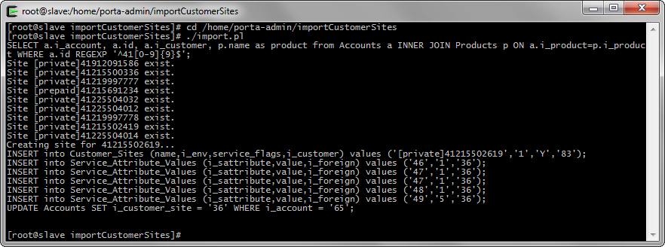

If everything is ok, go to the customers and account pages, you can view the changes:

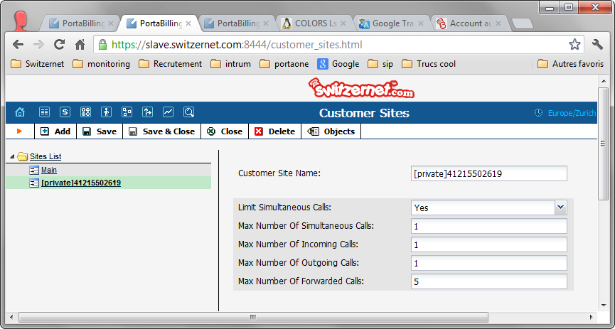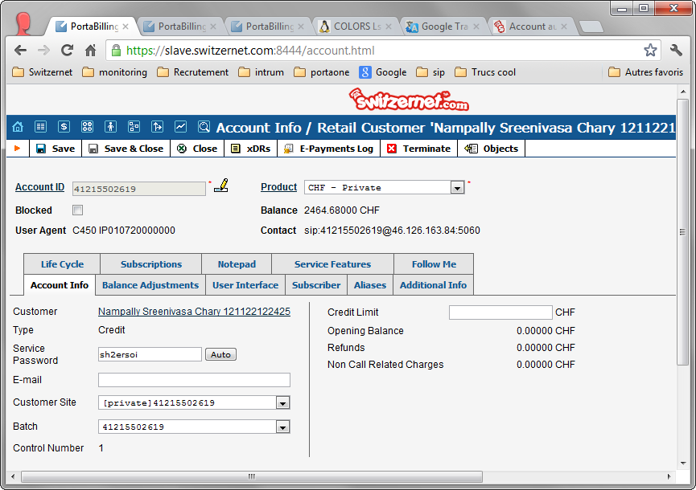

As you can view, the Customer has one site for each account with the type of site (private, business or prepaid). Note that sites for accounts with promotional product have the same name as for account with no promotional product.

**Import follow me**

It is now time to import the follow-me. Go in the pbs1 work folder. The script to use this time is ‘followme_download.pl’.

You still need to have the ‘*i_cust_corr.csv*’ in the folder, to know for which customer we need to get the data.

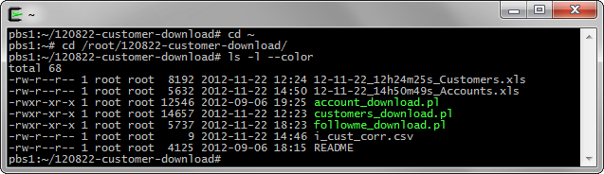

Run the ‘*./followme_download.pl*’ script :

|  |
| --- |
| [root@slave importCustomerSites]# ./followme_download.pl |

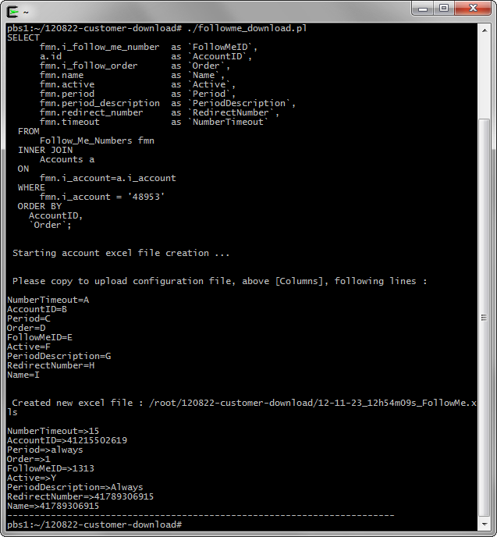

The script creates the Excel file of the customers’ Follow-Me and prints the new list of column for the configurations file.

If no error occurs, open a local terminal, download and verify the new excel file:

|  |
| --- |
| Nicolas Bondier@NicolasBondier ~  $ scp root@pbs1.switzernet.com:/root/120822-customer-download/12-11-23_12h54m09s_FollowMe.xls .  root@pbs1.switzernet.com's password:  12-11-23_12h54m09s_FollowMe.xls 100% 5632 5.5KB/s 00:00  Nicolas Bondier@NicolasBondier ~  $ cygstart 12-11-23_12h54m09s_FollowMe.xls |

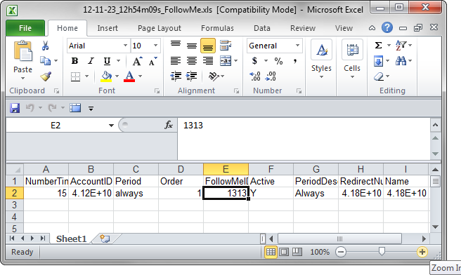

Once verified, go on slave and change directory to ‘*/home/porta-admin/imports/follow_me/*’ and import your new excel file.

|  |
| --- |
| [root@slave ~]# cd /home/porta-admin/imports/follow_me/  [root@slave follow_me]# ls -l  total 120  drwxr-xr-x 2 porta-admin staff 4096 Feb 7 2012 **CVS**  -rw-r--r-- 1 porta-admin staff 76800 Dec 4 2008 follow_me_numbers_example.xls  -rw-r--r-- 1 porta-admin staff 392 Sep 11 16:10 importCSV.cfg  -rw-r--r-- 1 root root 39 Sep 11 15:28 import_err.log  -rw-r--r-- 1 root root 260 Sep 11 15:28 import.log  -rwxr-xr-x 1 porta-admin staff 18067 Dec 4 2008 **import.pl**  -rw-r--r-- 1 porta-admin staff 412 Sep 11 16:09 importXLS.cfg  [root@slave follow_me]# scp root@pbs1.switzernet.com:/root/120822-customer-download/12-11-23_12h54m09s_FollowMe.xls .  root@pbs1.switzernet.com's password:  12-11-23_12h54m09s_FollowMe.xls 100% 5632 5.5KB/s 00:00  [root@slave follow_me]# |

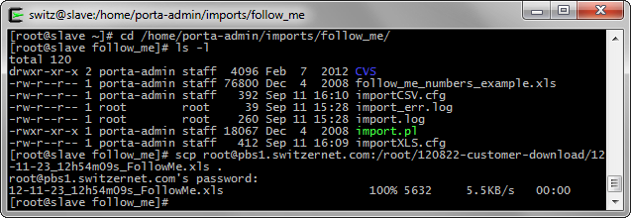

Open the ‘*importXLS.cfg*’ configuration file and past the column list under ‘*[Columns]*’:

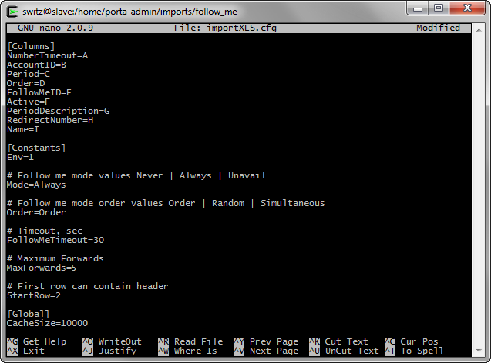

Verify all files are present and run the ‘*import.pl*’ script:

|  |
| --- |
| [root@slave follow_me]# ./import.pl -v -x 12-11-23_12h54m09s_FollowMe.xls -c importXLS .cfg |

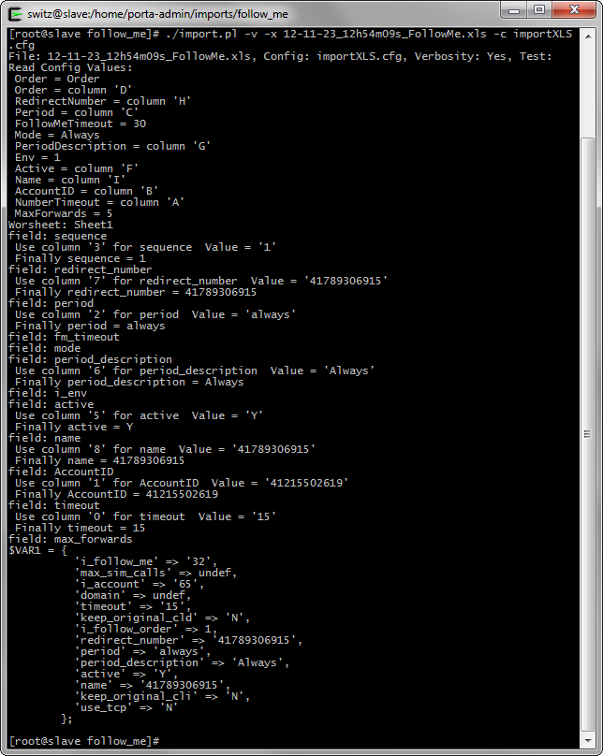

Inserting of the account’s Follow-Me is finished. We can see the new data in the new web interface:

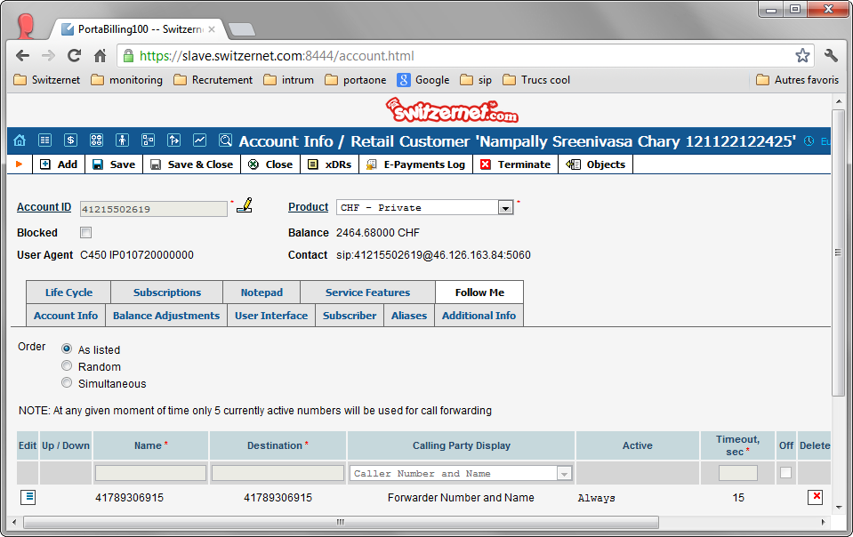

**Imports subscriptions**

The last data to import are the subscription. For this part, we made our own scripts, using SOAP.

Please note that we cannot set the subscriptions in the past. We have to start it at the first next month.

The script checks the subscription for each customer who have the old i_customer field filled. If the subscriptions differ, it synchronizes the subscriptions.

On slave server, change your directory to ‘*/home/porta-admin/importSubscriptions/*’. And run the ‘*import.pl*’ script:

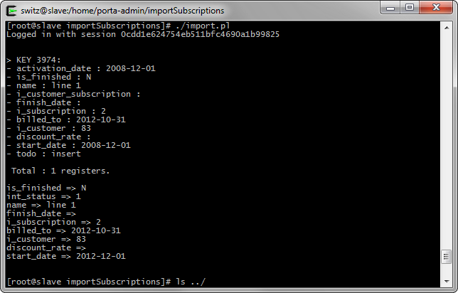

And once the script has finished, you can view the new pending subscription:

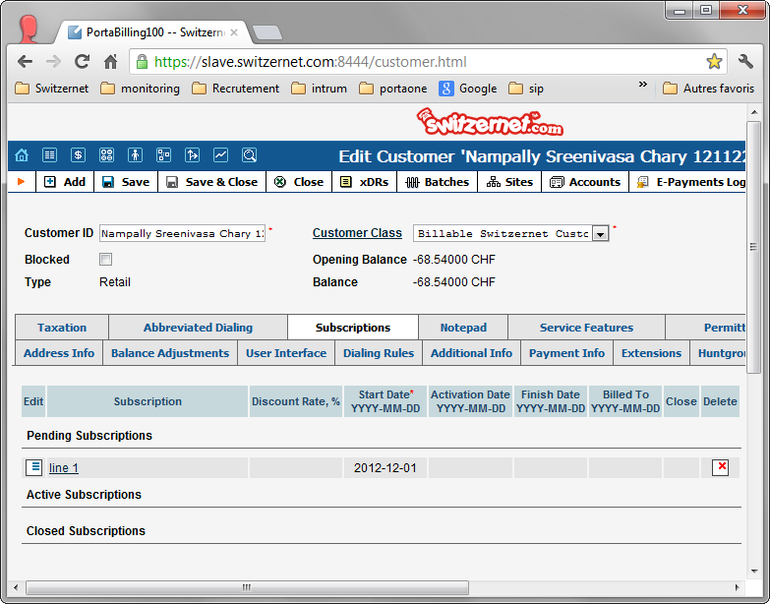

Your customer importing is finished!

**References**

The previous version of the importation procedure:   
<http://switzernet.com/3/public/130305-import-customers-how-to/>

The scripts details:   
<http://switzernet.com/3/public/130305-import-customers-how-to/>

* * *