**Dovecot shared folders  
AND LDAP**

Document created on 2013-12-12  
Nicolas Bondier

[[pdf](index.pdf)][[doc](index.docx)][[htm](index.htm)]

Contents

Introduction 3

Prerequisites 4

Configuration of Dovecot authentication 5

Mailboxes and configuration storage 7

PAM Authentication 8

Setting-up SSL/TLS encryption 9

Private mailboxes permissions 10

Creation of regular folders 10

Testing login 11

Shared mailboxes configuration 15

Creation of the dovecot user for shared mailboxes 15

Creation of a root directory for shared mailboxes 15

Configuration of the shared mailboxes 16

Incoming email configuration 20

Configuring Postfix with Dovecot LMTP 20

Incoming email on the shared accounts and sub-folders. 21

Testing sending and receiving emails 25

From and to personal inboxes 25

To shared folders 26

ACLs and shared folders management 28

Thunderbird useful tips for shared mailboxes 29

Files 30

Dovecot files and folder tree: 30

Postfix files: 30

Links 31

# Introduction

This document present the configuration of a dovecot server with LDAP authentication and IMAP folders shared between members.

# Prerequisites

We need one LDAP server and two Debian server with Dovecot installed and PAM configured for our LDAP server. The both dovecot servers store their configuration and mailboxes on the Ceph cluster and share the same data.

The LDAP installation is presented here <http://switzernet.com/3/public/131007-ldap-gosa-unix/> and the dovecot installation above a Ceph cluster is presented here <http://switzernet.com/3/public/130910-ceph-dovecot/>.

# Configuration of Dovecot authentication

As explained in the precedent document about Dovecot on Ceph cluster, the Dovecot configuration directory ‘/etc/dovecot’ is a link to a directory on the shared Rados block device. Both Dovecot servers have the same configuration and will not start if the block device is not mounted.

root@ceph-client-1:~# ls -l /etc/dovecot

lrwxrwxrwx 1 root root 46 Oct 1 14:16 /etc/dovecot -> /mnt/switzernet_rbd/131001-dovecot-data/config

root@ceph-client-1:~#

Bellow, is our configuration file with comment. Each part will be explained latter.

# 2.1.7: /etc/dovecot/dovecot.conf

# OS: Linux 3.8.13-xxxx-grs-ipv6-64-vps x86_64

protocols = imap lmtp

log_timestamp = "%Y-%m-%d %H:%M:%S "

mail_privileged_group = vmail

disable_plaintext_auth = yes

ssl = yes

ssl_cert = < /mnt/switzernet_rbd/131001-dovecot-data/certs/switzernet_and_gd_bundle.crt

ssl_key = < /mnt/switzernet_rbd/131001-dovecot-data/certs/switzernet.com.key

# Location for the mail storage on shared block device. Each user have a distinguish folder.

mail_location = maildir:/mnt/switzernet_rbd/131001-dovecot-data/Maildir/accounts/%u:LAYOUT=fs

mail_access_groups = vmail

# Configuration for storing on OCFS2.

mail_fsync = always

mail_nfs_storage = yes

mail_nfs_index = yes

mmap_disable = yes

# Auth user name format. This is the format used by pam.

auth_username_format = %n

namespace {

type = private

separator = /

prefix =

subscriptions = yes

inbox = yes

}

namespace {

type = public

separator = /

prefix = Root/

location = maildir:/mnt/switzernet_rbd/131001-dovecot-data/Maildir/root/:LAYOUT=fs

subscriptions = no

ignore_on_failure = yes

list = yes

}

service imap {

# Tell imap to do post-login lookup using a socket called "imap-postlogin"

executable = imap imap-postlogin

}

service imap-postlogin {

# All post-login scripts are executed via script-login binary

executable = script-login /mnt/switzernet_rbd/131001-dovecot-data/scripts/link_shared_mailboxes.sh

# The script process runs as the user given here (v2.0.14+):

user = root

# This UNIX socket listener must use the same name as given to imap executable

unix_listener imap-postlogin {

}

}

# Postfix authentication

service auth {

unix_listener /var/spool/postfix/private/auth {

mode = 0660

# Assuming the default Postfix user and group

user = postfix

group = postfix

}

}

# Local delivery agent for Postfix

service lmtp {

unix_listener /var/spool/postfix/private/dovecot-lmtp {

group = postfix

mode = 0600

user = postfix

}

}

# Sqlite database with email adress and username

passdb {

driver = sql

args = /etc/dovecot/dovecot-sql.conf.ext

}

# LDAP authentication through pam, as it is configured in our system.

passdb {

driver = pam

args = session=yes failure_show_msg=yes dovecot

}

# Sqlite database with email adress and username

userdb {

driver = sql

args = /etc/dovecot/dovecot-sql.conf.ext

}

# LDAP authentication through pam, as it is configured in our system.

userdb {

driver = passwd

}

auth_mechanisms = plain login

protocol imap {

mail_plugins = acl imap_acl autocreate

}

plugin {

# When the mailbox doeesn’t exist, this plugin create the basic folders.

autocreate = Drafts

autocreate2 = Sent

autocreate3 = Junk

autocreate4 = Trash

autosubscribe = Drafts

autosubscribe2 = Sent

autosubscribe3 = Junk

autosubscribe4 = Trash

# With global ACLs:

acl = vfile

# some logging

mail_log_events = delete undelete expunge copy mailbox_delete mailbox_rename flag_change save mailbox_create

# Allown authenticated keyword

acl_anyone = allow

}

## Mailboxes and configuration storage

On our installation, all dovecot files are stored under the same folder on the Rados block device.

The paths are not the same as in the [[Dovecot on Ceph cluster](http://switzernet.com/3/public/130910-ceph-dovecot/index.htm#_Toc366866329)] document.

The Rados Block device is mounted on ‘/mnt/switzernet_rbd/’.

The Dovecot folder ‘/mnt/switzernet_rbd/131001-dovecot-data’ has been manually created.

We created under this folder:

- A ‘config’ directory in that is the copy of the ‘/etc/dovecot’ configuration directory. On each of the server, ‘/etc/dovecot’ have been replaced with a symbolic link to ‘/mnt/switzernet_rbd/131001-dovecot-data/config’.

- A ‘certs’ folder for the SSL certificates.

- A ‘Maildir’ folder for the storage.

- A ‘scripts’ folder for post-login scripts.

The ‘Maildir’ folder has:

- An ‘accounts’ directory, for the mailboxes of LDAP user accounts.

- A ‘root’ directory, which is the root folder of all shared mailboxes.

## PAM Authentication

The ‘/etc/pam.d/dovecot’ file has the following lines:

root@ceph-client-2:~# cat /etc/pam.d/dovecot

#%PAM-1.0

@include common-auth

@include common-account

@include common-session

root@ceph-client-2:~#

Verify or change the content of the included files:

- Account rule in ‘/etc/pam.d/common-account’:

account required pam_permit.so

- Authentication rule in ‘/etc/pam.d/common-auth:

auth required pam_permit.so

In the ‘/etc/dovecot/dovecot.conf’, set the parameters as given. Under ‘passdb’, ‘session=yes’ is needed for some plug-ins, and ‘dovecot’ argument is the file under ‘/etc/pam.d/’ where to find the PAM configuration.

passdb {

# LDAP authentication through pam, as configured in our system.

driver = pam

args = session=yes failure_show_msg=yes dovecot

}

userdb {

# User database use unix GID and UID

driver = passwd

}

With PAM, the only supported authentication mechanism is plaintext. We must set the ‘auth_mechanisms’ variable this way:

auth_mechanisms = plain login

## Setting-up SSL/TLS encryption

With the current authentication process, it is required to set-up the SSL/TLS encryption to not send plaintext passwords over the network.

First we had to create a private key, then provide it to the SSL certificate provider (GoDaddy) to get our ‘.crt’ file. We also have to get ‘.crt’ bundle of the certification authority.

Place all the files in the ‘certs’ folder and create a new ‘.crt’ files with all certificates. Order must be ‘your_cert.crt’, ‘your_provider_cert.crt’.

root@ceph-client-1:/mnt/switzernet_rbd/131001-dovecot-data/certs# cat switzernet.com.crt gd_bundle.crt > switzernet_and_gd_bundle.crt

Change the rights of the files. The private key should have 0400 rights and certificates should have 0444 rights. Dovecot will read them under the root privileges, so the owner must be root.

root@ceph-client-1:/mnt/switzernet_rbd/131001-dovecot-data/certs# ls -l

total 8

-r--r--r-- 1 root root 3197 Oct 10 14:12 gd_bundle.crt

-r--r--r-- 1 root root 5092 Oct 10 15:43 switzernet_and_gd_bundle.crt

-r--r--r-- 1 root root 1895 Oct 10 14:12 switzernet.com.crt

-r-------- 1 root root 1704 Oct 10 14:58 switzernet.com.key

Finally, add the following lines to your ‘/etc/dovecot/dovecot.conf’:

disable_plaintext_auth = yes

ssl = yes

ssl_cert = < /mnt/switzernet_rbd/131001-dovecot-data/certs/switzernet_and_gd_bundle.crt

ssl_key = < /mnt/switzernet_rbd/131001-dovecot-data/certs/switzernet.com.key

And restart Dovecot on the both servers:

root@ceph-client-1:/mnt/switzernet_rbd/131001-dovecot-data/certs# /etc/init.d/dovecot restart

Restarting IMAP/POP3 mail server: dovecot.

root@ceph-client-1:/mnt/switzernet_rbd/131001-dovecot-data/certs#

## Private mailboxes permissions

The ‘Maildir’ directory has the “execute” (for cd) and “read” (for listing) permissions for everybody. It also have the sticky bit for not permitting to users to delete their own folder.

root@ceph-client-1:/mnt/switzernet_rbd/131001-dovecot-data# getfacl Maildir

# file: Maildir

# owner: root

# group: root

# flags: --t

user::r-x

group::r-x

other::r-x

The ‘accounts’ directory must have 777 rights for permitting any user to add new mailboxes. It also have the sticky-bit ‘t’ for not letting users to remove the mailbox.

root@ceph-client-1:/mnt/switzernet_rbd/131001-dovecot-data# getfacl Maildir/accounts

# file: Maildir/accounts

# owner: root

# group: root

# flags: --t

user::rwx

group::rwx

other::rwx

## Creation of regular folders

Inside the plugin directive of the ‘/etc/dovecot/dovecot.conf’, place the following lines for auto-creating the basic folders at first login.

plugin {

# When the mailbox doeesn’t exist, this plugin create the basic folders.

autocreate = Drafts

autocreate2 = Sent

autocreate3 = Junk

autocreate4 = Trash

autosubscribe = Drafts

autosubscribe2 = Sent  
 autosubscribe3 = Junk

autosubscribe4 = Trash

}

## Testing login

We can now test to login with a new user. First we have to create it in the Gosa web interface.

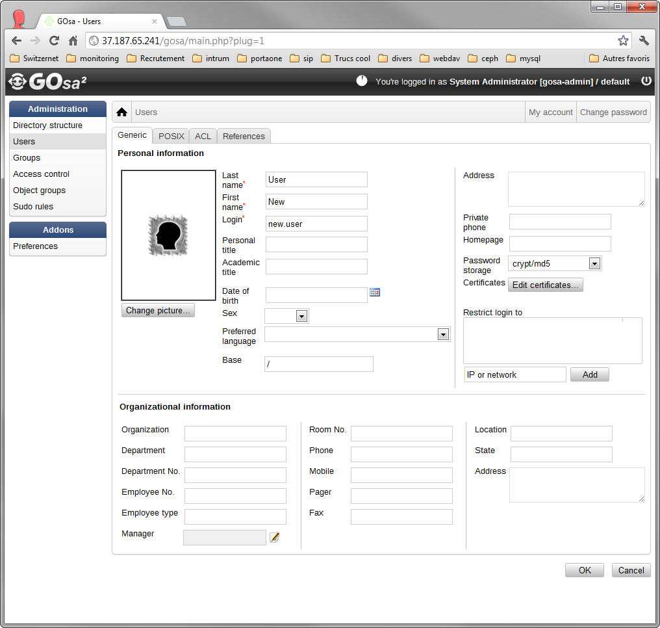

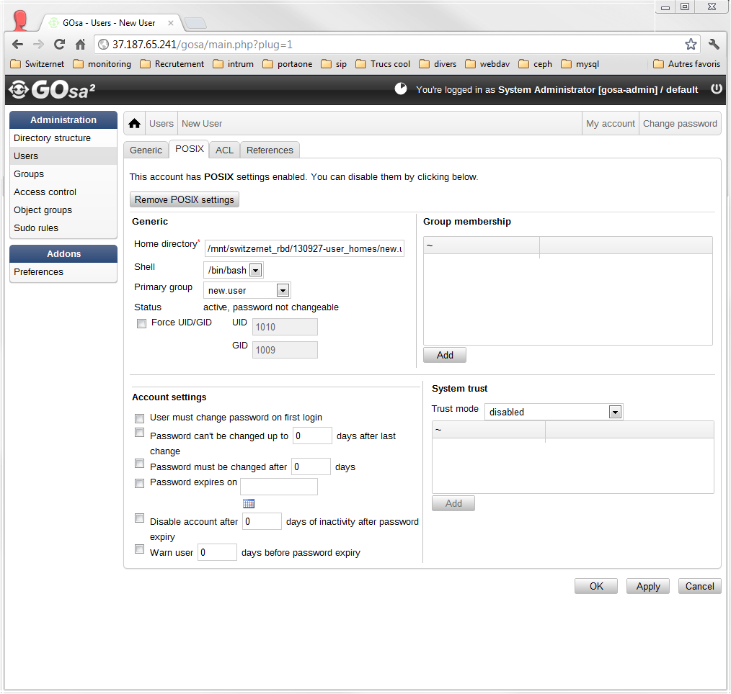

And then configure our IMAP client. Here we use thunderbird:

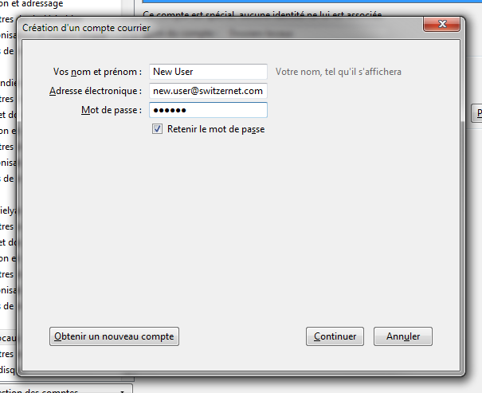

Manual settings:

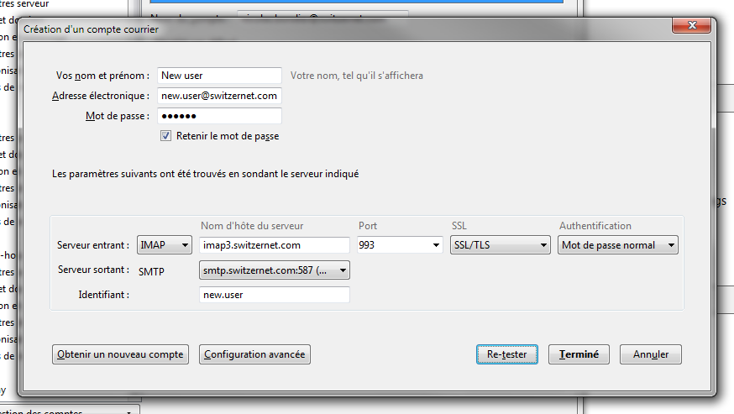

The connection is done. The lock on the letter icon means that the connection is encrypted:

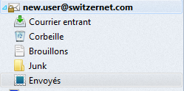

# Shared mailboxes configuration

## Creation of the dovecot user for shared mailboxes

For each of the dovecot servers, add a new user and group ‘vmail’. It will be the primary user used for the reception and storage of emails in the shared mailboxes.

root@ceph-client-1:~# groupadd vmail --gid 999

root@ceph-client-1:~# useradd vmail --uid 999 --gid 999

Our LDAP users will also be authorized to access shared mailboxes. We will use two types of permissions:

Virtual mailboxes from a SQLite

## Creation of a root directory for shared mailboxes

root@ceph-client-1:/mnt/switzernet_rbd/131001-dovecot-data/Maildir# ls

accounts

Under ‘Maildir’, create the ‘root’ directory.

mkdir root

It must be readable and writable by the ‘vmail’ user.

chown vmail:vmail root

The group options must be respected for the subfolders/subdirectories.

chmod g+rwxs root

Here come the ACLs. First set the largest rights for all users to read, write, and execute to the directory. The ‘-d’ option describes the ALCs to apply to the sub-folders of this directory.

setfacl -m mask::rwx root

setfacl -dm mask::rwx root

The ‘vmail’ client have all access to this directory and the permission must be inherit to the new subdirectories.

setfacl -m d:g::rwx root

setfacl -dm d:g:vmail:rwx root

Do not let users to delete mailboxes in this directory.

chmod +t root

Verify your ACL:

root@ceph-client-1:/mnt/switzernet_rbd/131001-dovecot-data/Maildir# getfacl root

# file: root

# owner: vmail

# group: vmail

# flags: -st

user::rwx

group::rwx

mask::rwx

other::---

default:user::rwx

default:group::rwx

default:mask::rwx

default:other::---

## Configuration of the shared mailboxes

First, we need to add in our ‘dovecot.conf’ file two namespaces. One for the private mailboxes and the second one for the shared mailbox:

namespace {

type = private

separator = /

prefix =

subscriptions = yes

inbox = yes

}

namespace {

type = public

separator = /

prefix = root/

location = maildir:/mnt/switzernet_rbd/131001-dovecot-data/Maildir/root/:LAYOUT=fs

subscriptions = no

ignore_on_failure = yes

list = yes

}

Now restart dovecot on both servers and restart your mail client. At launch, the mail client still have the same mailboxes displayed.

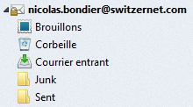

In the subscription management windows, we can see the new namespace ‘root’. But it can’t be selected because not recognized as a mailbox.

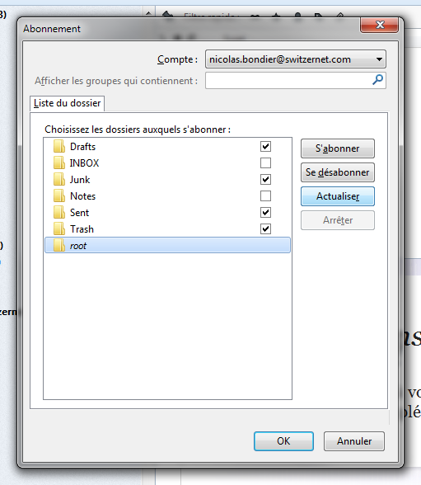

For this, we must create the minimum content of a mailbox.

In the path of the shared namespace, create a ‘dovecot-acl’ file with the content:

root@ceph-client-1:/mnt/switzernet_rbd/131001-dovecot-data/Maildir/root# cat dovecot-acl

anyone keilrwts

And create the default directories of the Maildir storage:

root@ceph-client-1:/mnt/switzernet_rbd/131001-dovecot-data/Maildir/root# mkdir tmp

root@ceph-client-1:/mnt/switzernet_rbd/131001-dovecot-data/Maildir/root# mkdir cur

root@ceph-client-1:/mnt/switzernet_rbd/131001-dovecot-data/Maildir/root# mkdir new

root@ceph-client-1:/mnt/switzernet_rbd/131001-dovecot-data/Maildir/root# ls -l

total 0

drwxrws---+ 2 root vmail 3896 Dec 11 11:38 cur

-rw-rw----+ 1 root vmail 16 Dec 11 11:37 dovecot-acl

-rw-rw----+ 1 emin.gabrielyan vmail 0 Dec 11 11:26 dovecot-acl-list

drwxrws---+ 2 root vmail 3896 Dec 11 11:38 new

drwxrws---+ 2 root vmail 3896 Dec 11 11:38 tmp

Restart your thunderbird and see the subscription list:

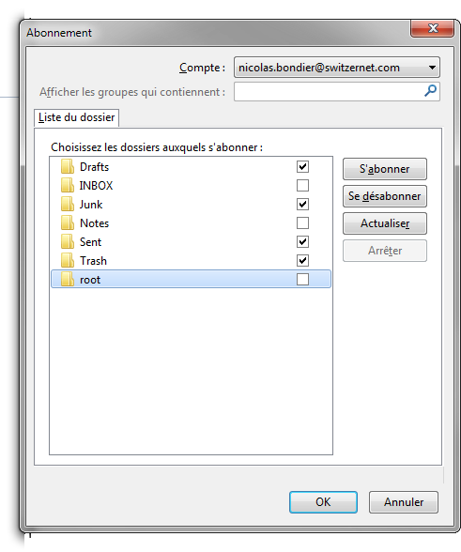

The folder can now be subscribed and you will see it displayed in your thunderbird folders (You may need to restart thunderbird again the first time):

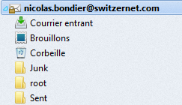

The root folder cannot be deleted or renamed. You can now create new mailboxes inside of this folder.

Example, we create a new folder in the root directory. After subscribed in all accounts to this folder, we can see it in all account folder tree:

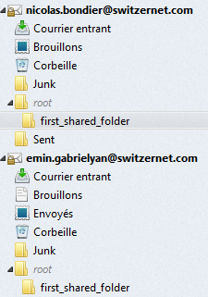

# Incoming email configuration

## Configuring Postfix with Dovecot LMTP

The SMTP server that will be used for sending and receiving emails is Postfix.

First install Postfix:

root@ceph-client-1:~# aptitude install postfix

root@ceph-client-2:~# aptitude install postfix

On our Rados block device, we will store all configuration files. Copy and replace the ‘/etc/postfix’ folder by a symbolic link to the Rados block device (for both servers).

root@ceph-client-1:~# cp -r /etc/postfix /mnt/switzernet_rbd/131015-postfix

root@ceph-client-1:~# rm -r /etc/postfix

root@ceph-client-1:~# ln -s /mnt/switzernet_rbd/131015-postfix/ /etc/postfix

root@ceph-client-2:~# rm -r /etc/postfix

root@ceph-client-2:~# ln -s /mnt/switzernet_rbd/131015-postfix/ /etc/postfix

We now have the same configuration files for all postfix servers.

We edited the ‘main.cf’ with the parameters bellow.

We use the dovecot LMTP socket for authenticating the users and storing the emails. This way, postfix doesn’t need to access the LDAP users to authenticate them

This configuration is standard. Notice the SQLite virtual alias maps database that will be explained in the next chapter.

queue_directory = /var/spool/postfix

myhostname = mail.switzernet.com

alias_maps = hash:/etc/aliases

alias_database = hash:/etc/aliases

myorigin = /etc/mailname

mydestination = testmail.switzernet.com, switzernet.com, testmail.intarnet.com, intarnet.com, localhost

relayhost =

mynetworks = 127.0.0.0/8 [::ffff:127.0.0.0]/104 [::1]/128

mailbox_transport = lmtp:unix:private/dovecot-lmtp

mailbox_size_limit = 0

recipient_delimiter = +

inet_interfaces = all

message_size_limit = 0

virtual_alias_maps = sqlite:/etc/postfix/sqlite-virtual.cf

transport_maps = hash:/etc/postfix/transport

## Incoming email on the shared accounts and sub-folders.

We needed to be able to receive emails in some of the shared inboxes and its sub-folder.

For this purpose, we use a SQLite database for virtual alias maps only for the shared folders. The goal of this database is to tell to postfix, when delivering email with LMTP and to a user who is not a LDAP user but a shared directory, for which virtual user and which mailbox the email is, depending on the full email address. Postfix and dovecot use the same table of the database.

Create the database:

root@ceph-client-1:~# sqlite3 /mnt/switzernet_rbd/131205-mail-server-www/131108-imap-admin/virtual.sqlite

The SQL for the table creation is bellowed.

CREATE TABLE 'virtual_Mailboxes' (

i_mailbox INTEGER PRIMARY KEY AUTOINCREMENT,

address TEXT NOT NULL,

path TEXT NOT NULL

);

CREATE UNIQUE INDEX path_address ON virtual_Mailboxes (address, path);

Here is the configuration file for the SQL back-end ‘/etc/postfix/sqlite-virtual.cf’ with the SQL request. (The ‘@switzernet.com’ is only for matching the ‘mydestination’ variables of the ‘main.cf’ configuration file):

#

# sqlite config file for local(8) aliases(5) lookups

#

# Path to database

dbpath = /mnt/switzernet_rbd/131108-www/131108-imap-acl/virtual.sqlite

# See sqlite_table(5) for details.

query = SELECT (i_mailbox||'@switzernet.com') FROM virtual_Mailboxes WHERE address='%s';

Postfix use only ‘i_mailbox’, which will be considered as a username and send to this user to dovecot during the LMTP delivering.

You may need to run the following command to create the aliases database from ‘/etc/aliases’.

root@ceph-client-1:~# newaliases

In Dovecot configuration file, we add the LMTP service:

# Local delivery agent for Postfix

service lmtp {

unix_listener /var/spool/postfix/private/dovecot-lmtp {

group = postfix

mode = 0600

user = postfix

}

}

Now we need to tell to postfix how to authenticate users for sending and receiving emails. It will use SASL for authenticating Dovecot’s users, who are themselves authenticated with PAM.

First, in Dovecot configuration file, we add the authentication service:

service auth {

unix_listener /var/spool/postfix/private/auth {

mode = 0660

# Assuming the default Postfix user and group

user = postfix

group = postfix

}

}

Then in ‘/etc/postfix/master.cf’, use a dedicated submission port for the authentication (details here: <http://wiki2.dovecot.org/HowTo/PostfixAndDovecotSASL#line-41>).

submission inet n - - - - smtpd

-o smtpd_tls_security_level=none

-o smtpd_sasl_auth_enable=yes

-o smtpd_sasl_type=dovecot

-o smtpd_sasl_path=private/auth

-o smtpd_sasl_security_options=noanonymous

-o smtpd_sasl_local_domain=$myhostname

-o smtpd_client_restrictions=permit_sasl_authenticated,reject

-o smtpd_sender_login_maps=hash:/etc/postfix/virtual

-o smtpd_recipient_restrictions=reject_non_fqdn_recipient,reject_unknown_recipient_domain,permit_sasl_authenticated,reject

In dovecot, we must add the second authentication with the SQLite database instead of the LDAP database (through PAM).

Another authentication is set before the PAM authentication:

# Sqlite database with email adress and username

passdb {

driver = sql

args = /etc/dovecot/dovecot-sql.conf.ext

}

# Sqlite database with email adress and username

userdb {

driver = sql

args = /etc/dovecot/dovecot-sql.conf.ext

}

Dovecot will receive the email send by postfix and match the user part of the address (without the ‘@domain.com’ part) in the same database, to get all the user variables including the mailbox path.

The user part send through LMTP is the ‘i_mailbox’ field that Postfix get from the ‘virtual_alias_maps’ database. It will be used by Dovecot to get all other information on a shared account from the SQLite database.

The ‘/etc/dovecot/dovecot-sql.conf.ext’ returns:

- Mailbox path

- UID and GID dovecot must run under for reading and storing the emails.

- The password is random because we do not want to connect to these accounts directly and store them. LMTP doesn’t use it.

driver = sqlite

connect = /mnt/switzernet_rbd/131205-mail-server-www/131108-imap-admin/virtual.sqlite

default_pass_scheme = PLAIN

user_query = SELECT '' AS home, ('maildir:/mnt/switzernet_rbd/131001-dovecot-data/Maildir/root/'||path) AS mail, '999' AS uid, '999' AS gid FROM 'virtual_Mailboxes' WHERE i_mailbox = '%n';

password_query = SELECT (lower(hex(randomblob(16)))) as password;

iterate_query = SELECT i_mailbox AS username FROM 'virtual_Mailboxes';

After the modifications, restart Dovecot and Postfix and both servers.

We insert our folder in the alias map with the address ‘first_shared_folder@switzernet.com’:

root@ceph-client-1:~# sqlite3 /mnt/switzernet_rbd/131205-mail-server-www/131108-imap-admin/virtual.sqlite

sqlite>

sqlite> INSERT INTO 'virtual_Mailboxes' (address, path) VALUES ('first_shared_folder@testmail.switzernet.com','first_shared_folder');

sqlite>

Here is the example in the database:

sqlite> .tables

virtual_Mailboxes

sqlite> SELECT * FROM virtual_Mailboxes;

i_mailbox address path

--------- ------------------------------------------- -------------------

1 first_shared_folder@testmail.switzernet.com first_shared_folder

The steps when receiving an email are the following:

1. To resume, postfix receive an email to ‘first_shared_folder@testmail.switzernet.com’.
2. If address is in the SQLite database, the user is a shared mailbox and ‘i_mailbox’, will replace the username ‘first_shared_folder’.

sqlite> SELECT (i_mailbox||'@switzernet.com') FROM virtual_Mailboxes WHERE address='first_shared_folder@testmail.switzernet.com';

(i_mailbox||'@switze

--------------------

1@switzernet.com

1. An authentication request and the mails are sent to Dovecot though LMTP. Dovecot looks in the SQLite database to authenticate with the user part of the mail address, which is “1” and get where to store the email:

sqlite> SELECT '' AS home, ('maildir:/mnt/switzernet_rbd/131001-dovecot-data/Maildir/root/'||path) AS mail, '999' AS uid, '999' AS gid FROM 'virtual_Mailboxes' WHERE i_mailbox = '1';

home mail [...] uid gid

---- ------------[...]-------------------- --- ----

maildir:/mnt[...]/first_shared_folder 999 999

sqlite>

## Testing sending and receiving emails

We can now test receiving and sending email. As we currently use our primary domain for emails, we have created the testmail subdomain to test sending the email to our new servers. Our DNS configuration is the following. This is the sub-domain used in our precedent examples:

;;;; Tests emails

testmail IN MX 5 mail-a

testmail IN MX 5 mail-b

mail-a IN A 5.135.149.193

mail-b IN A 5.135.149.195

### From and to personal inboxes

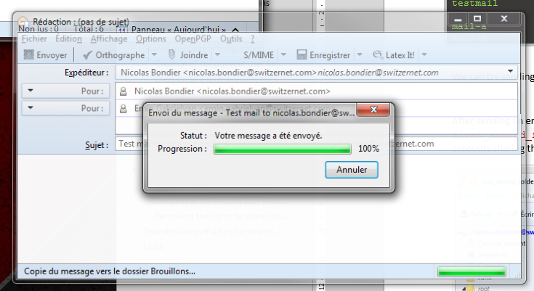

Sending email

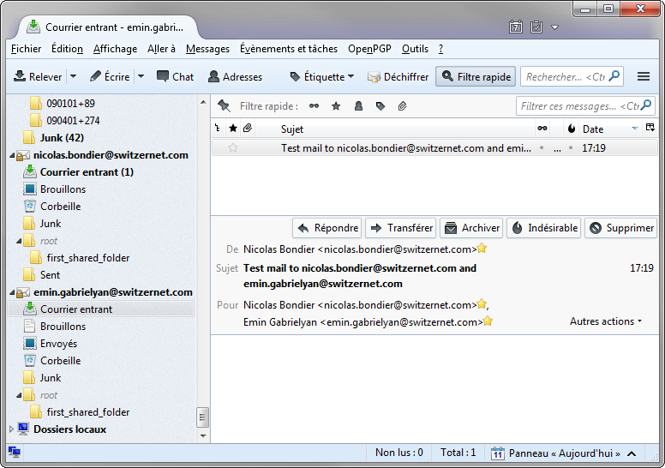

Email reception

### To shared folders

After sending an email from an external web mail to ‘first_shared_folder@testmail.switzernet.com’, we received it to our mailbox. All accounts sharing the sub-folder see the email in the public namespace:

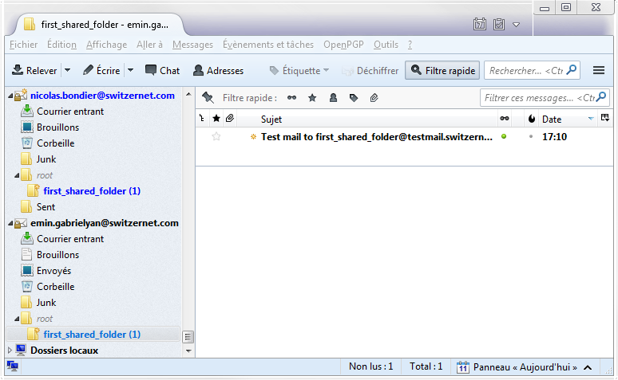

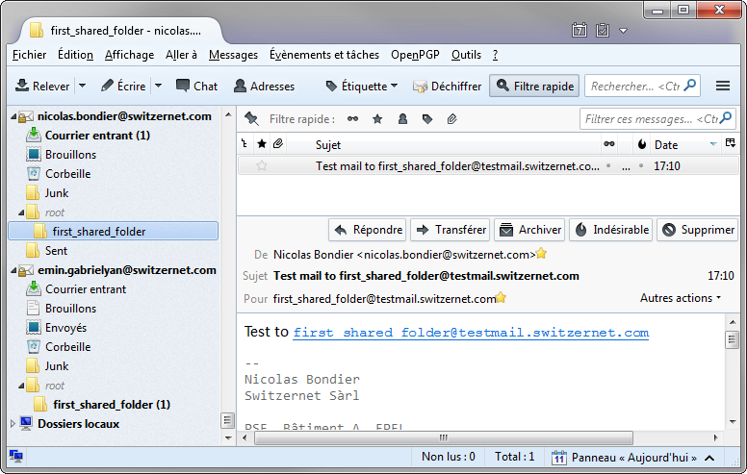

# ACLs and shared folders management

For managing the shared folder incoming email addresses and the user and group ACLs, we added a web interface.

The link the documentation will be added later.

# Thunderbird useful tips for shared mailboxes

Here is an extension for changing the default identities of outgoing emails depending of the current selected folder/sub-folder: <https://addons.mozilla.org/fr/thunderbird/addon/folder-account/?src=cb-dl-updated>

# Files

## Dovecot files and folder tree:

root@ceph-client-1:/mnt/switzernet_rbd# tree 131001-dovecot-data -L 2

131001-dovecot-data

|-- certs

| |-- gd_bundle.crt

| |-- switzernet_and_gd_bundle.crt

| |-- switzernet.com.crt

| `-- switzernet.com.key

|-- config

| |-- dovecot.conf

| `-- dovecot-sql.conf.ext

|-- logs

| `-- mails.log

|-- Maildir

| |-- accounts

| | |-- emin.gabrielyan

| | |-- new.user

| | `-- nicolas.bondier

| `-- root

| |-- cur

| |-- dovecot-acl

| |-- dovecot-acl-list

| |-- dovecot-uidvalidity

| |-- dovecot-uidvalidity.52a84f4d

| |-- first_shared_folder

| |-- new

| `-- tmp

`-- scripts

`-- post-login.sh

Files in orange are included in the downloadable archive [[131001-dovecot-data.tar.gz](data/131001-dovecot-data.tar.gz)].

## Postfix files:

root@ceph-client-1:/mnt/switzernet_rbd# tree -L 2 131015-postfix

131015-postfix

|-- main.cf

|-- master.cf

|-- sqlite-virtual.cf

`-- virtual.sqlite

Files in orange are included in the downloadable archive [[131015-postfix.tar.gz](data/131015-postfix.tar.gz)].

# Links

This document: <http://switzernet.com/3/public/131007-ldap-gosa-unix/>

Debian LDAP PAM: <https://wiki.debian.org/fr/LDAP/PAM>

Gosa: <https://oss.gonicus.de/labs/gosa>

OpenLDAP: <http://www.openldap.org/>

This document is related to the project including:

Ceph cluster: <http://switzernet.com/3/public/130925-ceph-cluster/>

Dovecot + Ceph: <http://switzernet.com/3/public/130910-ceph-dovecot/>

* * *



Copyright © 2013 by Switzernet