Crontab quick guide

Created by Eric Murillo on 2019-04-06

Table of Contents

Introduction 1

How to edit Crontab Scheduler tasks 1

System-wide crontab scheduler 1

Additional Crontab examples 1

Crontab Example 1 1

Crontab Example 2 1

Crontab Example 3 1

Crontab Example 4 1

Crontab Example 5 1

Crontab Example 6 1

References 1

End of document 1

# Introduction

Every user, as well as administrator of the Linux system, very often need to execute some programs automatically on a regular basis.

For example, an administrator may need to monitor a disk usage of a system. In this case, a cron scheduler is a very handy tool to achieve this goal.

Let's say that the system administrator needs to execute **/home/murilloe/backup.sh** script every **Sunday** at **2:36 AM**. In this case, the administrator would edit his **crontab** file as shown on the figure below:

**Bash commands**

$ sudo crontab -e

The format of Crontab entry is simple as it is divided into 7 fields separated by spaces or tabs. The 6th field, in this case, the username, can be omitted as it is only used by the system-wide crontab scheduler.

The following code illustrates a single Crontab entry to allow automatic script execution every **Sunday**at **2:36 AM**:

**Crontab job**

36 2 * * 7 root /home/murilloe/backup.sh

There is a very useful web that translates the crontab jobs to human expression. The screenshot below illustrates our current example and its translation.

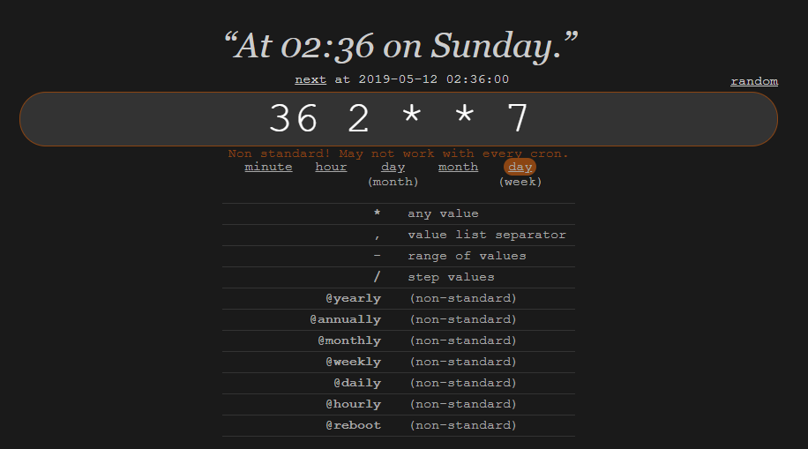

The above example is rather self-explanatory. What may not be so obvious is the use of **\*** sign in the above crontab entry example. The **\*** character is a wildcard with literally translates to always. Below you can find some other basic crontab examples:

|  |  |
| --- | --- |
| **Crontab entry** | **Description** |
| */5 * * * * | Run Crontab job at every 5 minutes |
| 0 * * * * | Execute Crontab job every hour |
| 0 0 * * * | Execute crontab job every day at 00:00 hours |

# How to edit Crontab Scheduler tasks

User can edit their crontab jobs be entering the following **crontab**command:

**Bash commands**

$ crontab -u 'nameuser'-e

The above command will open your personal crontab configuration file using your default text editor. Simply make your changes and save the file. There is no need to restart your crontab as it will pick up your changes automatically. To list your crontab task enter:

**Bash commands**

$ crontab -l

Lastly, if you need to remove your crontab tasks execute the below command. Please note that this will remove all you crontab entries:

**Bash commands**

$ crontab -r

# System-wide crontab scheduler

Many of the services use crontab automatically. They store their crontab scheduler configuration directly into /etc/cron.d directory. Any files located in this directory are automatically picked up and executed by the crontab scheduler.

Linux system administrators can also take advantage of crontab preconfigured schedules directories **/etc/cron.daily**, **/etc/cron.hourly**, **/etc/cron.monthly** and **/etc/cron.weekly**.

The crontab files located within these directories are periodically traversed and execute by crontab scheduler. So for example crontab files found in **/etc/cron.daily** directory are executed every day. Furthermore, if root wishes to run eg. **backup.sh** script once a week he will place it into **/etc/cron.weekly** directory.

# Additional Crontab examples

## Crontab Example 1

Crontab example to run the **updatedb**command **35** minutes past every hour.

**Crontab job**

35 * * * * updatedb

## Crontab Example 2

Crontab example to execute **/home/murilloe/backup.sh** at **2:00 PM** on **10th** of **March**, **June**, **September** and **December**.

**Crontab job**

00 14 10 3,6,9,12 * /home/murilloe/backup.sh

## Crontab Example 3

This crontab example runs **/home/murilloe/backup.sh** at **1:25 AM**, **1:50 AM every Tuesday** and on **15th of every month**.

**Crontab job**

25,50 1 15 * 2 /home/murilloe/backup.sh

## Crontab Example 4

This crontab example runs **/home/murilloe/backup.sh** at **9.00 PM** **every Monday**, **Wednesday**, **Friday**. Please note that using names week days and month names is an extension for some crontab versions.

**Bash commands**

00 21 * * Mon,Wed,Fri /home/murilloe/backup.sh

## Crontab Example 5

The following crontab example executes **/home/murilloe/backup.sh** every 5 minutes during the 5 working days (Monday - Friday), every week and month.

**Crontab job**

*/5 * * * 1-5 /home/murilloe/backup.sh

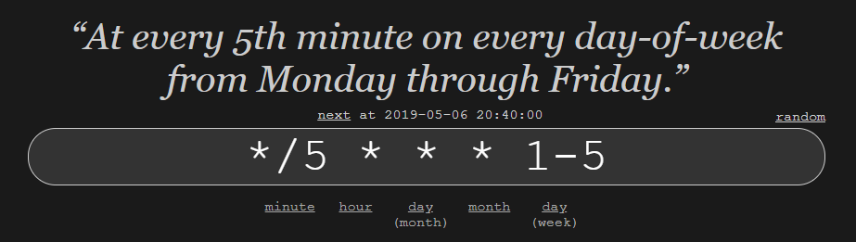

## Crontab Example 6

This crontab example runs **/home/murilloe/backup.sh** script at **every minute past every 4th hour on Sunday**.

**Crontab job**

* */4 * * sun /home/murilloe/backup.sh

# References

* <https://crontab.guru/>
* <https://www.adminschoice.com/crontab-quick-reference>

# End of document

* * *

© 4z.com