How to configure device Grandstream DP715
Updated by Sonja Guicheux on 2020-05-08
Created by Sonja Guicheux on 2019-09-12

Table of Contents
Introduction 1
Documentation 1
Configuration 1
Change password 1
Manual configuration 1
Find IP 1
Change SIP number 1
Factory settings 1
Reset Base 1
Reset handphone 1
References 1
https://www.youtube.com/watch?v=igjhI1CUoLU 1
End of document 1

Introduction
This document will explain how to configure model GRANDSTREAM DP715.

Documentation
In the case of fraud attack customer is obliged to change VoIP password. Sometimes he needs to change a sip number.
But sometimes customer cannot access on grandstream interface with default password. In that case he must reset base.
Let start with changing VoIP password first.

Configuration

Change password
Customer can change his VoIP password by himself. How? Simple
- Log on account from our website:

https://www.switzernet.com/home/

Login = your phone number or your email

Password = your password for login ( it’s not same login password and VoIP or service password).

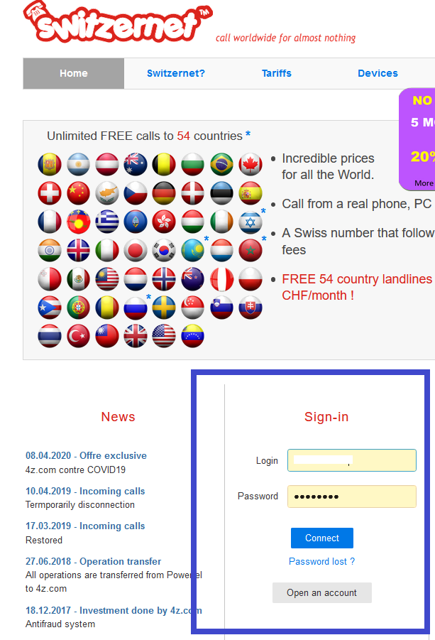

Now you are at your account .
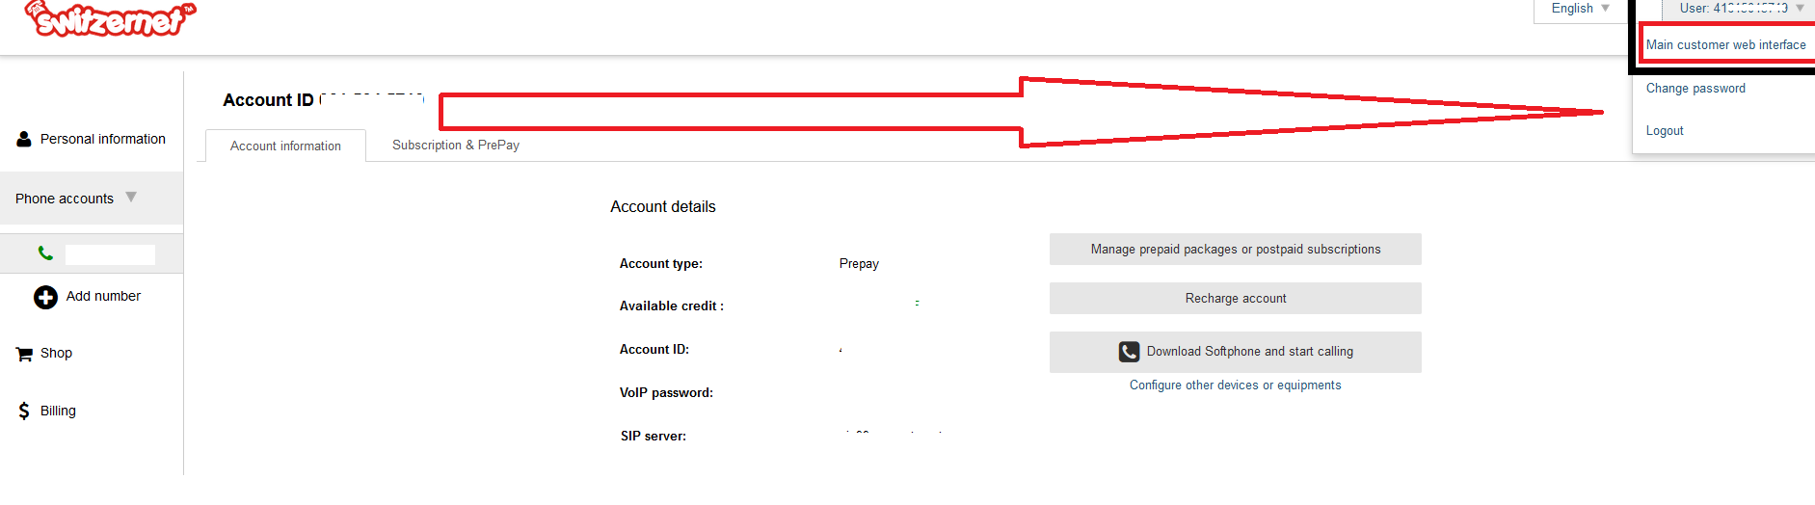

- Click on User 41….( your phone number) at right corner up.

- Click on Main customer web interface to access on your porta billing account.

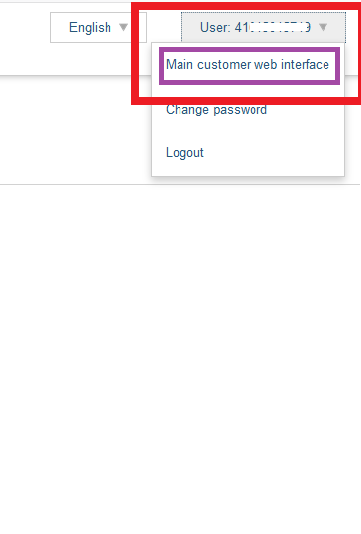

- Put cursor on small man

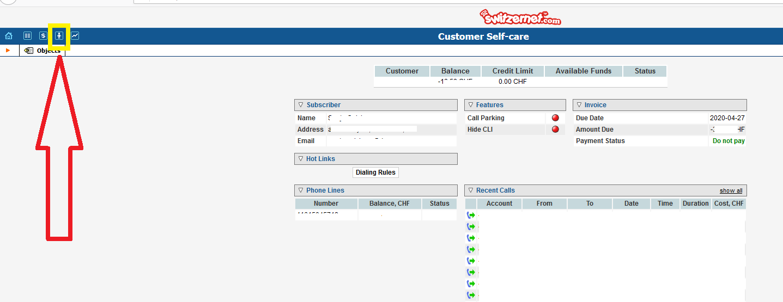


Front of you will be written Accounts.

- Click on Accounts.

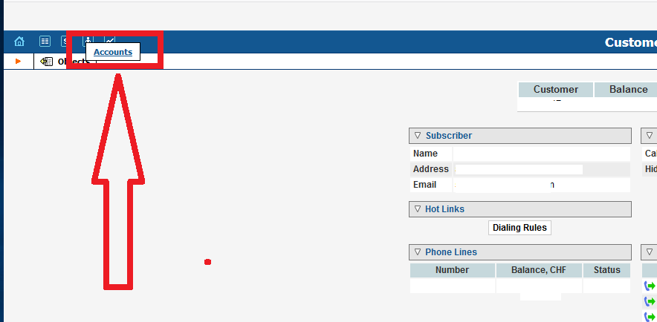

Here you must type your phone number for which you want to change VoIP password.

- Type your number and click on Show Accounts.

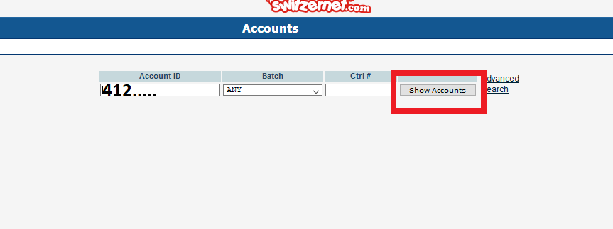

- Click on Auto to change service / VoIP password ( service password and VoIP password are same thing).

- When you change password click on Save and Close.

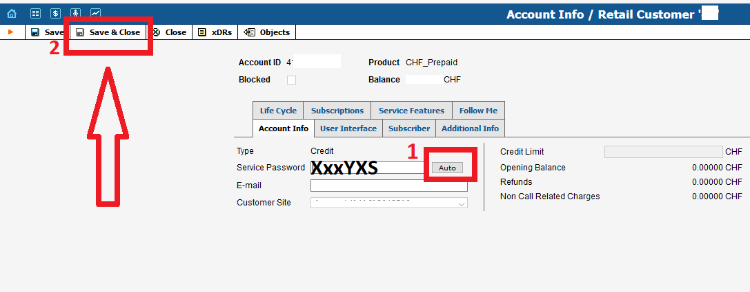

- Now unplug from electricity and after 2 minutes plug again.
In the case that it does not work on this way ( something is written on display), you are obliged to change VoIP password manually from grandstream interface.
For that you need IP address.

Manual configuration

Find IP

- To find ip on dp715 call ***02#

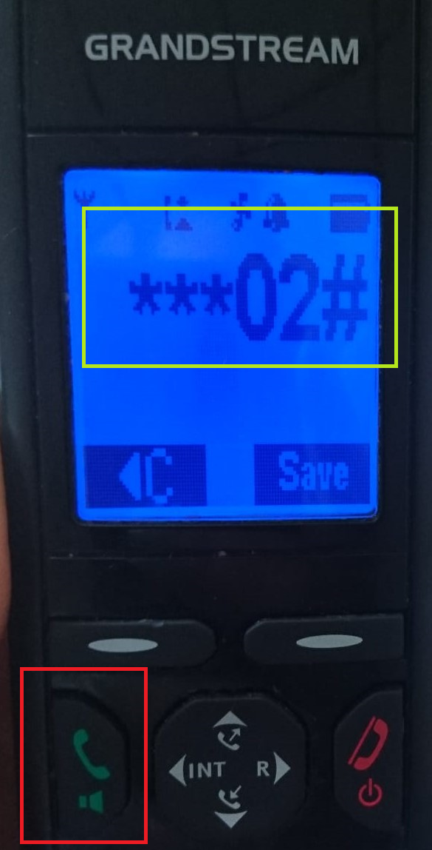

- Listen your IP address, write on paper or directly in browser

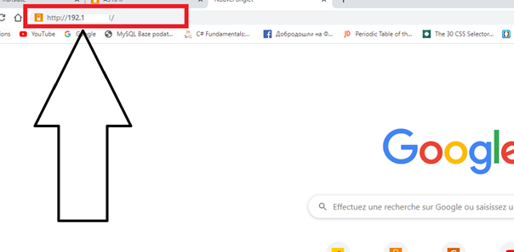

Password per default is admin.
In case that you cannot login with default password , you must reset the base. Here

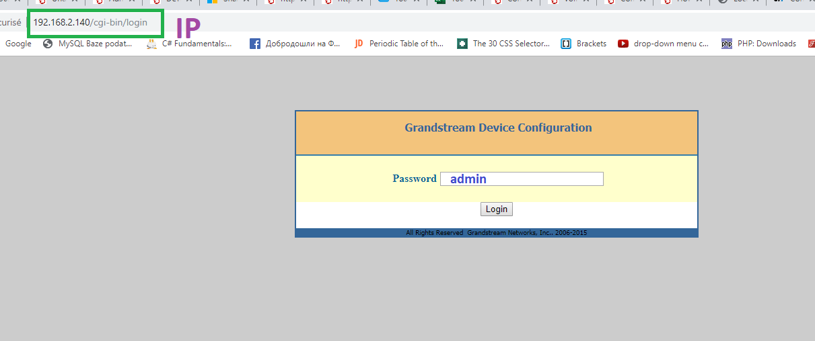

- Click on HANDSETS

- From PB (PB = porta billing) take your VoIP password which you just change.

- Fill areas
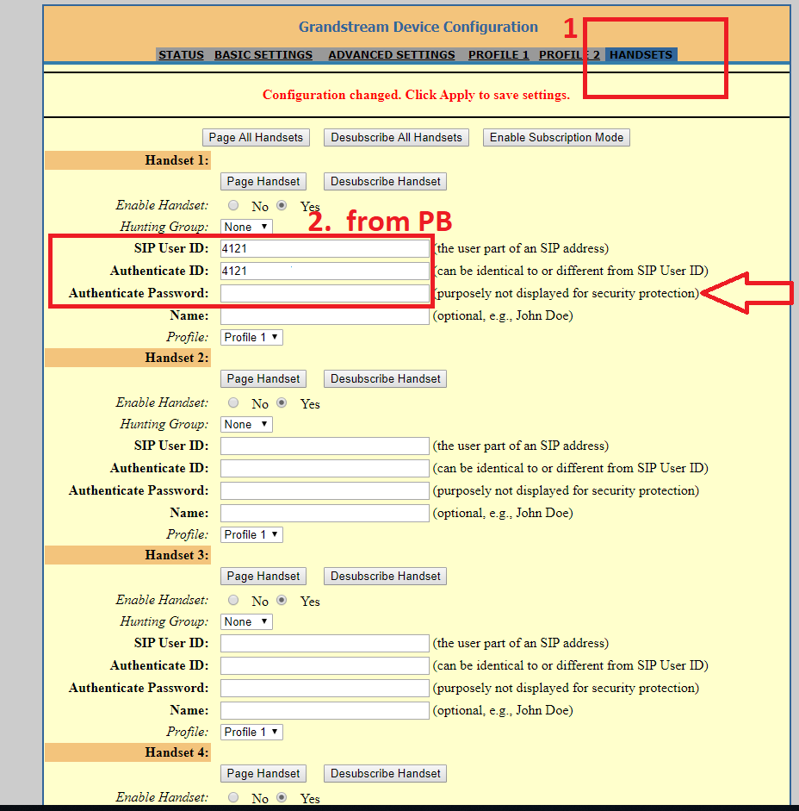

- Click Update and Apply

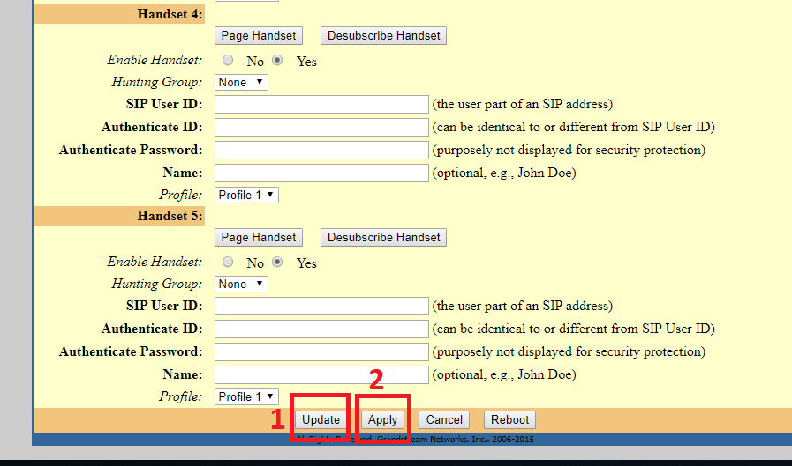

Change SIP number

- Go on Profile 1

- Here you can change SIP number if is necessary

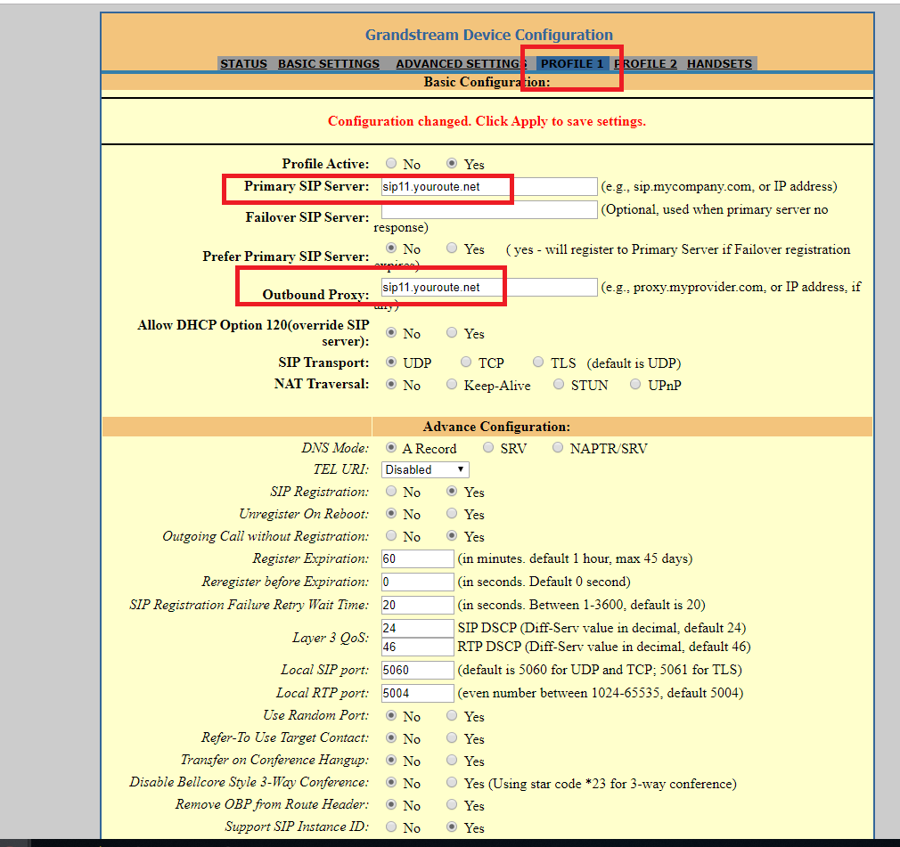

Rest leave like on photos below

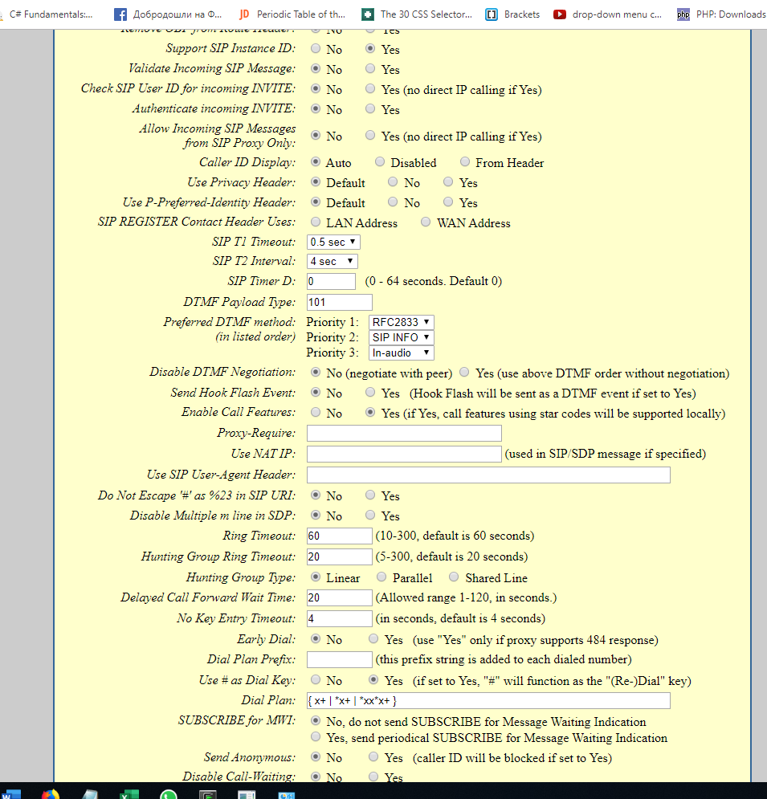
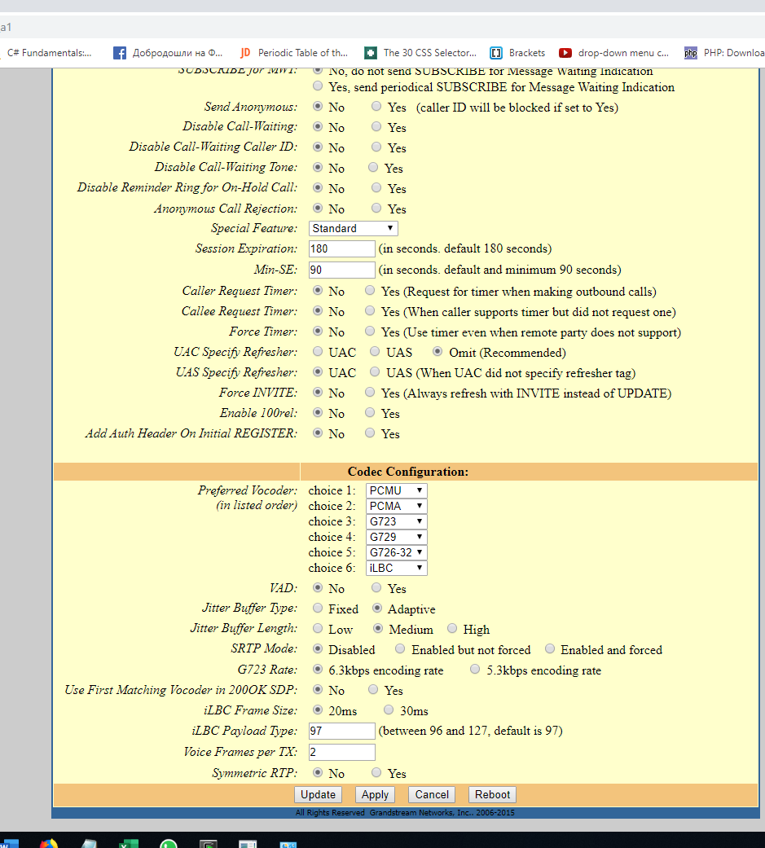

- Click Update and Apply

- Refresh your page

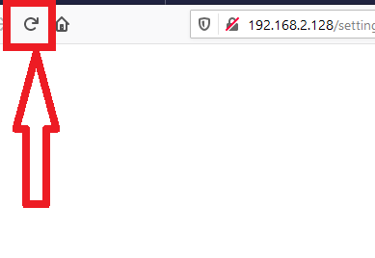

- Now check if your device is registered on page Status

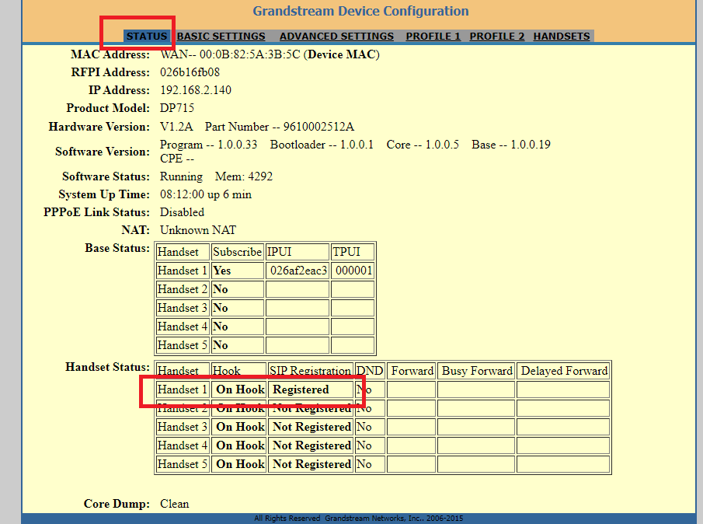

If you made all like on instructions above, your device will be registered.

Factory settings

Reset Base

On base of device you can see pin hole ( like for sim card on iPhone)

- With paper clip you reset (keep like that 10 sec then pull out). Now we reboot on factory settings.

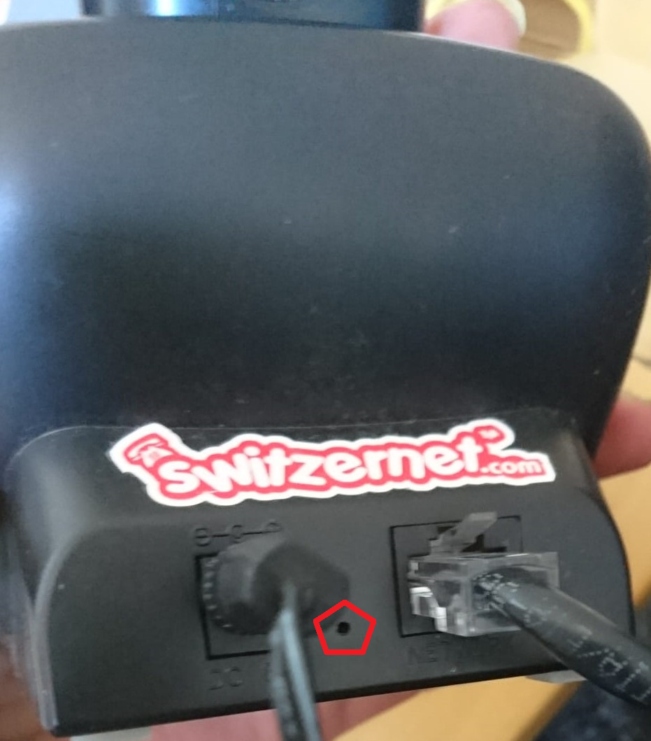

Reset handphone

- Press right button with white line ( blue square on photo below).

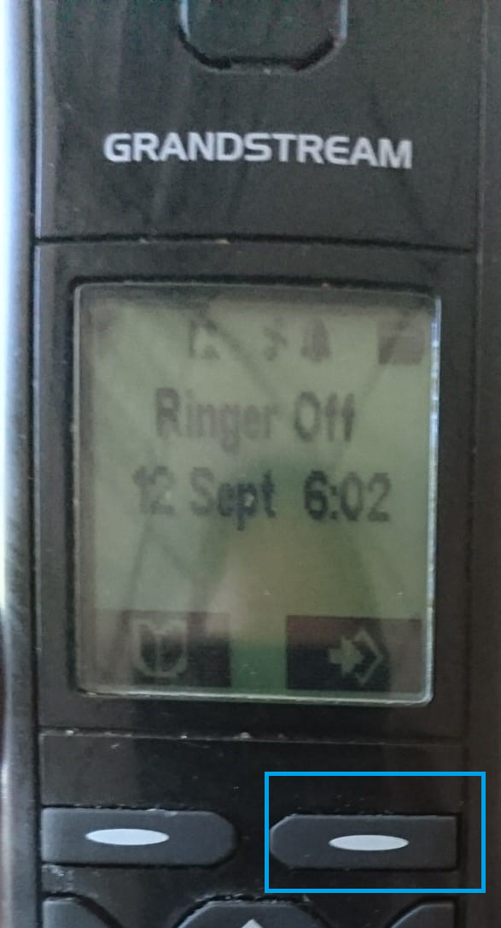

- Go down with arrow until Handset and press button right (red square photo below)

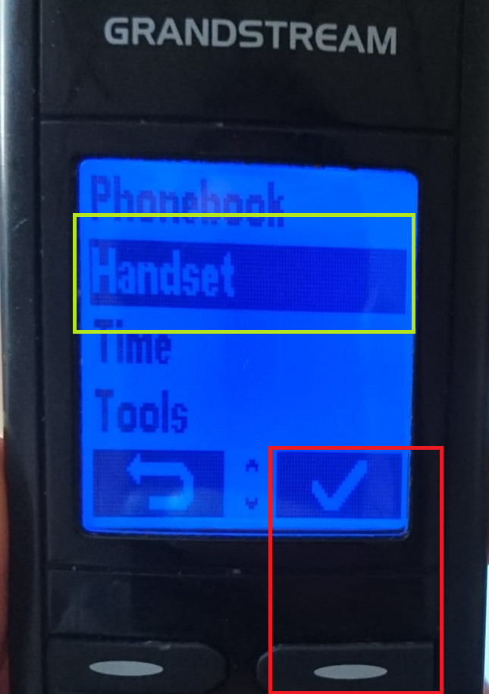

- Now you will see Select Base. Press same button to go into

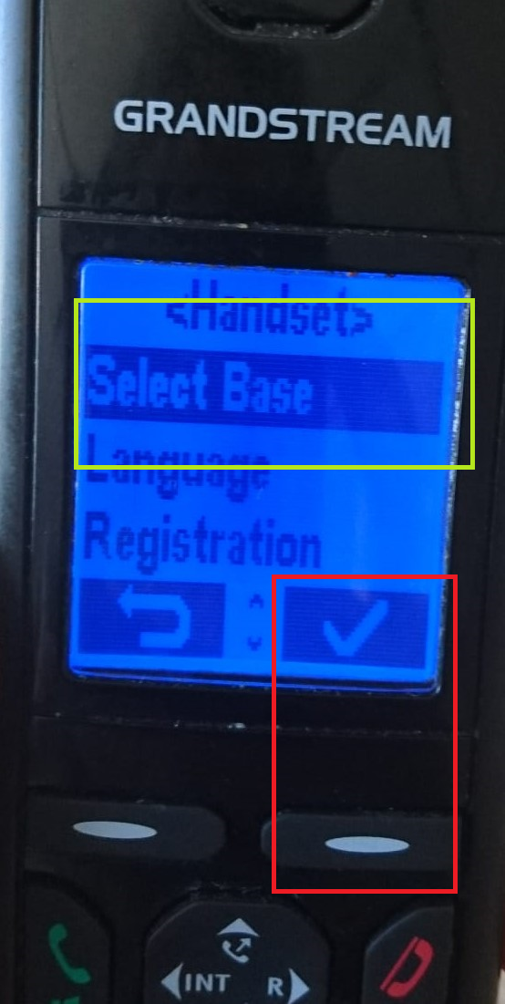

- Now select Auto and press button for validation

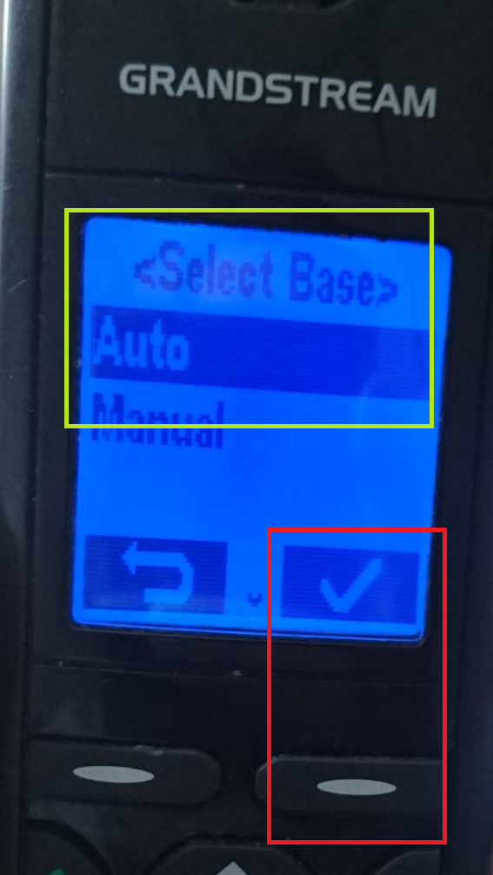

- Now in same Handset find Registration

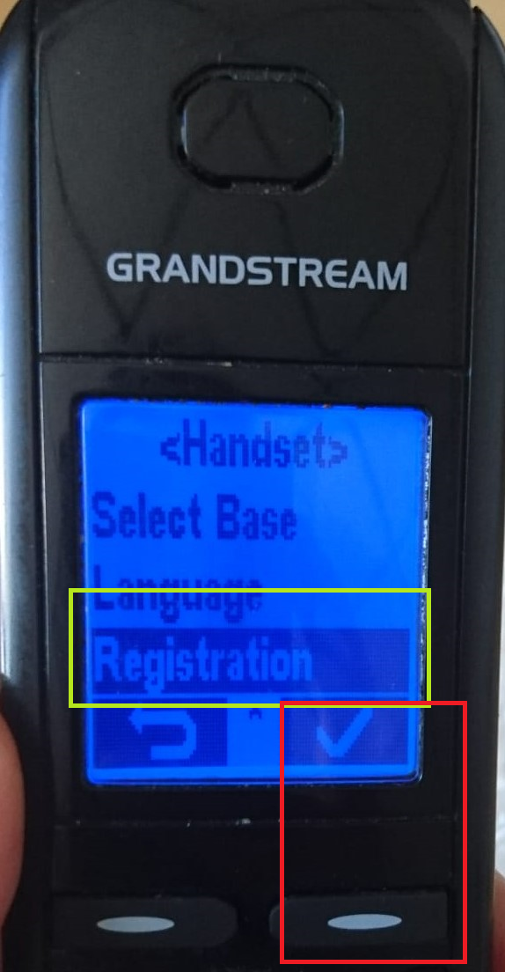

- Select Register

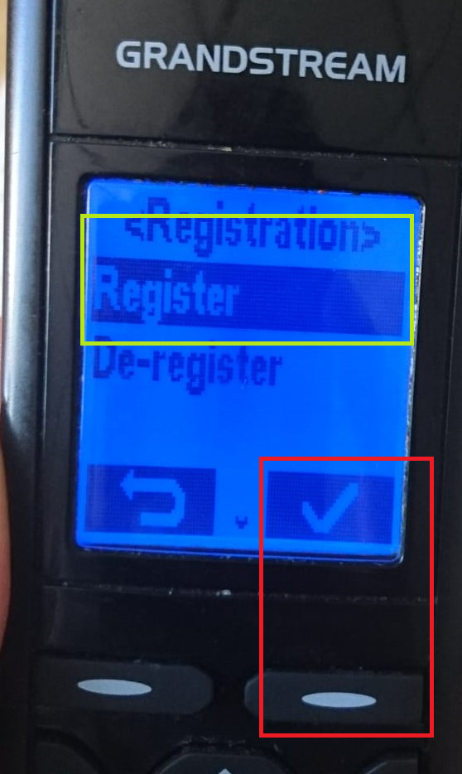

- Select Base 1

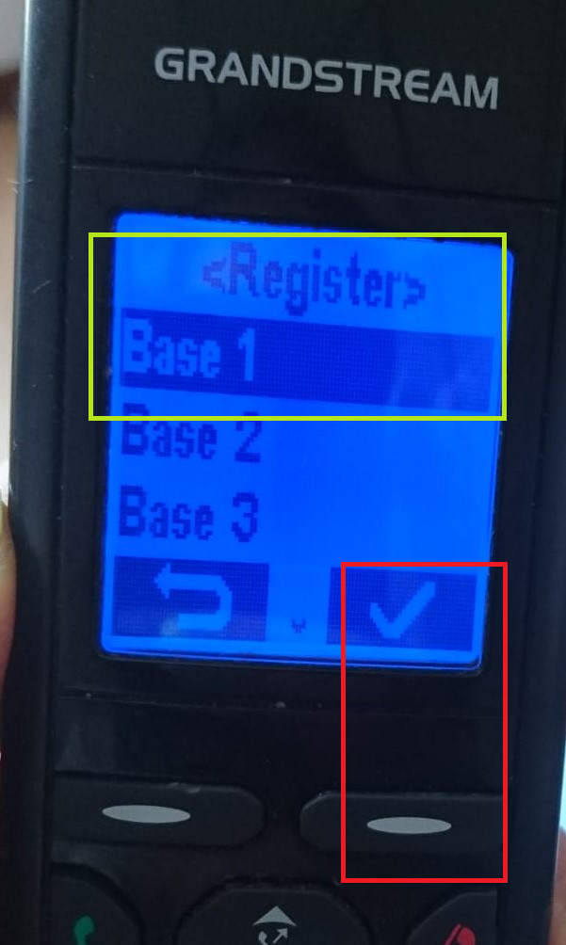

*After rebooting on factory settings, you must configure your device manually. Here

References

https://www.youtube.com/watch?v=igjhI1CUoLU

End of document
* * *
© 4z.com

