191011-How-to-install -Ubuntu-on-windows
Created by Sonja Guicheux on 2019-10-24
Table of Contents
Introduction 1
Documentation 1
Validation 1
References 1
https://tutorials.ubuntu.com/tutorial/tutorial-ubuntu-on-windows#0 1
End of document 1

Introduction
This document has a content and explanation how to install Ubuntu on windows.

Documentation
First check update for windows.
Icon for windows ( left down on taskbar) -> settings -> update & security

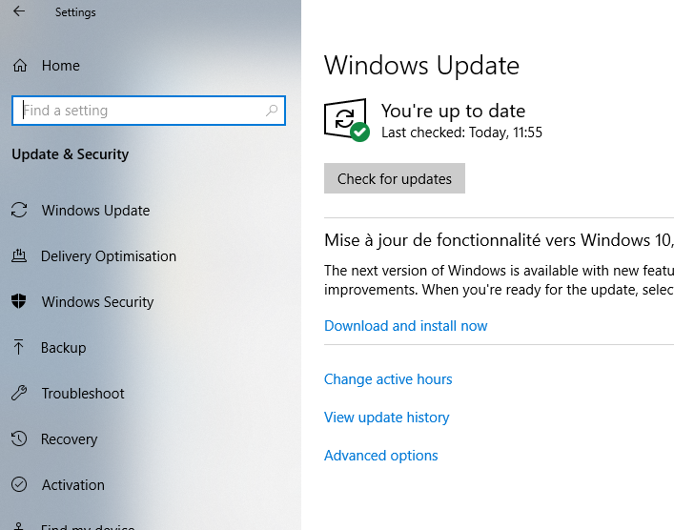

Check if is turn on developer mode
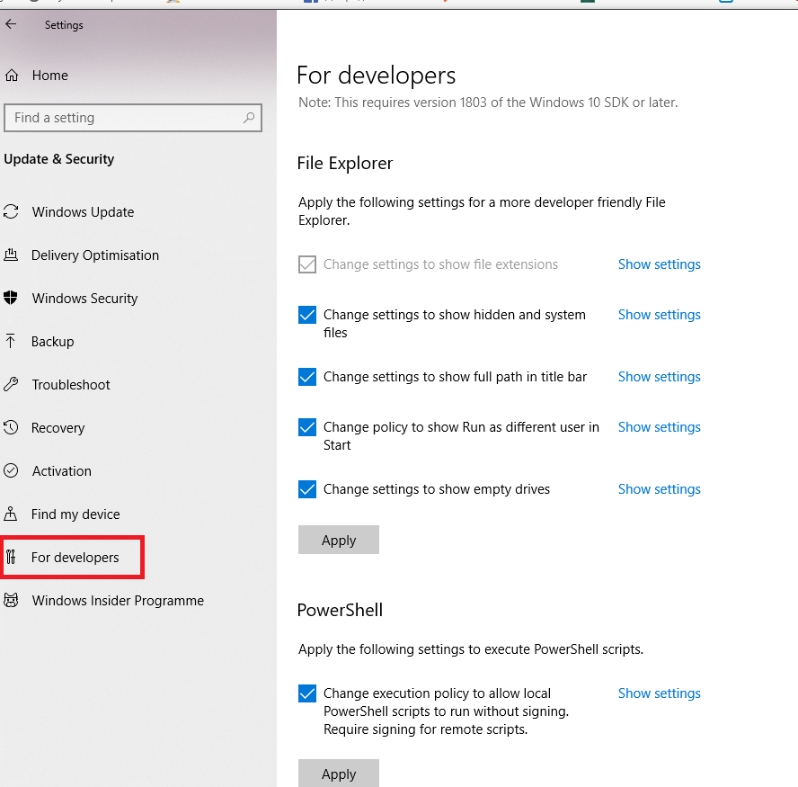

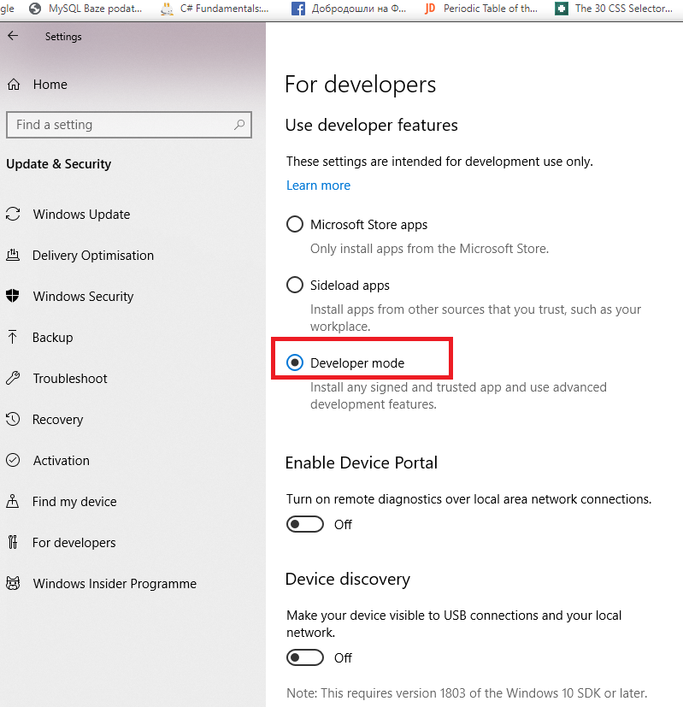

And for Linux in windows features
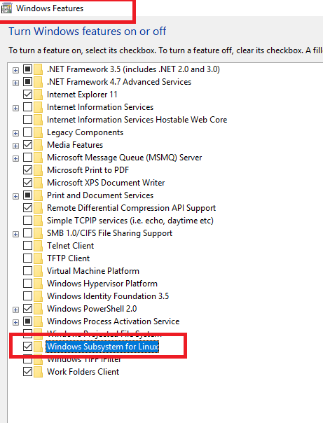

Now you can download Ubuntu from MS store
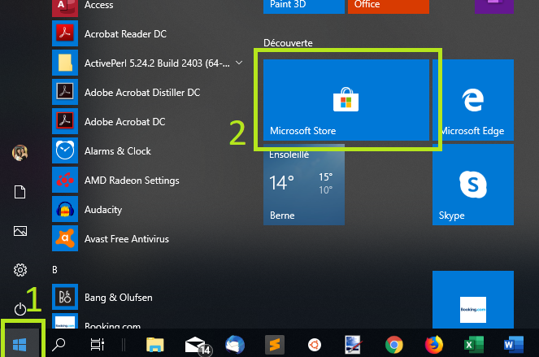

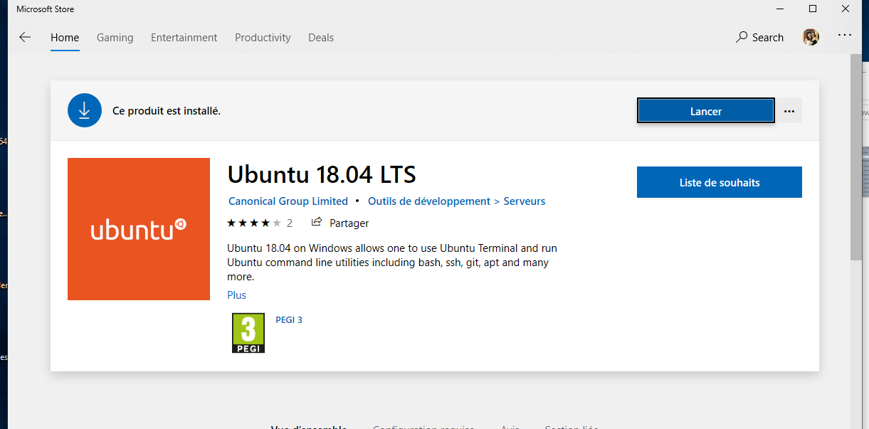

When launched for the first time, Ubuntu will inform you that it's ‘Installing' and you'll need to wait a few moments.
When complete, you'll be asked for a username and password specific to your Ubuntu installation. These don't need to be the same as your Windows 10 credentials. With this step complete, you'll find yourself at the Ubuntu bash command line.

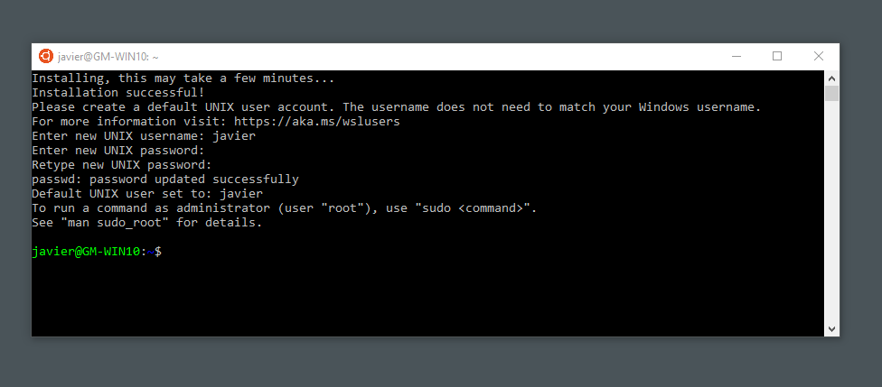
Good luck ☺

References

https://tutorials.ubuntu.com/tutorial/tutorial-ubuntu-on-windows#0
https://www.wikihow.com/Become-Root-in-Ubuntu

End of document
* * *
© 4z.com

