191025-How-to-log-as-root-on-Linux
Created by Sonja Guicheux on 2019-10-25

Table of Contents
Introduction 1
Login as root 1
First way 1
Second way 1
References 1
https://www.youtube.com/watch?v=K1wr4Iugcio 1
End of document 1

Introduction
This document has a content how to log as root on Linux terminal

Login as root
How we know , we are using terminals a lot in our job. For login we need to be root user on our server.
It exists 2 ways how to log as root on Linux terminal.

First way
This way you can use if you know root password.
In terminal type next command “ su ”
su
And press Enter
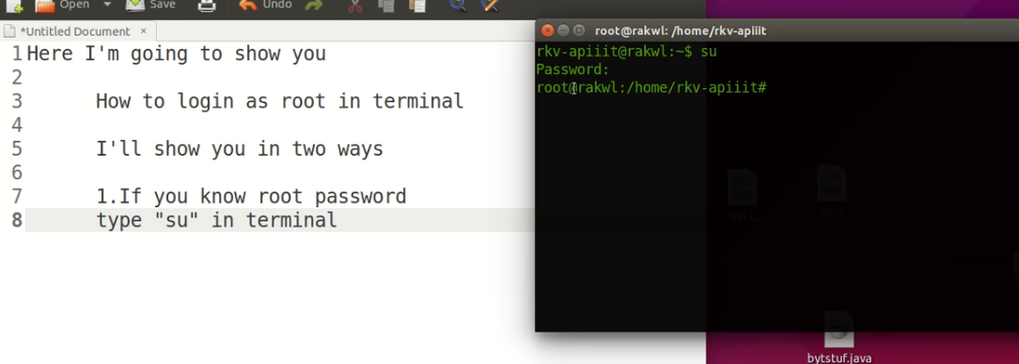
It will ask you for root password.
Type password ( or copy) and press Enter.

Second way
In case you don’t know root password
Type “ sudo su “
sudo su
And press Enter
It will ask you for password. That password it’s your user password ( not root)

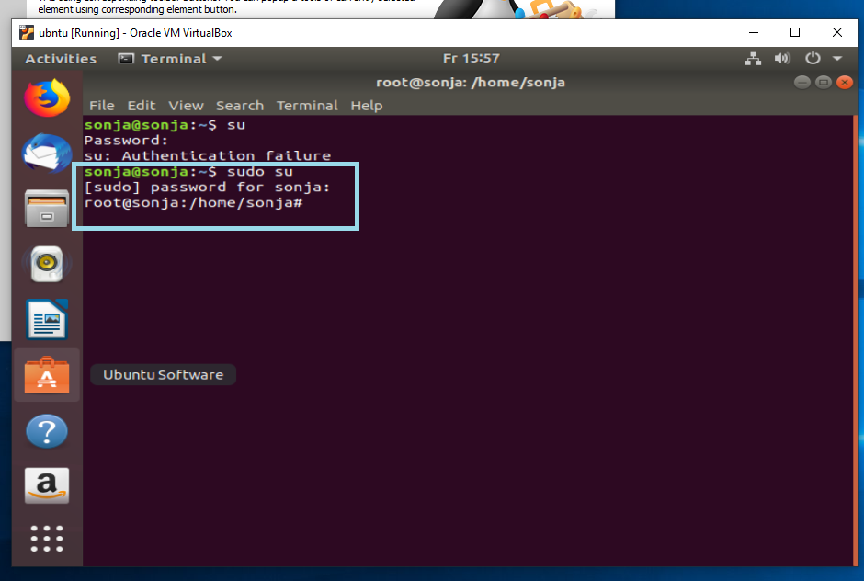

When you log on this way, you can change root password and next time log as root ( on first way) 😉

References

https://www.youtube.com/watch?v=K1wr4Iugcio

End of document
* * *
© 4z.com

