191028-How-to-use-virtual-machine

Created by Sonja Guicheux on 2019-10-28

Table of Contents

Introduction 1

Documentation 1

VirtualBox 1

Ubuntu 1

Installation Ubuntu on VirtualBox 1

References 1

https://www.youtube.com/watch?v=K1wr4Iugcio 1

End of document 1

191028-How-to-use-virtual-machine

Created by Sonja Guicheux on [2019-10-28](index.htm)

Table of Contents

Introduction 1

Documentation 1

VirtualBox 1

Ubuntu 1

Installation Ubuntu on VirtualBox 1

References 1

https://www.youtube.com/watch?v=K1wr4Iugcio 1

End of document 1

# 

# Introduction

This document has a content how to use VirtualBox.

VirtualBox is app where you can install different operative system.

We will use to install ubuntu.

# Documentation

## VirtualBox

Download virtual box for windows <https://www.virtualbox.org/wiki/Downloads>

Install virtual box on your computer.

## Ubuntu

Download Ubuntu <https://ubuntu.com/download/desktop>

### Installation Ubuntu on VirtualBox

1. Click on New

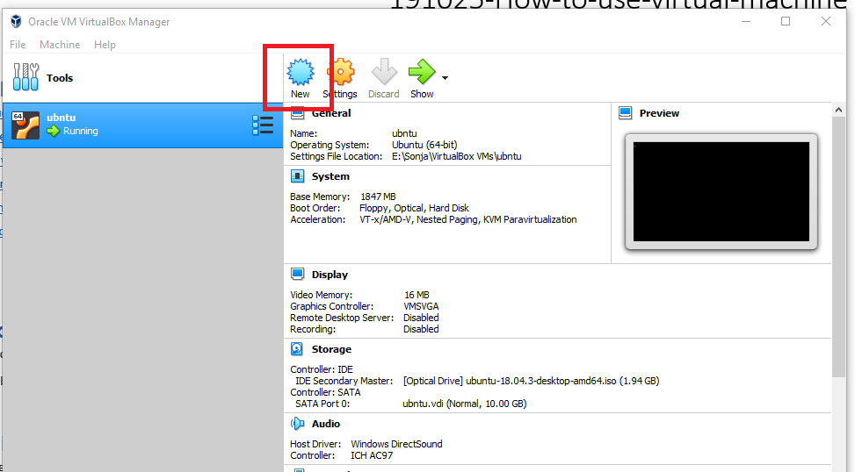

1. Type ubuntu and click next

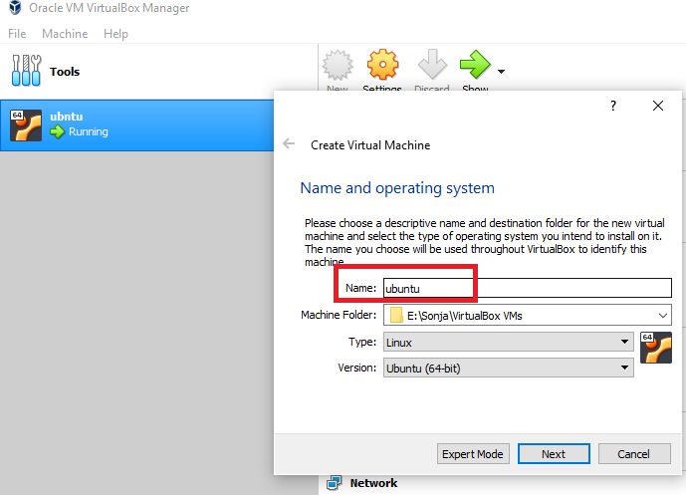

1. Rest leave how it was by default

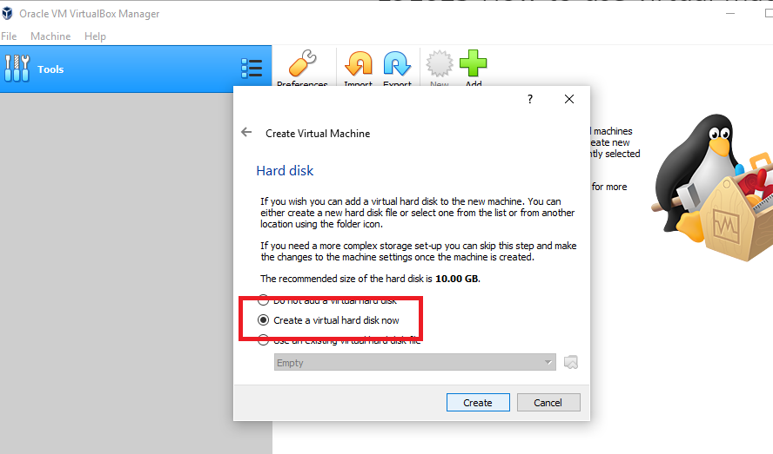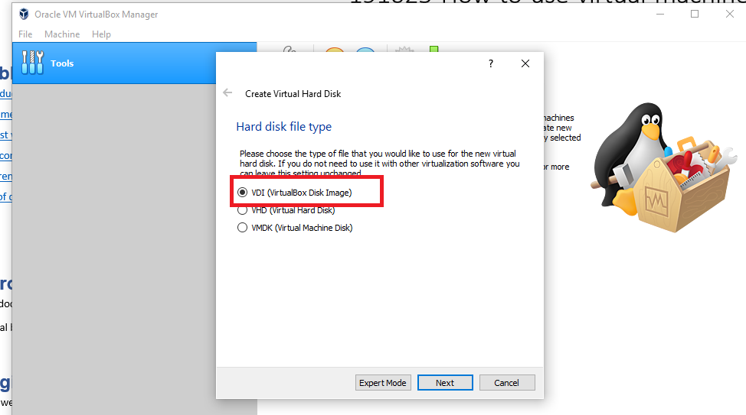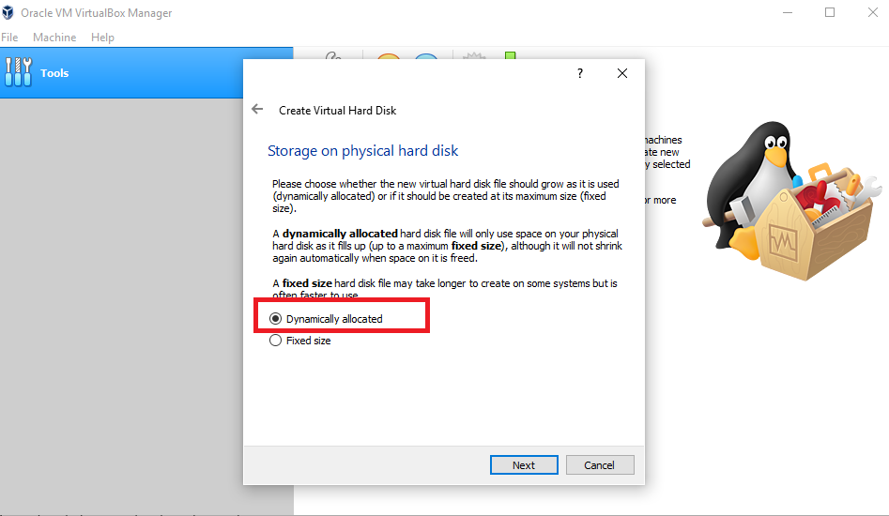

1. Now choose your ubuntu for installation

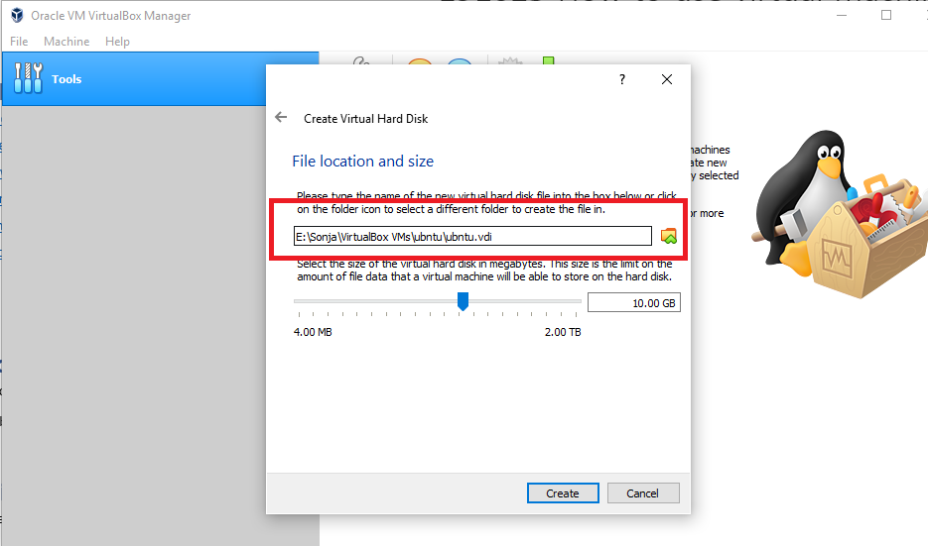

1. Click install ubuntu

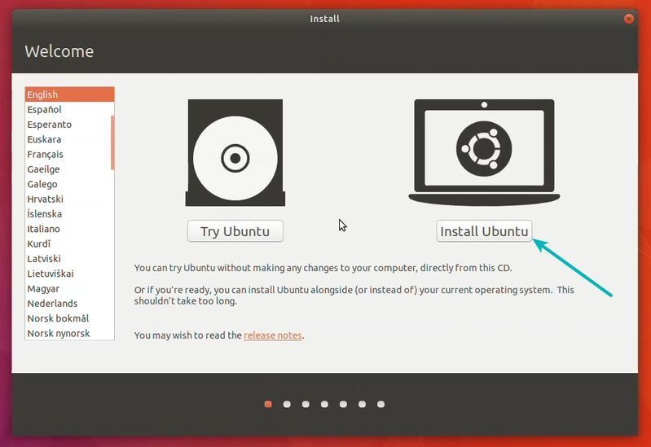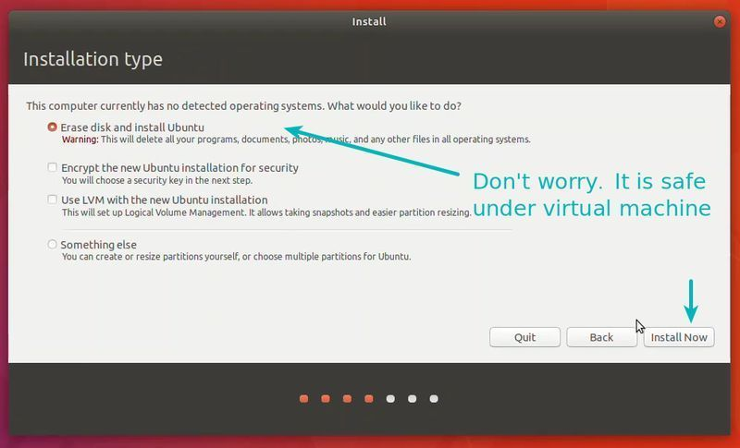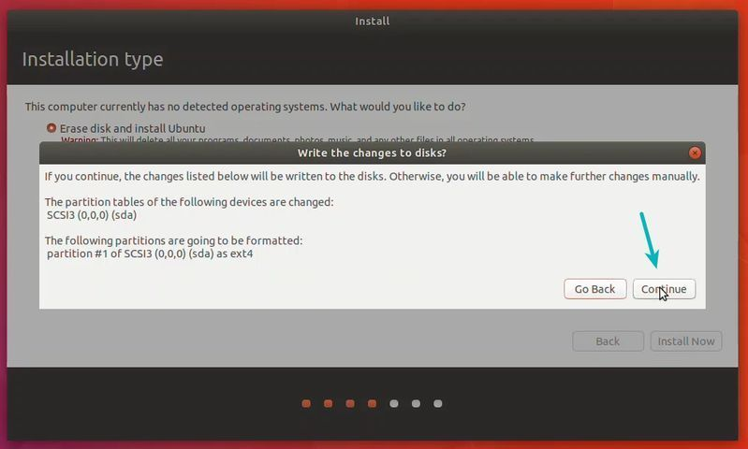

1. Choose timezone

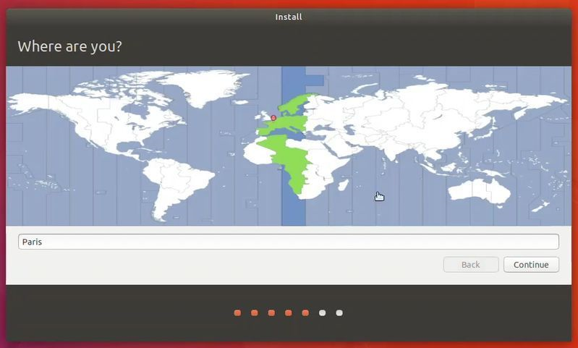

1. Choose language for keyboard

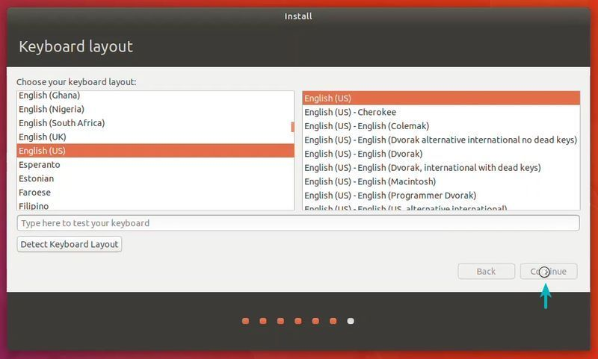

1. Make your profile

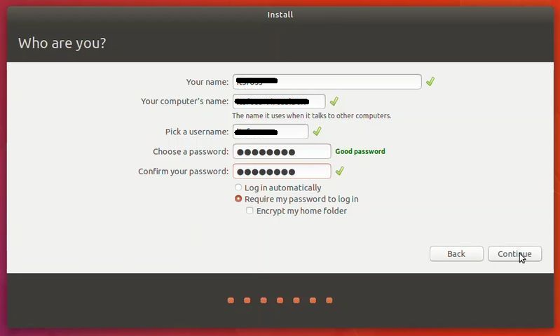

1. Wait few min to installation finish

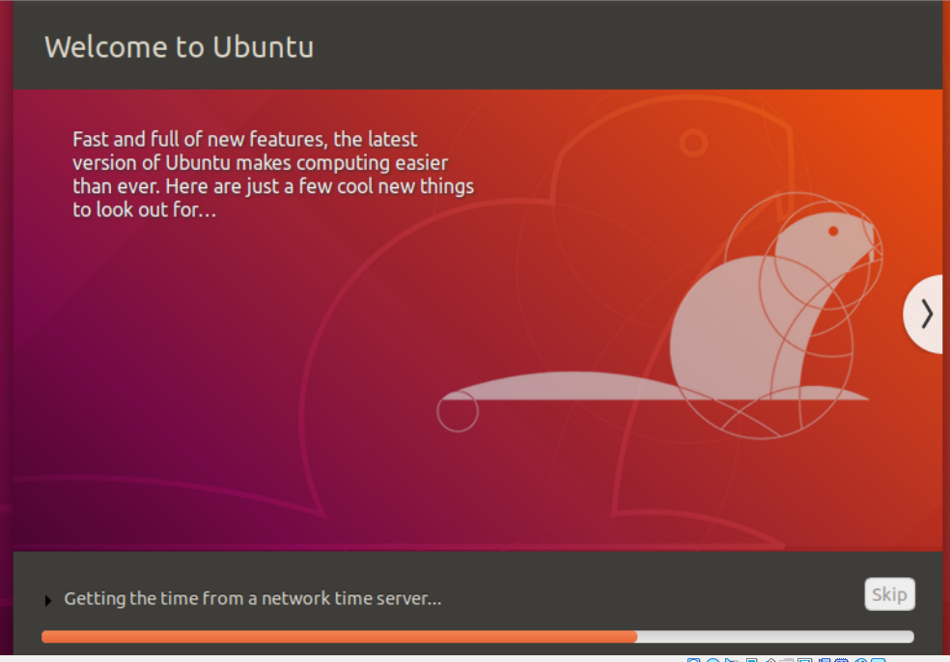

1. Click on Restart Now.

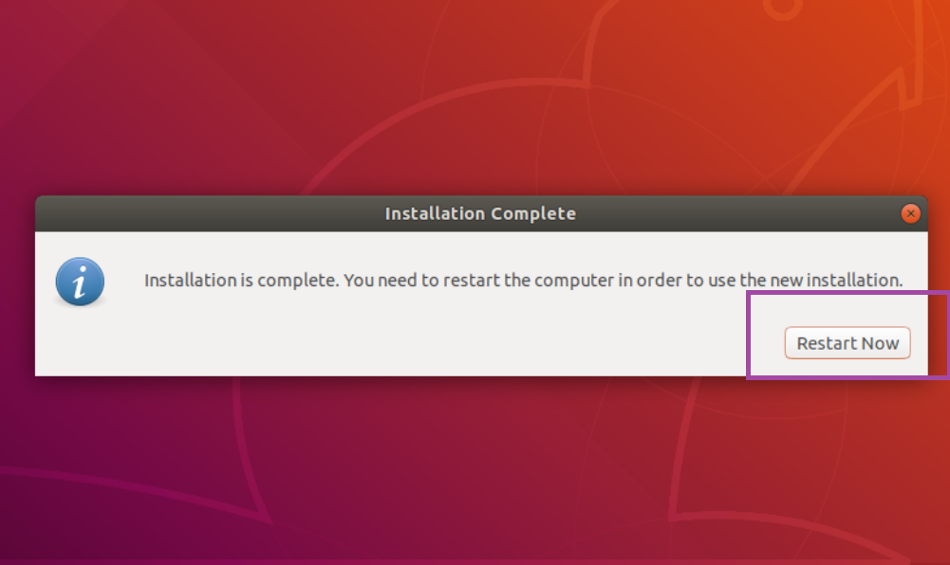

1. After restart logon your ubuntu

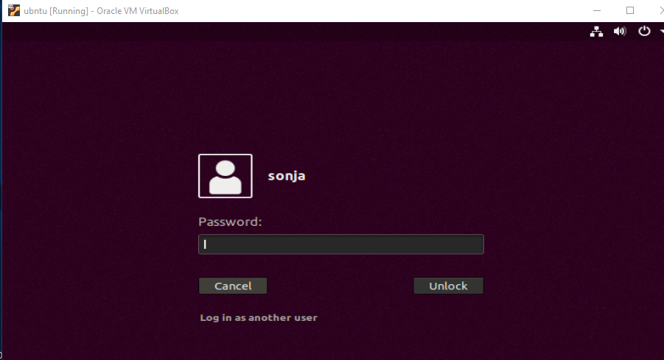

# References

<https://itsfoss.com/install-linux-in-virtualbox/>

# End of document

* * *

© 4z.com