200221-1-How-to-configure-Zoiper-on- smartphone
Created by Sonja Guicheux 2020-02-21

Introduction
This document has a content how to configure softphone application ZoiPer on android system of smarthopne

Configuration Zoiper

- Download app.
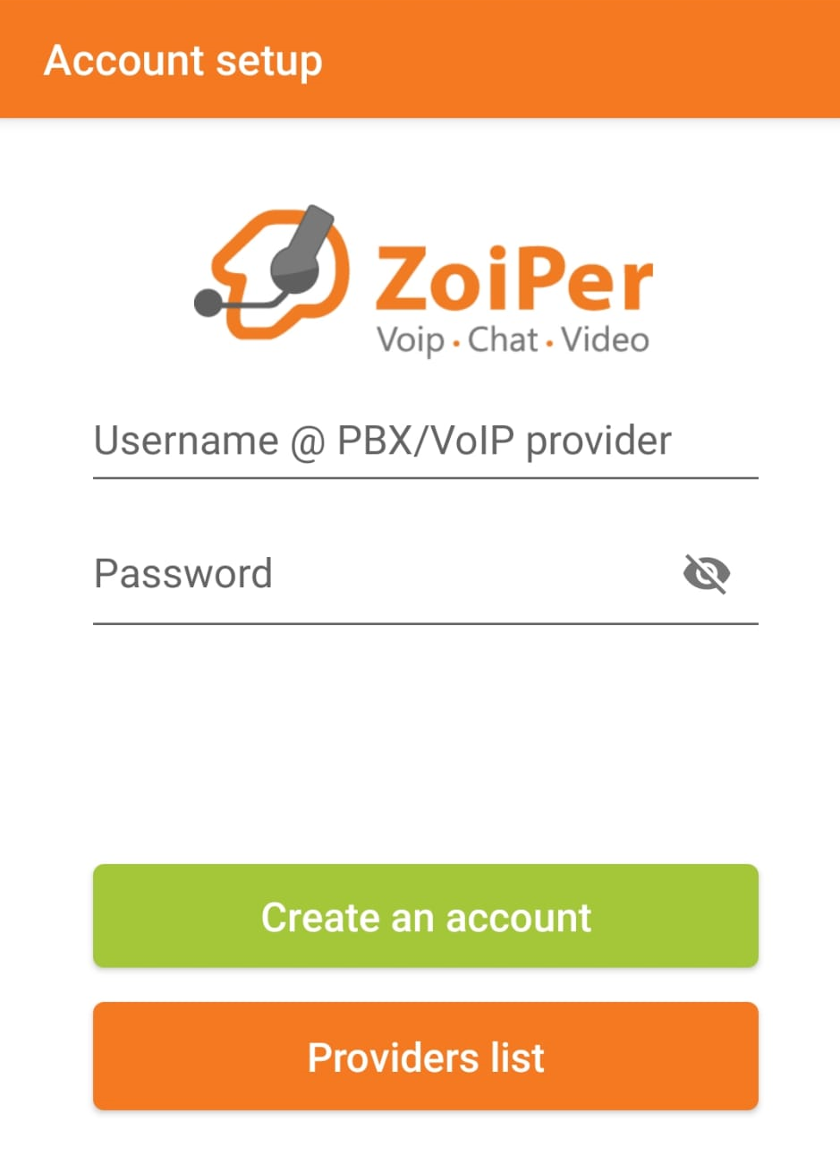

- Fill your 4Z.COM number ( 41xxxxxxxxx) and service password and click on CREATE ACCOUNT. Look photo below.
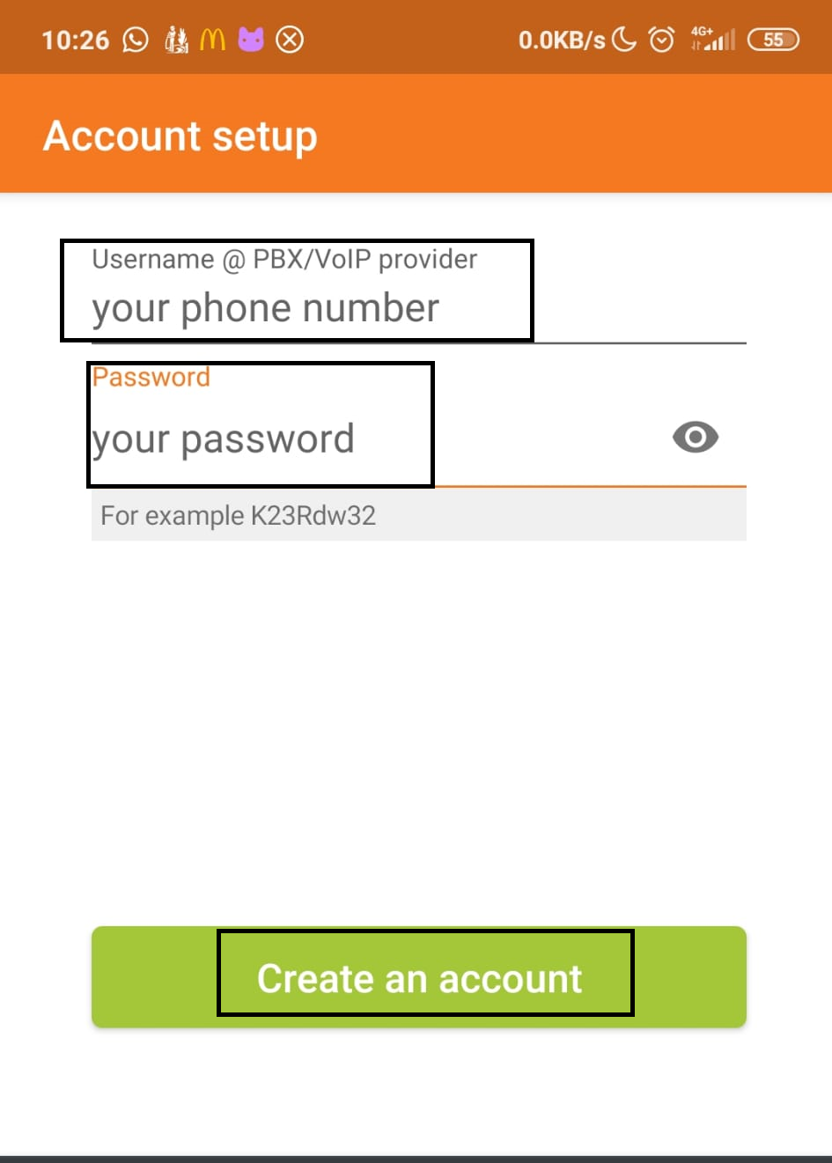

- Fill your sipxx.youroute.net and click NEXT (photo below)
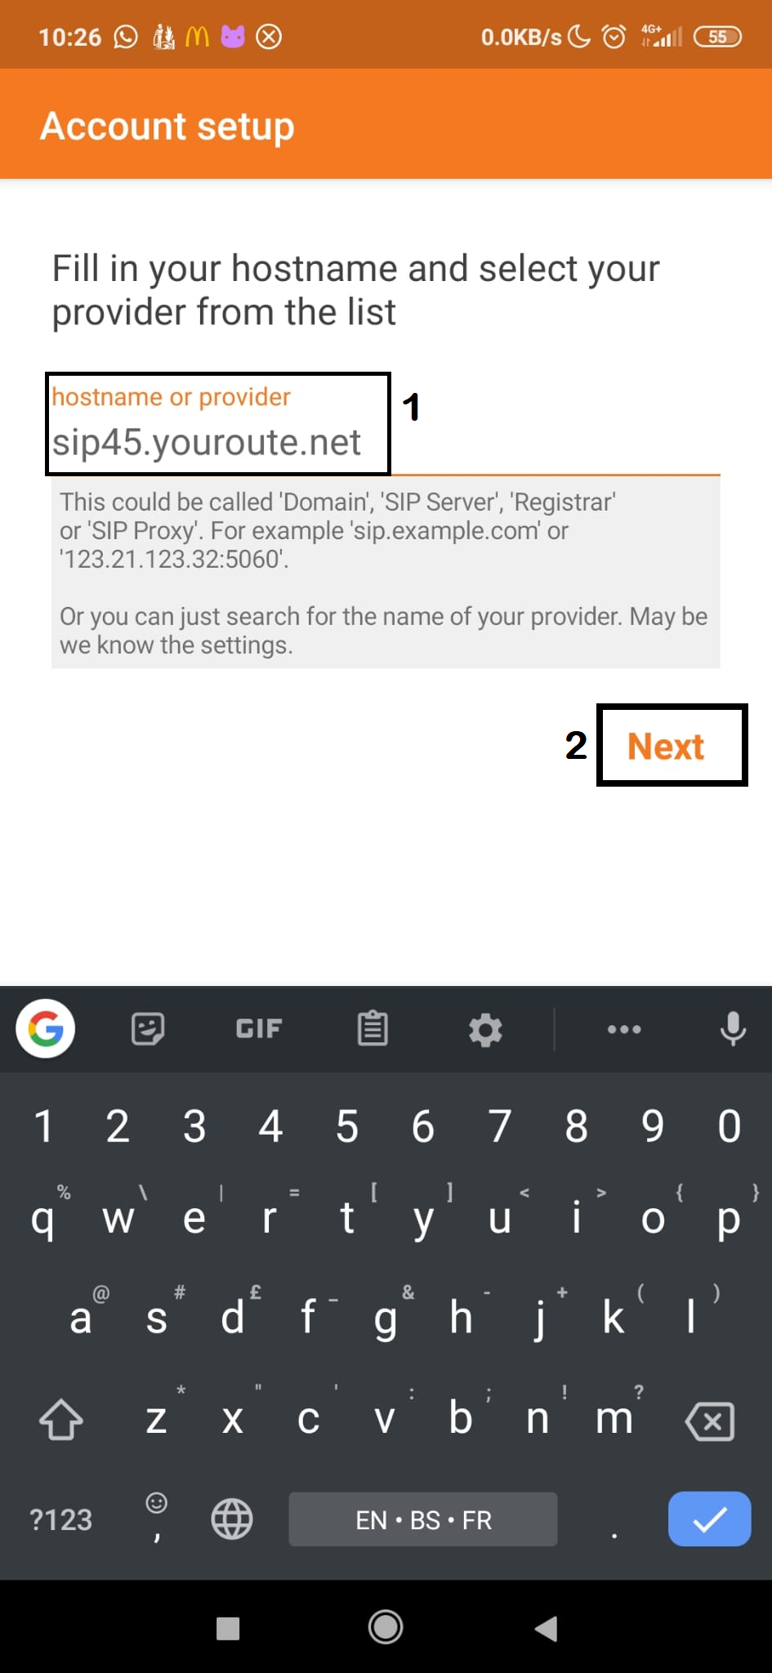

- Now you have this page where you have to fill data.
Click on small square. Now you can type your 4Z.COM number and SAME sip ( like on photo above).
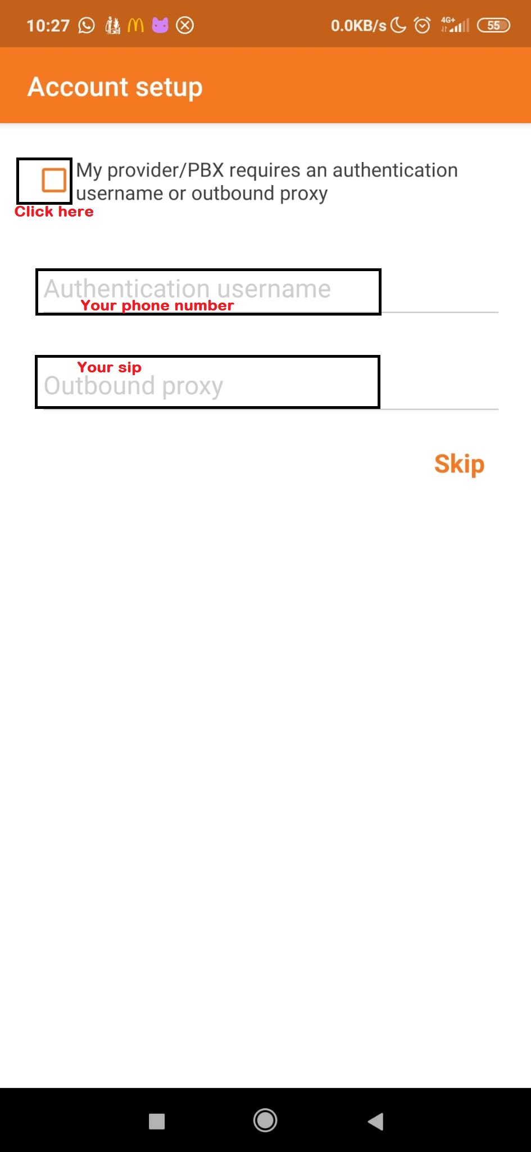
- It’s looks like this. And click NEXT
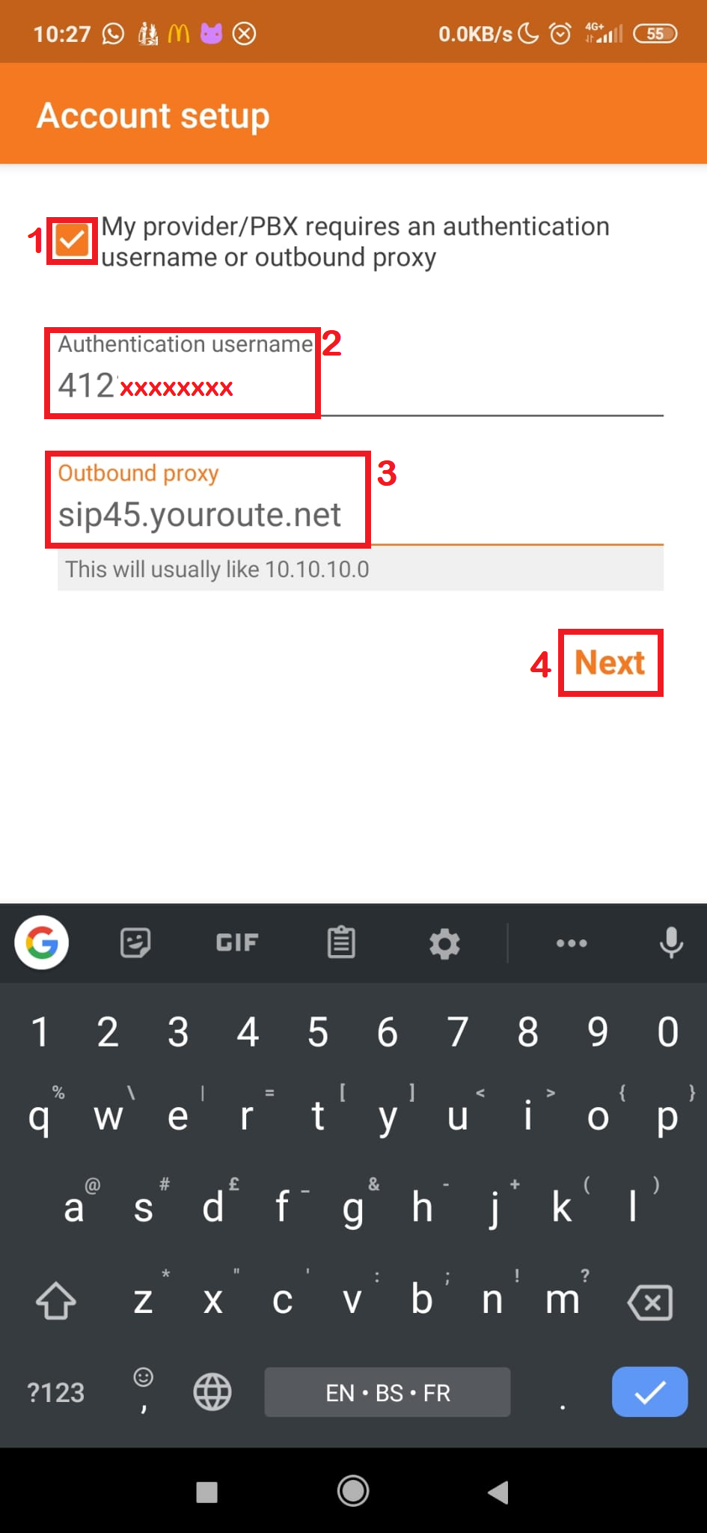

- Wait a bit and click on SIP UDP and click FINISH
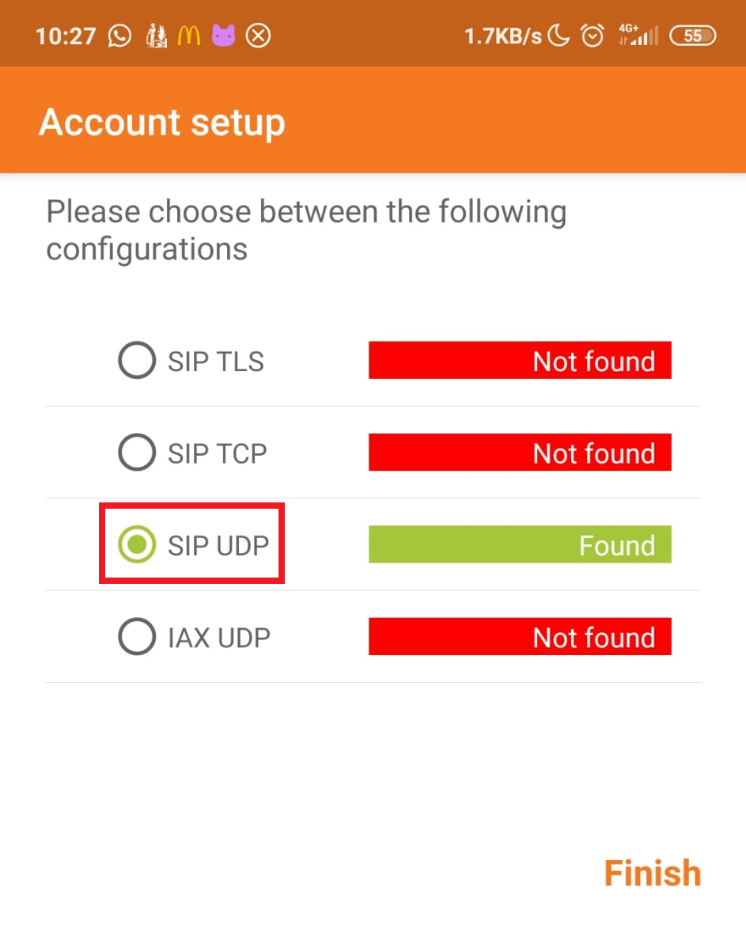

- Click on Menu
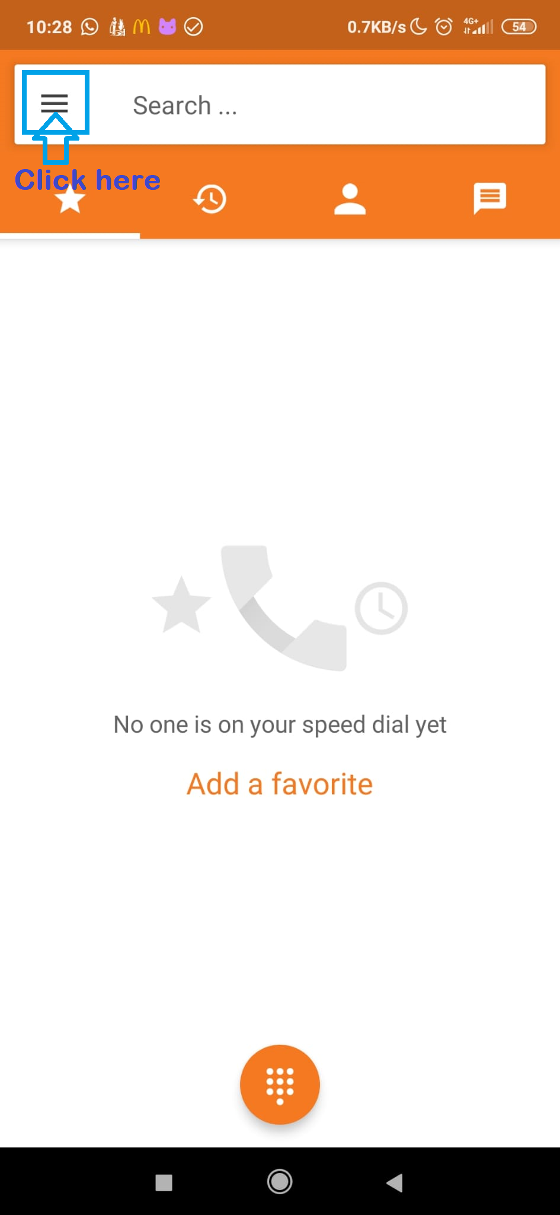

- Click on Settings
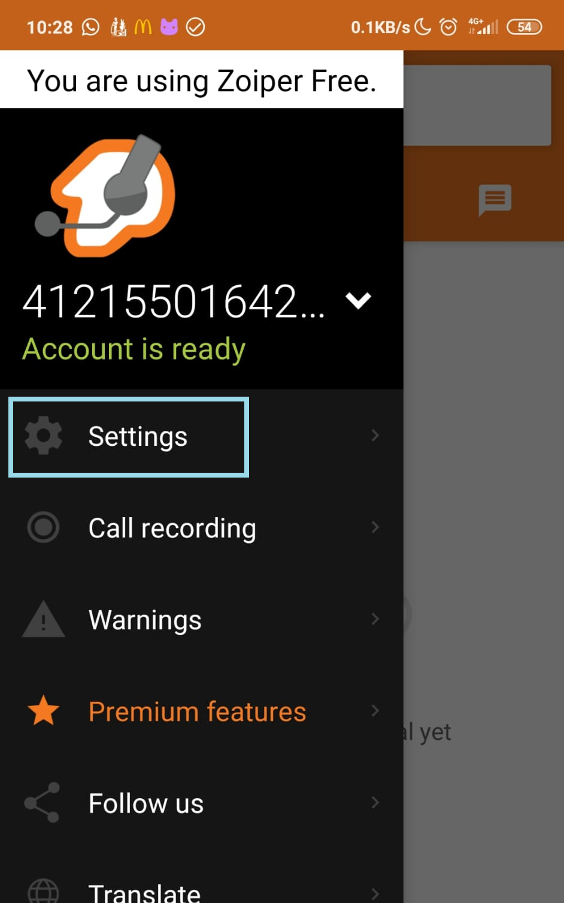

- Click on your account ( blue square , photo below)
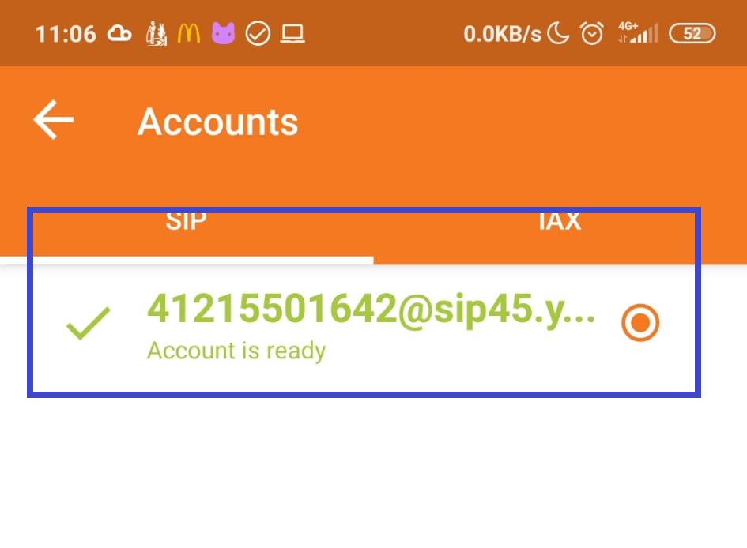

- If you followed well previous instructions your account should look like this on photo
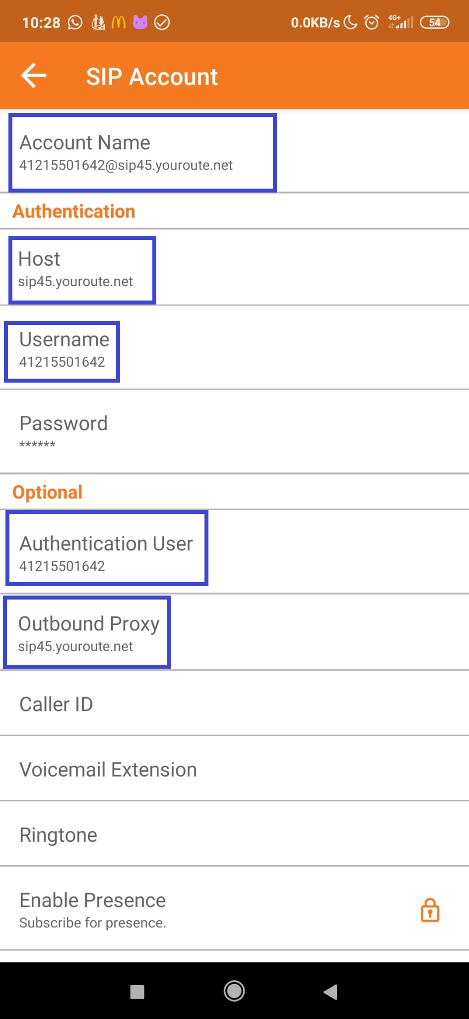

- Now scroll down until NETWORK
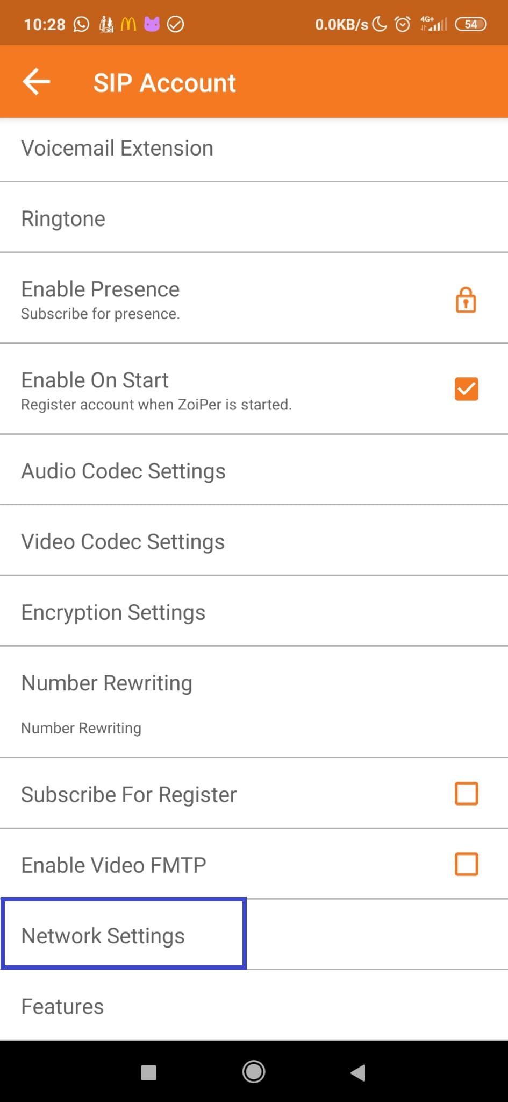

- When you click on NETWORK, Transport type MUST be UDP, and Use STUN = NO
Now, go out from there
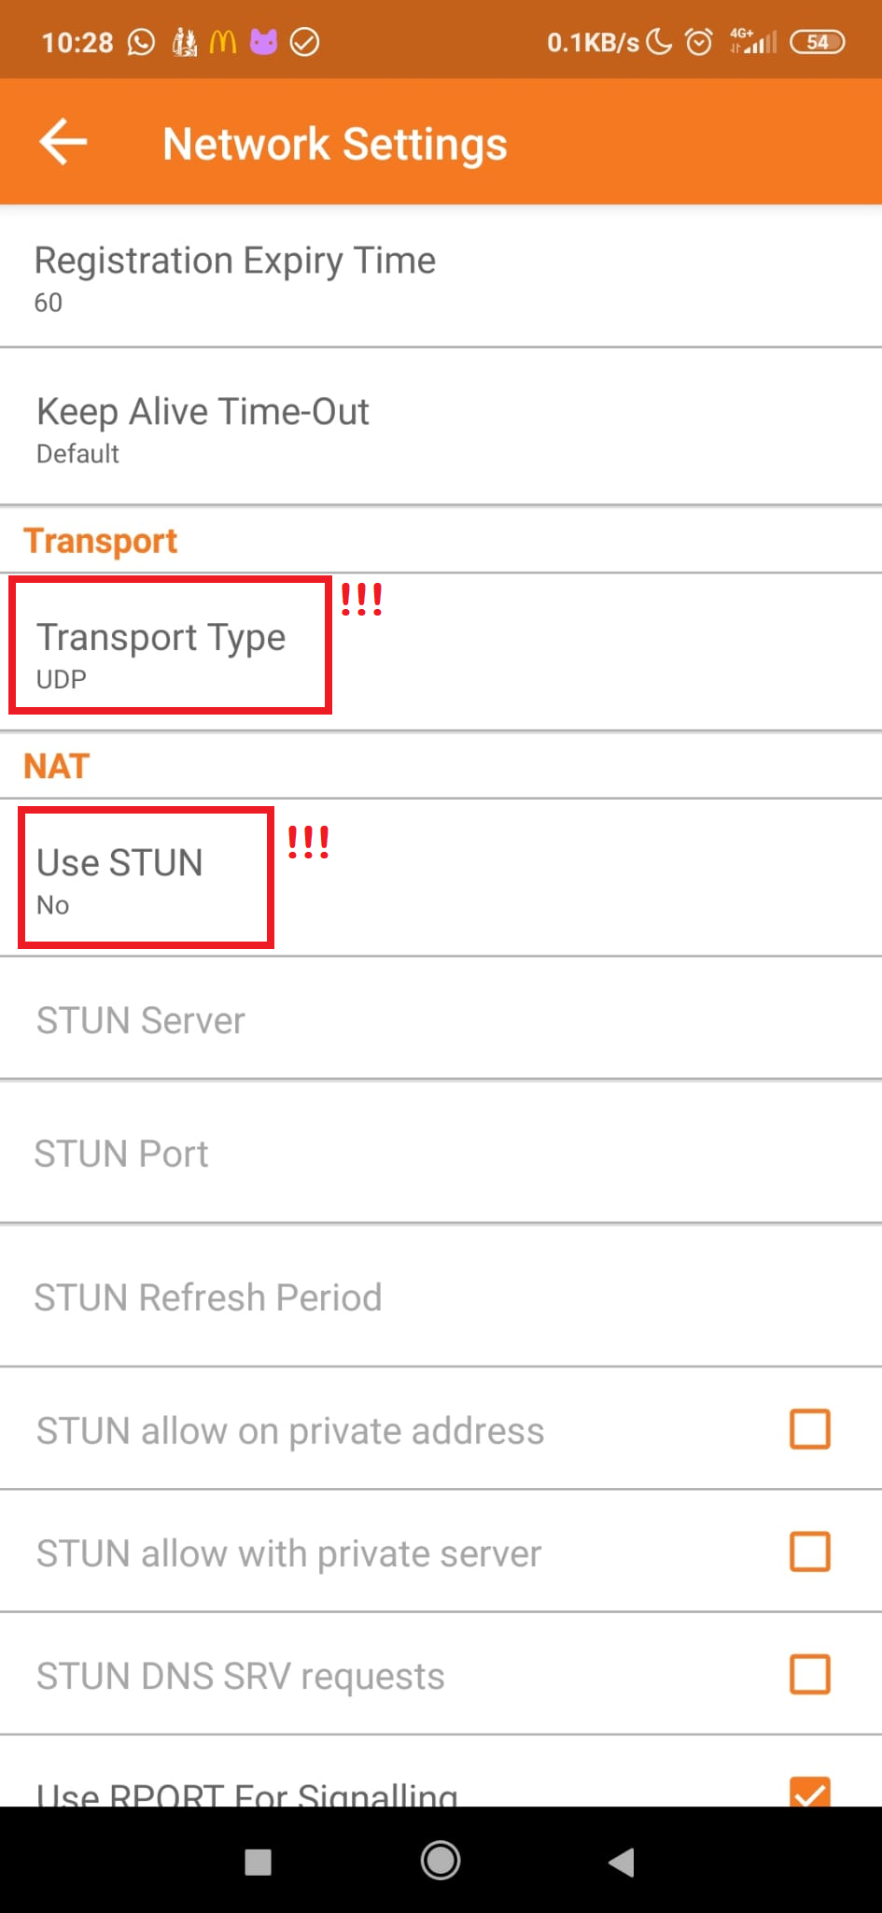

- Here you can see the account is configured well.
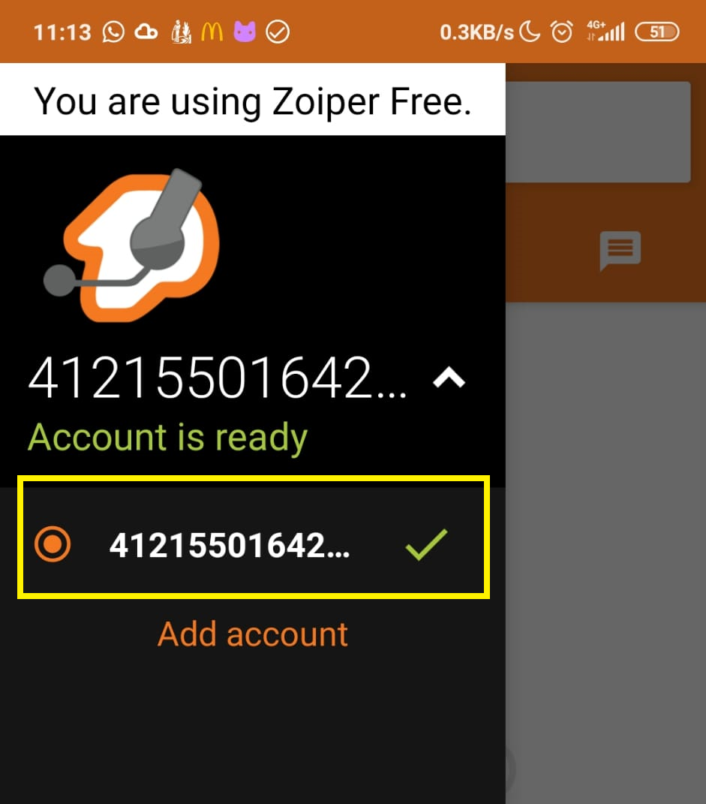

- And, at the end, test calls
