How to configure Linphone on PC
Created by Sonja Guicheux on 2020-04-16

Table of Contents
Introduction 1
Descriptions 1
Zoiper 1
Download 1
Configuration 1
References 1
End of document 1

Introduction
This document will explain how to configure application Linphone on your PC

Descriptions
Linphone is softphone application for VoIP calls. To use any softphone application, you need wi-fi or mobile data.

Linphone
Follow the steps to configure your application well

Download
- Download application https://www.linphone.org/
- Install application.
- Open application.

Configuration
Click on Assistant.
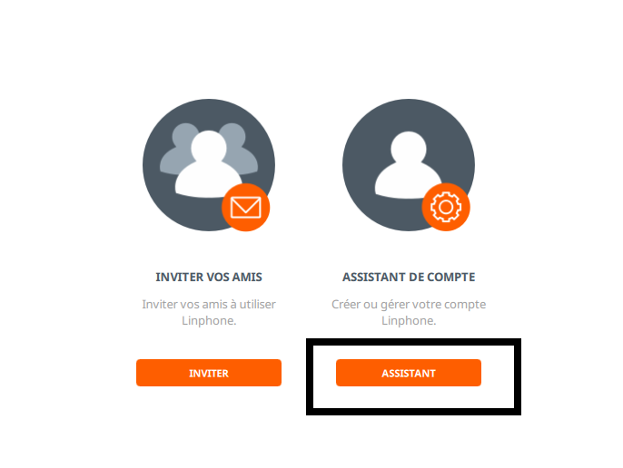

Then on Utiliser un comte sip.
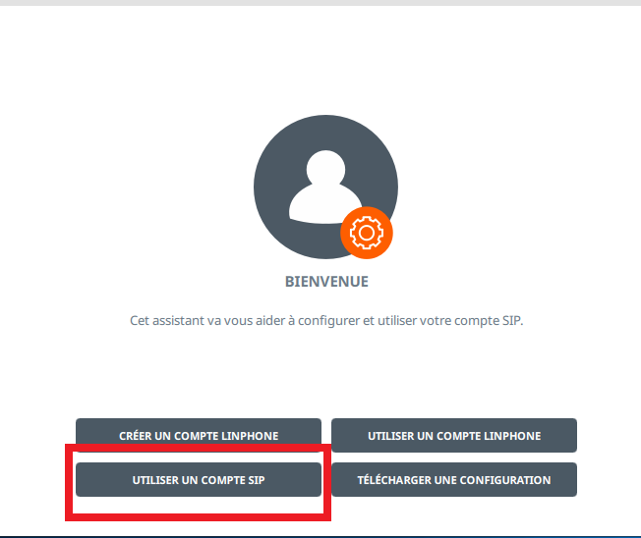

Fill your data here.
*sipxx.youroute.net -> change xx in your sip number which you are using already.
*Transport is always UDP.
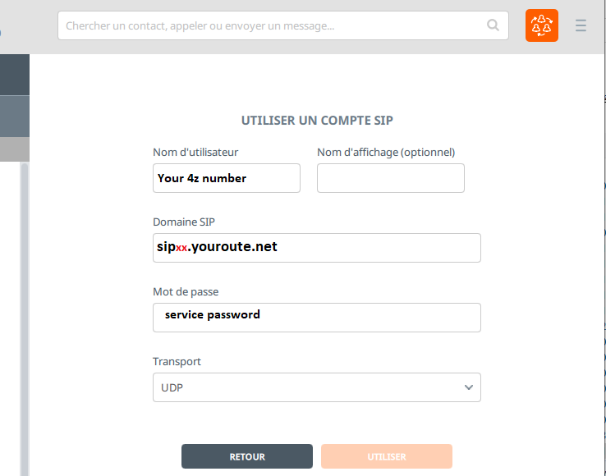

And click Utiliser.
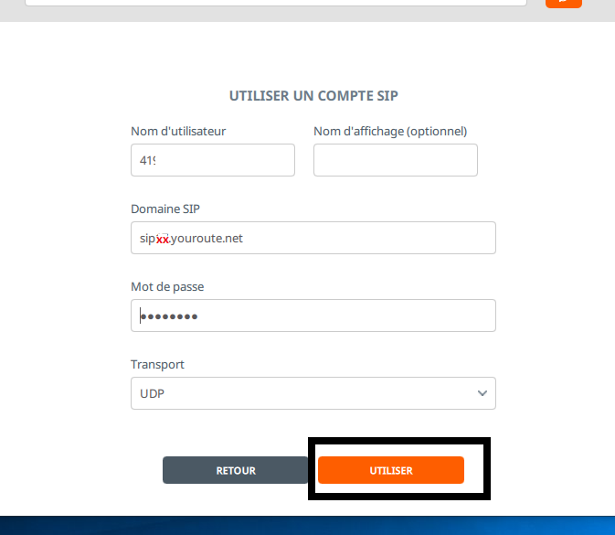

Click on your account.


Click on that second arrow to change in sip account.
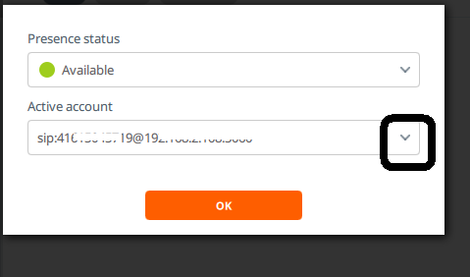

Select secound one where is written sip:……..@sipxxyouroute.net
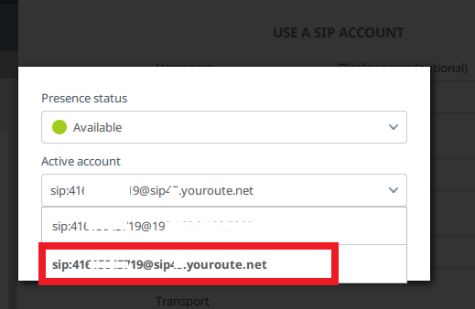

And click OK
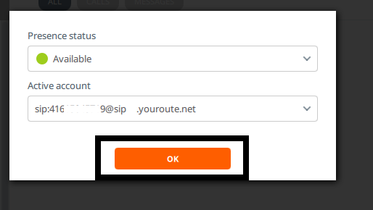

Now type number which you want to call.
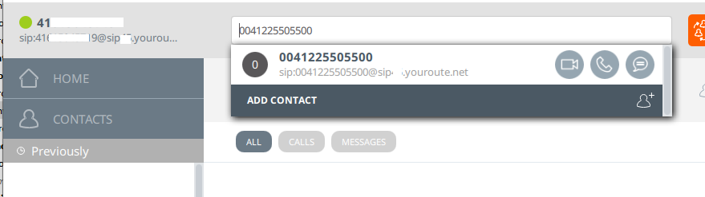

I calling our support center.
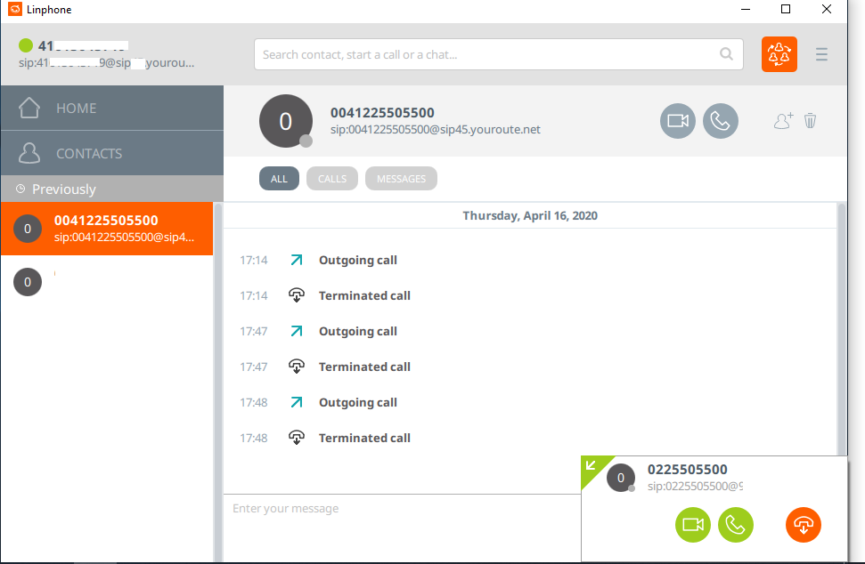

And my colegue answered on my call 😊
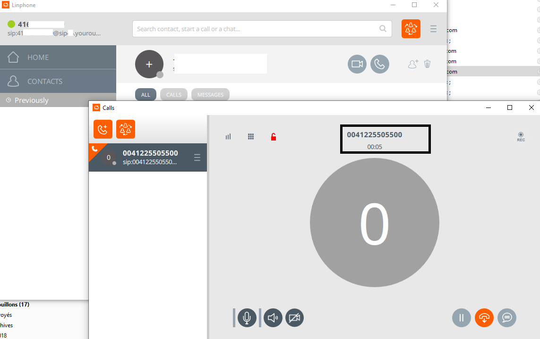
Good luck for you 😉

References
https://www.linphone.org/

End of document
* * *
© 4z.com

