How to configure Zoiper on PC

Created by Sonja Guicheux on 2020-04-16

Table of Contents

Introduction 1

Descriptions 1

Zoiper 1

Download 1

Configuration 1

References 1

End of document  1

# Introduction

This document will explain how to configure application Zoiper on your PC

# Descriptions

Zoiper is softphone application for VoIP calls. To use any softphone application, you need wi-fi or mobile data.

# Zoiper

Follow the steps to configure your application well

## Download

1. Download application <https://www.zoiper.com/en/voip-softphone/download/current>.
2. Install application.
3. Open application.

## Configuration

Click on **Continue as a Free user**

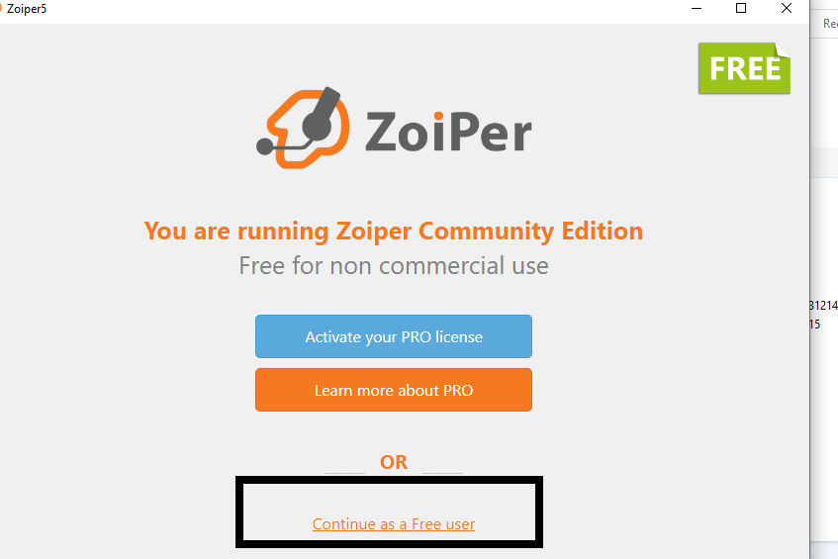

Here fill your datas.

***Username/ login*** is your 4z number. **41……...**

***Password*** is your **service password** form porta billing

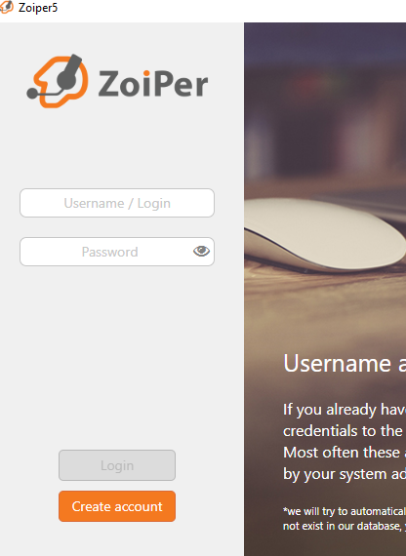

Click Login

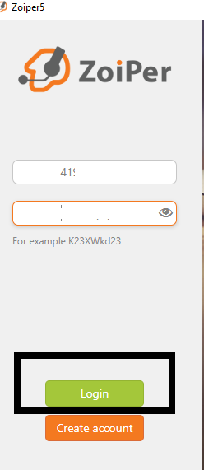

Fill sip. Ofc you will put your sip number.

And click **Next**

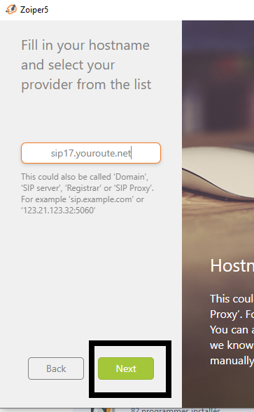

Here, click on that ***small square Optional***. Then you will have possibility to fill next areas.

***Authentication username*** is **your 4z number**.

***Outbound proxy*** is **same sip** what you put in previous step .

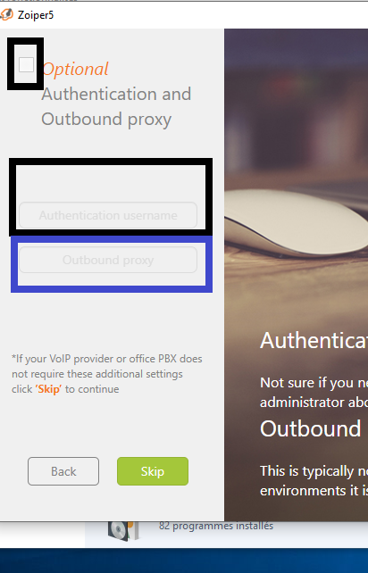

It looks like this.

Now click **Next**

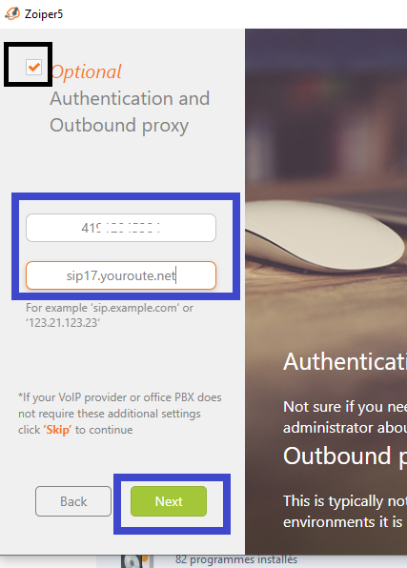

Here click on **UDP** and wait to finish loading.

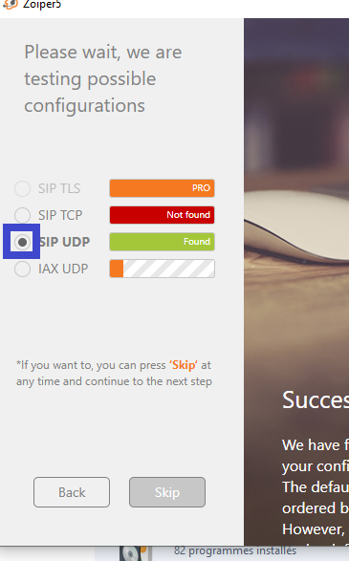

When is finish loading all, Click **Next.**

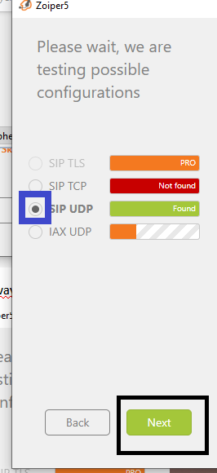

Here you can see that your account is registered well.

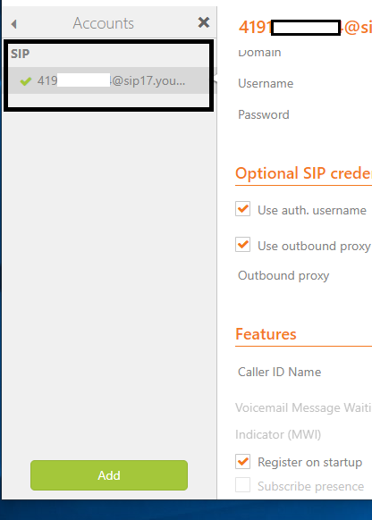

Good luck for you 😉

# References

<https://www.zoiper.com/en/voip-softphone/download/current>

# End of document

*   *   *

© 4z.com