ASTPP (4.0) installation

By Yevgeniya Suminova on 2021-03-10

Contents

Prerequisits 1

Procedure 1

End of document 1

# Prerequisits

1. VPS server Centos 7
2. To know how to point subdomain to an IP

Video instructions used: <https://www.youtube.com/watch?v=fFIuCyEMEq4>

# Procedure

1. Order /reinstall a VPS with Centos 7 operation system.

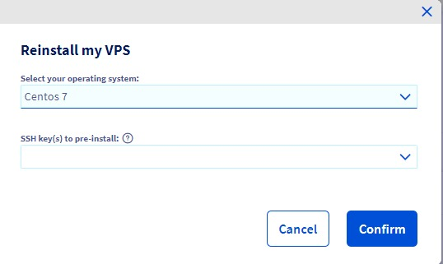

1. Enter via SSH to the server

ssh centos@51.79.54.205

1. Change to root user

sudo su

1. enter to the root directory

cd

1. type “ls”. This is what you must see:

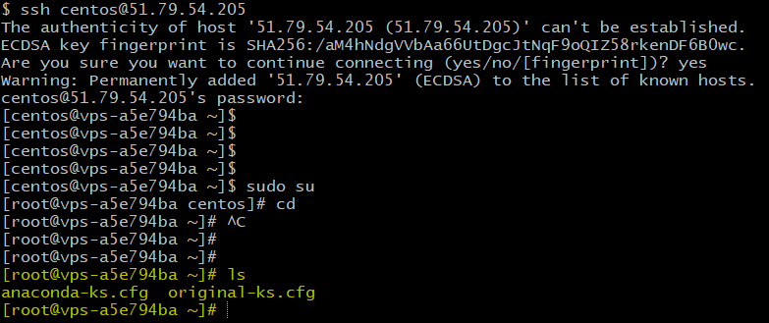

1. Check your OS version

cat /etc/redhat-release

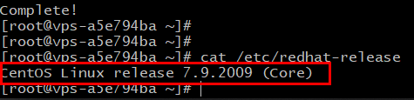

1. Run following command:

sudo yum install epel-release

1. Confirm by “y”

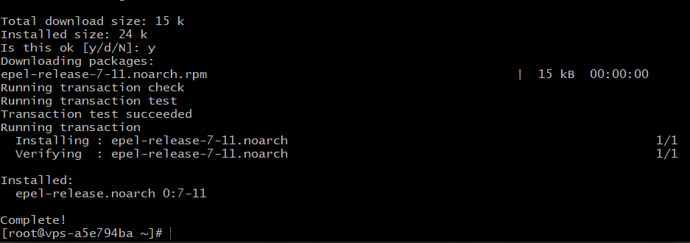

1. Install wget. (Confirm with “y”)

yum install wget

1. Run the following:

wget https://raw.githubusercontent.com/iNextrix/ASTPP/v4.0.1/install.sh -O install.sh

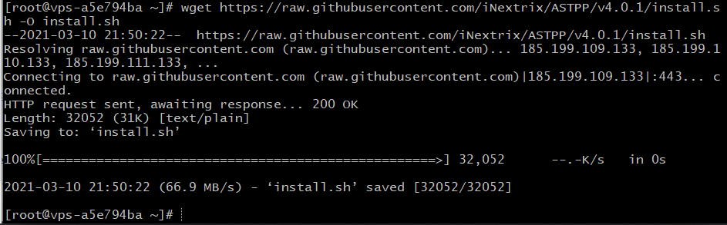

1. Check it is downloaded

ls

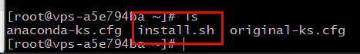

1. Give permission to the file:

chmod +x install.sh

1. Proceed with installation

./install.sh

1. Process seems freezed at this point:

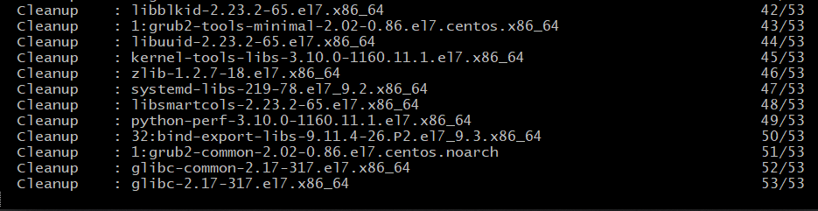

Just wait, it will continue in a while. Do not type anything

1. You need to agree with the license. Hit Enter until you reach 100%

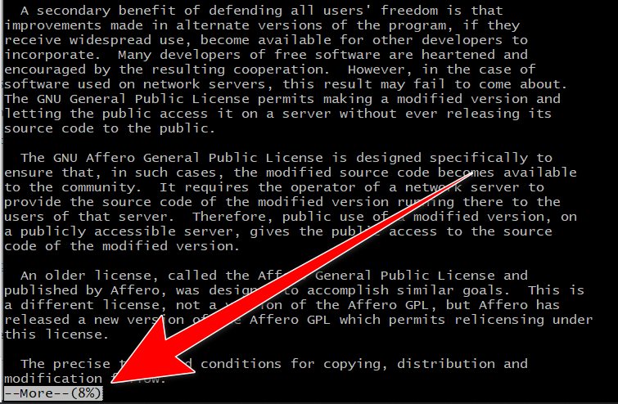

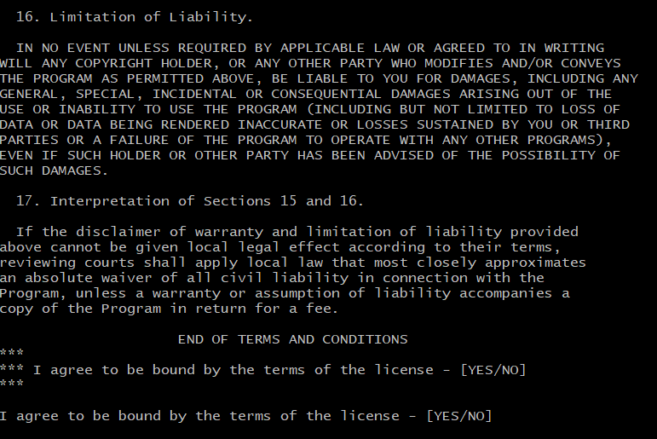

1. Type “YES” and Enter
2. Enter domain

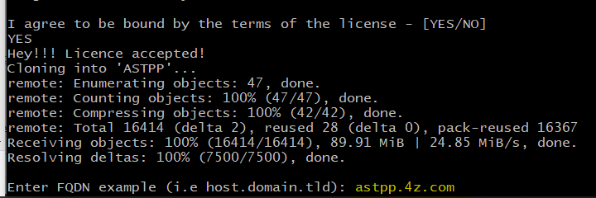

1. Enter email address. I took contact@4z.com
2. It will take a while and will install different packages: Mysql, then FreeSwitch and other packages and dependencies as well
3. You will be asked to enter some information like Country, email, etc… See the screenshot and do the same

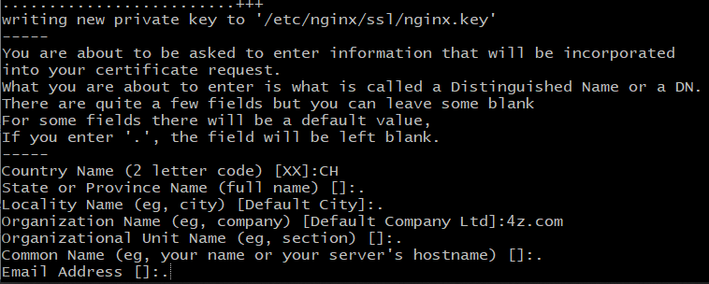

1. You will be asked: Do you want to install and configure Fail2ban ? (y/n) => Hit “y”
2. Fill fail2ban@4z.com for both client’s and sender email addresses:

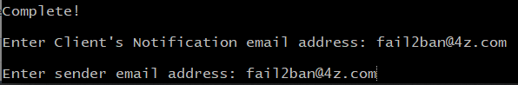

1. You will see the following:

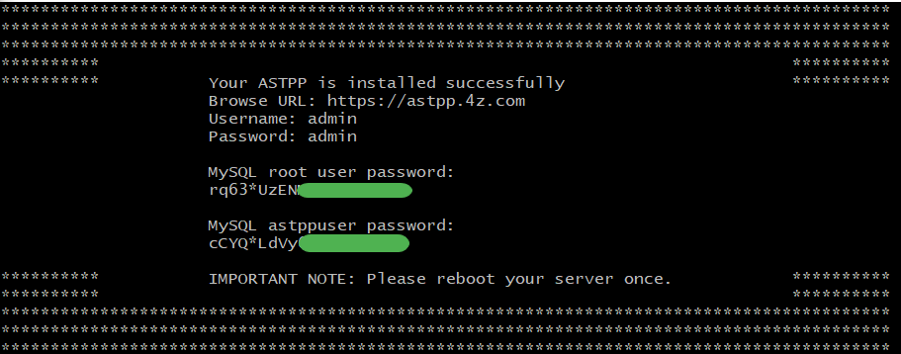

1. Reboot your server:

systemctl reboot

1. Now we need to generate SSL certificate. For that install certbot:

sudo yum install certbot-nginx

1. Generate the certificate for your domain

sudo certbot --nginx -d astpp.4z.com

1. It will request you for the email address. Use contact@4z.com
2. It will ask you the following;

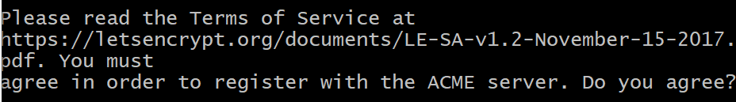

1. Type “Y”
2. Type “N” for the next question:

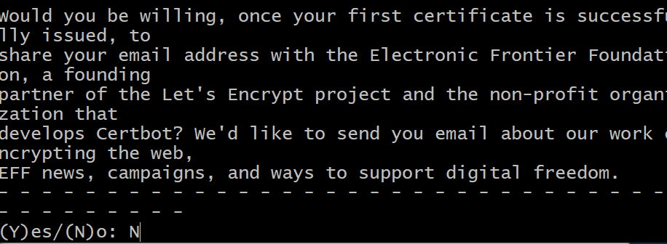

1. You will see “Congratulations!” if it is successful.

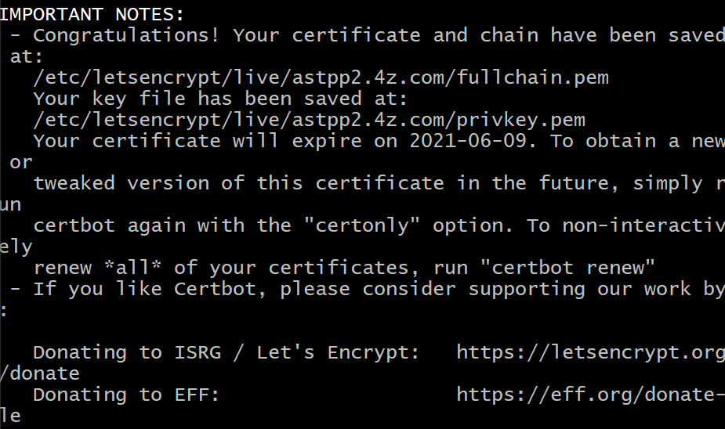

1. You are done with installation!
2. Now go to web interface https://astpp.4z.com and change admin’s password

# End of document

4z.com