How to merge numerical values of an excel file into a DOC with a limited number of decimals after the point

Switzernet

2008-03-04

This DOC is merged with an excel fie ‘input.xls’

Merge Record Number is:

The current value is: 90.909090909090907
The current value rounded is: 90.91

The first value shows plenty of digits after the decimal point. The value is inserted into the DOC file using the standard Insert Merge Field panel:

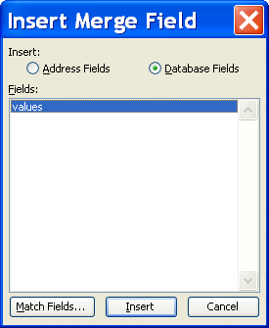

A solution is to use the =FIXED() function in excel to replace the digital values with safe text values. However this solutions handicaps the excel file for further use of values:

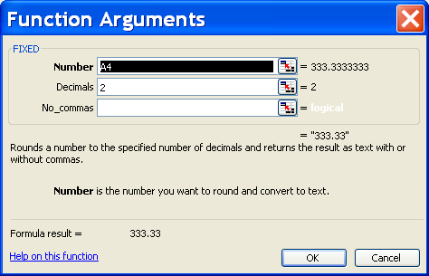

The second value of this DOC is rounded to display only two positions after the decimal point. This value is inserted differently.

Use [Insert] ➔ [Field…] menu command:

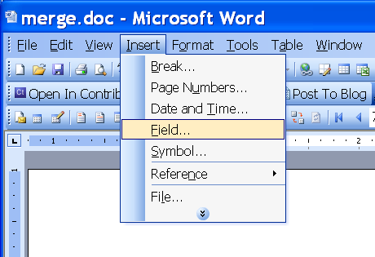

Then choose Formula:

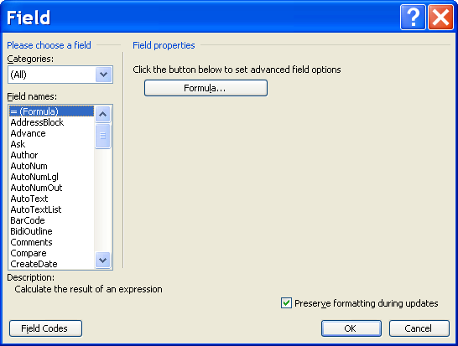

Type in the Formula filed mergefield “values” (where “values” is the name of the corresponding field in your excel file). In the drop-down menu choose the desired number display format:

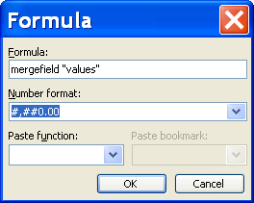

Download:
The input excel file [xls]
The merge DOC file [doc]
The merged output doc file [doc]
The web format [htm]

* * *

