Using MS Word field formulas to compute the previous date of a given input date

Emin Gabrielyan
2008-09-04

Download the MS Word file:
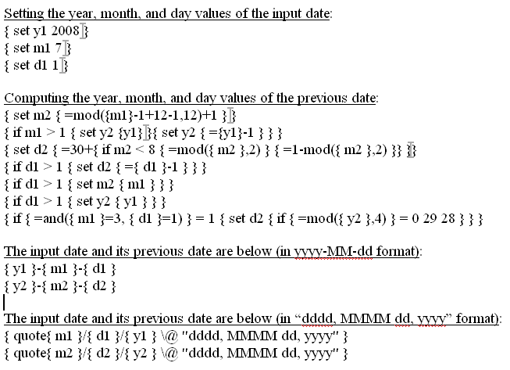
[doc]

In order to unhide all field formulas, select the yellow area containing the calculations on dates. Right-click and choose “Toggle Field Codes” from the pop-up menu. Whenever you make changes, select the whole area and choose “Update Field” from the right-click pop-up menu, for the changes to take effect.

Setting the year, month, and day values of the input date:

Computing the year, month, and day values of the previous date:

>

>
>
>

The input date and its previous date are below (in yyyy-MM-dd format):
2008-7-1
2008-6-30

The input date and its previous date are below (in “dddd, MMMM dd, yyyy” format):
Tuesday, July 01, 2008
Monday, June 30, 2008

References:
http://office.microsoft.com/en-us/word/HP051862181033.aspx
http://office.microsoft.com/en-us/word/HP051861861033.aspx
http://switzernet.com/public/080902-layout-red-slip/
http://unappel.ch/public/080902-layout-red-slip/
http://www.addbalance.com/word/datefields1.htm
http://www.addbalance.com/word/datefields2.htm
http://forums.techguy.org/business-applications/265813-creating-field-word-excel-formula.html
Several dates for a reference [xls]
http://switzernet.com/public/080904-word-field-date-calc/
http://unappel.ch/public/080904-word-field-date-calc/

* * *
Copyright © 2008 Switzernet

