Computing the yesterday’s date with MS Word field formulas considering the leap years of Gregorian calendar

Emin Gabrielyan
2008-09-20
Switzernet

This document demonstrates calculations on dates with MS-Word field formulas only. Date samples are read from an excel file. For each read date sample, MS-Word field formulas presented in this document compute the previous date, and the last date of the previous month.

The input excel file 1
Computing the date of yesterday 2
Computing the yesterday of the 1st of the month 7
References 10

The input excel file

This document is merged with an excel file [xls] containing list of dates. The excel file provides a list of randomly generated dates:
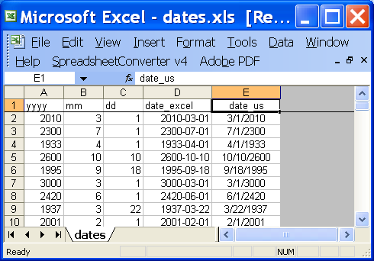
[xls]

Download the excel file [xls] and this doc file [doc] and merge them locally on your computer. For merging a doc file with an Excel file, in MS Word menu select [View] – [Toolbars] – [Mail Merge], then with [Open Data Source] icon browse and link the excel file to the Word document.
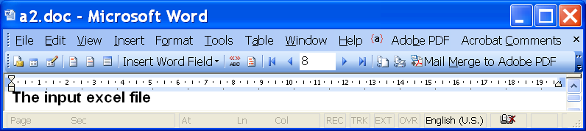

Computing the date of yesterday

The toggle fields below in this chapter create the date of yesterday (for each date value read from the excel file). The screenshot is followed by the toggle fields themselves (you cannot see the formulas in the HTML version of this doc, open the DOC version [doc]). We read from the Excel file [xls] the date in US format “MM/DD/YYYY”. MS Word interprets and stores the dates in US format only (irrespectively to date, time, language, and regional options setting of your computer).

The date format specifier “\@” helps to retrieve the year, month, and day individual composites of the today value. The bookmarks “yestyear”, “yestmonth”, and “yestday” are the composite values of the yesterday’s date computed with arithmetic field formulas {=…}. The “yestleap” is true if “yestyear” corresponds to a leap year. The leap year computation is accurate and follows the complete definition of leap years in Gregorian calendar [wiki].

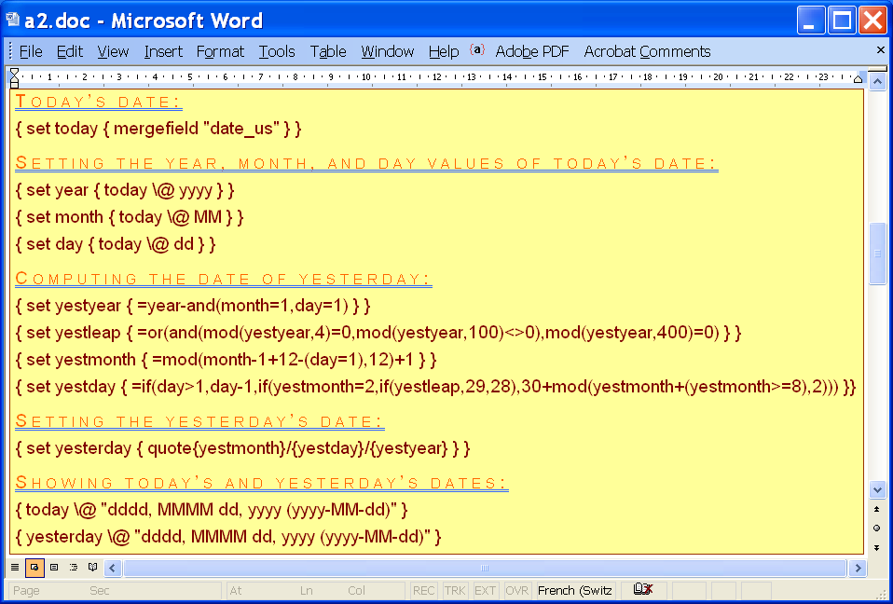
[doc]
Today’s date:

Setting the year, month, and day values of today’s date:

Computing the date of yesterday:

Setting the yesterday’s date:

Showing today’s and yesterday’s dates:
Monday, June 10, 1996 (1996-06-10)
Sunday, June 09, 1996 (1996-06-09)

The field codes can be viewed or unviewed by selecting the above yellow area and choosing in the right-click pop-up menu “Toggle Field Codes”. The formulas for computing the yesterday’s date, are completely compatible with excel formulas and can be copy-pasted back-and-forth between Excel cells and MS-Word fields. Joined are an excel file using exactly the same formulas [xls] and an html page [htm] demonstrating the operation of the file with web forms (without an excel program).

When the DOC file is merged with an excel file, changing of the record with [Previous Record] and [Next Record] buttons, updates all field codes of the document [doc].

If you make modifications in formulas, or if you deal with a standalone doc file not linked with an excel file, you may need to re-execute the field codes after your changes. To re-execute the field codes select the area with field codes, and in the right-click pop-up menu chose “Update Field”.

The following bookmarks will be defined in the document, once the filed codes are executed at least once. To see bookmark panel, choose [Insert] – [Bookmark…] in the main MS Word menu:
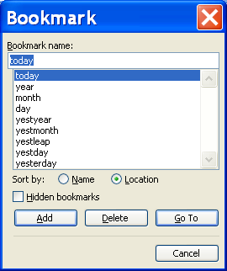
These bookmarks correspond to 9 variables defined in this document.

Computing the yesterday of the 1st of the month

The formulas of this section are simplified for the case when we need only the last day of the previous month (i.e. the yesterday of the 1st of the current month). Below is a screenshot of toggle fields, followed by the MS-Word toggle fields themselves (viewable only in DOC version [doc] and not in HTML). The final value of the yesterday variable is the last day of the previous month. In this example, the value of “day” is not used.

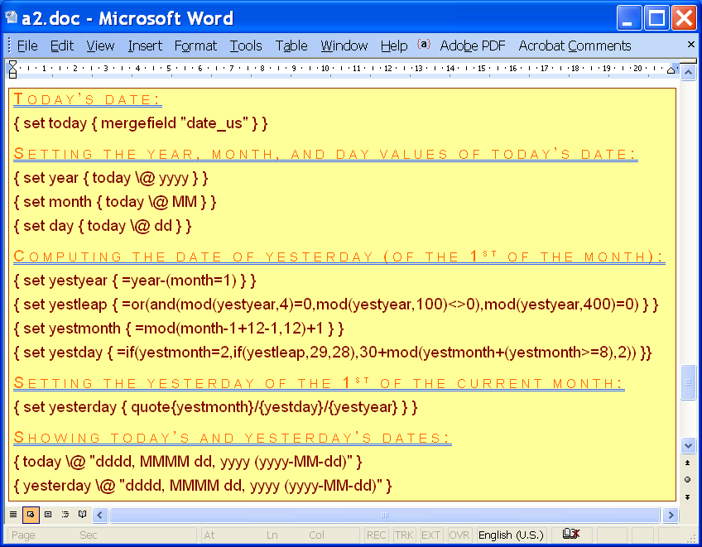
[doc]
Today’s date:

Setting the year, month, and day values of today’s date:

Computing the date of yesterday (of the 1st of the month):

Setting the yesterday of the 1st of the current month:

Showing today’s and yesterday’s dates:
Monday, June 10, 1996 (1996-06-10)
Friday, May 31, 1996 (1996-05-31)

The execution of these field codes generates the following bookmarks, corresponding to the variables defined in the above yellow area.
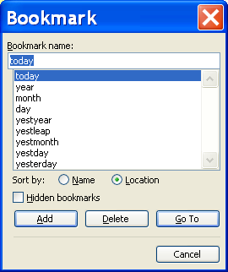

As before, the arithmetic formulas for computing the values of the yesterday of the 1st of the current month are fully compatible with excel. Joined is an excel file using the formulas of this chapter [xls].
yestyear=year-(month=1)
yestleap=OR(AND(MOD(yestyear,4)=0,MOD(yestyear,100)<>0),MOD(yestyear,400)=0)
yestmonth=MOD(month-1+12-1,12)+1
yestday=IF(yestmonth=2,IF(yestleap,29,28),30+MOD(yestmonth+(yestmonth>=8),2))
A web page demonstrating the operation of the excel file is joined as well [htm].

References
Creating a field in Word with an Excel formula:
http://forums.techguy.org/business-applications/265813-creating-field-word-excel-formula.html
Using MS Word field formulas to compute the previous date of a given input date (without merging with an excel file):
http://switzernet.com/public/080904-word-field-date-calc/
http://unappel.ch/public/080904-word-field-date-calc/
http://google.ch/search?q=Creating+a+field+in+Word+with+an+Excel+formula
http://google.ch/search?q=word+field+formulas+for+dates
Computing previous days’ values of a set of input dates with MS Word field formulas:
http://switzernet.com/public/080904-word-field-process-dates/
http://unappel.ch/public/080904-word-field-process-dates/
MS Word field formulas: creating arrays and computing dates using excel compatible formulas:
http://switzernet.com/public/080916-ms-word-field-formulas/
http://unappel.ch/public/080916-ms-word-field-formulas/
Generating overdue payment letters:
http://switzernet.com/company/080915-howto-word-formulas-reminders/
http://www.switzernet.com/public/080915-howto-word-formulas-reminders/
Leap year’s complete formula:
http://en.wikipedia.org/wiki/Leap_year
http://www.timeanddate.com/calendar/
Computing the yesterday’s date with MS Word field formulas considering the leap years of Gregorian calendar (this document):
http://switzernet.com/public/080920-word-field-yesterday-date-leap-years/
http://unappel.ch/public/080920-word-field-yesterday-date-leap-years/

* * *
Copyright © 2008 Switzernet

