Problem accessing Internet from PSE-A via the router of PSE-B
Emin Gabrielyan
2009-03-05

The ARP table on my computer shows:

$ arp -a

Interface: 192.168.1.8 --- 0x20002
Internet Address Physical Address Type
192.168.1.1 00-1c-11-39-ee-10 dynamic
192.168.1.2 00-19-cb-4d-88-f4 dynamic
192.168.1.10 00-19-cb-7c-a5-11 dynamic
192.168.1.11 00-1c-c0-6e-a6-46 dynamic
192.168.1.12 00-a0-c5-8f-b1-e6 dynamic
192.168.1.14 00-1c-c0-6e-a6-46 dynamic

$

In order to get the MAC addresses in ARP table you must select once each of these IP addresses as your gateways:

C:\Documents and Settings\Emin.Gabrielyan>route change 0.0.0.0 mask 0.0.0.0 192.168.1.1
C:\Documents and Settings\Emin.Gabrielyan>route change 0.0.0.0 mask 0.0.0.0 192.168.1.2
C:\Documents and Settings\Emin.Gabrielyan>route change 0.0.0.0 mask 0.0.0.0 192.168.1.10
C:\Documents and Settings\Emin.Gabrielyan>route change 0.0.0.0 mask 0.0.0.0 192.168.1.11
C:\Documents and Settings\Emin.Gabrielyan>route change 0.0.0.0 mask 0.0.0.0 192.168.1.12
C:\Documents and Settings\Emin.Gabrielyan>route change 0.0.0.0 mask 0.0.0.0 192.168.1.14

Selecting of 192.168.1.10 and 192.168.1.11 as your gateways makes no sense, but you get the MAC of these hosts in your ARP table.

The problem is that 192.168.1.11 (the wireless bridge client on the PSE-B side) has the same MAC address as the router 192.168.1.14 (in PSE-B) behind this bridge.

The second problem is that this MAC address (00-1c-c0-6e-a6-46) does not correspond neither to the MAC of the wireless bridge (192.168.1.11) nor to the MAC of the router (192.168.1.14), both in PSE-B.

MAC address of 192.168.1.10 AP according to its web interface
MAC is 00:19:cb:7c:a5:11
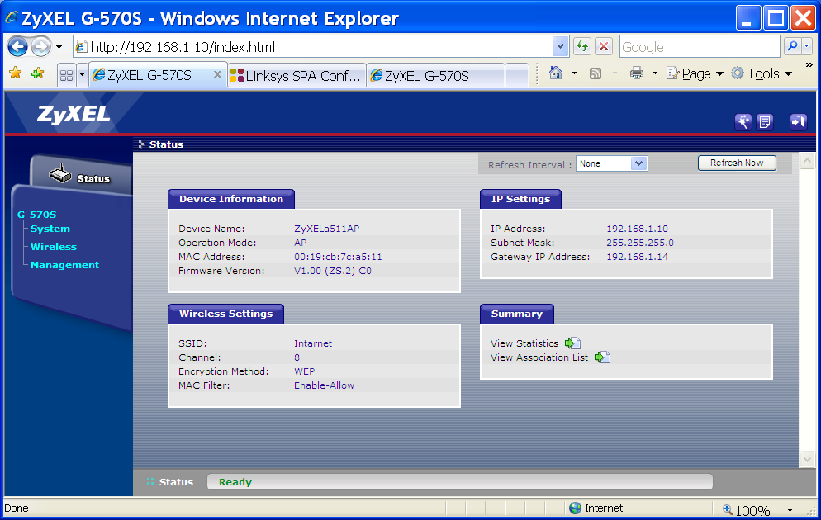

MAC address of Wireless bridge client in PSE-B according to its web interface
MAC address is 00:19:cb:7c:a5:12
Strangely, this address is displayed for a second, and then disappears from the page!
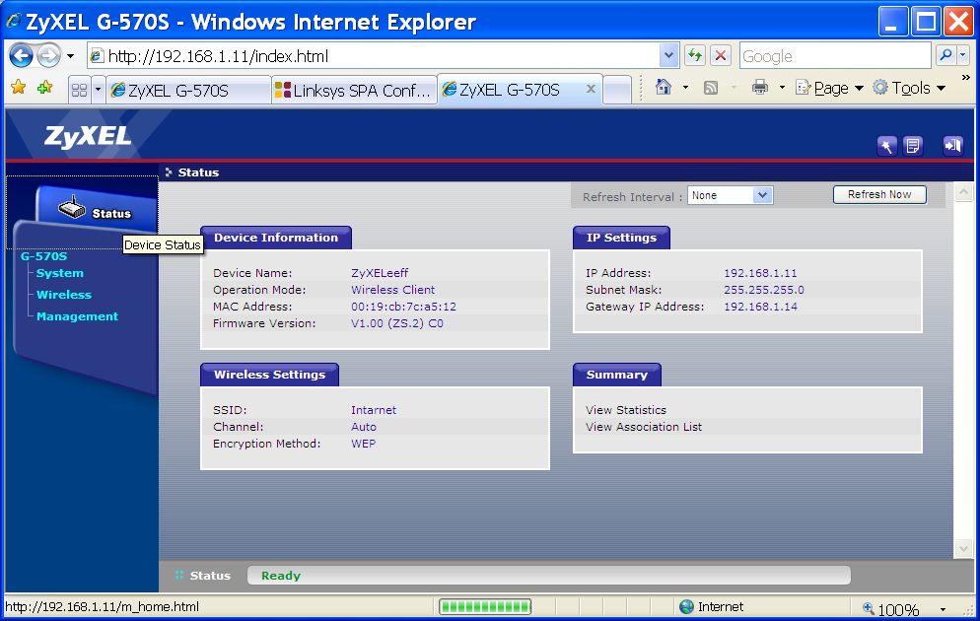

MAC address of the gateway 192.168.1.14
Address is 00:0E:08:CF:C1:CD


  

