Siemens Gigaset A160 + Linksys SPA1001
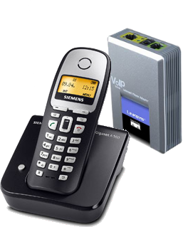 | CHF 69.-  Order now!

Description:
The Siemens Gigaset A160 is a wireless handset allows you to talk from any room of your house or office. Easily configurable, it is an excellent choice with Linksys SPA1001.

Developer website
SPA1001 description page

With subscription:
- Access to contractual discount rates: see the rates.
- Swiss fixnet line number
- No roaming: the rates are the same if you use your Switzernet account abroad.
- Free destinations (Switzerland included):


- Free mobile destinations for private customers: USA, Canada, Chine, Hong Kong, Singapore.
- Monthly fee: 9 CHF
- The invoice is sent on every 1st day of the month, payment reception deadline is 25 days
Subscription is available only for Swiss residents; for foreign residents please open a prepaid account.
> General conditions

Plugin scheme:
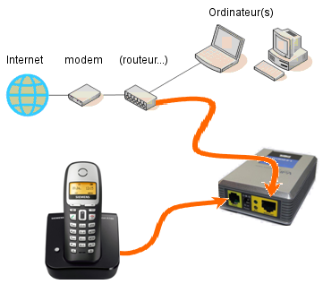
Computer(s)
(router…)
SPA1001
A160

Feedback

* * *

Copyright © 2009 Switzernet

