Siemens Gigaset A510 IP

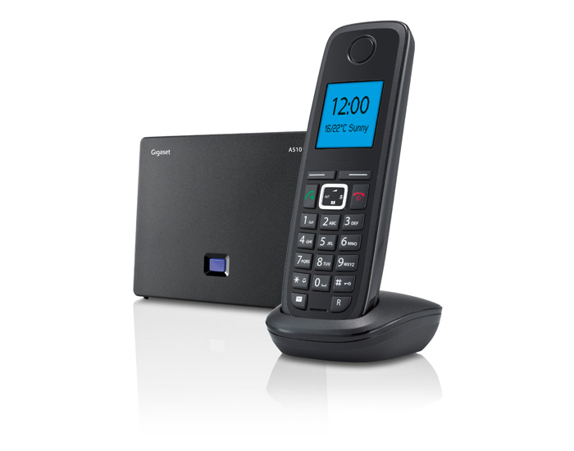 |   CHF 20.00 instead of CHF 69.00  Until 9 December 2012  Order now!

Description :
The Siemens Gigaset A510 IP is a wireless VoIP phone which allows you to talk from anywhere. Your calls will be retransmitted with an exceptional High Definition sound because of the Siemens HDSP technology. This phone has the hands-free features allowing you to do several tasks simultaneously in an easy way. You can also access to on-line services like the weather report, the notifications of your email or RSS flows.

Gigaset A150 IP official web site

With subscription:
- Access to contractual discount rates: see the rates.
- Swiss fix net line number
- No roaming: the rates are the same if you use your Switzernet account abroad.
- Free destinations (Switzerland included):


- Free mobile destinations for private customers: USA, Canada, Chine, Hong Kong, Singapore.
- Monthly fee: 9 CHF
- The invoice is sent on every 1st day of the month, payment reception deadline is 25 days
Subscription is available only for Swiss residents; for foreign residents please open a prepaid account.
> General conditions

Plugin scheme:
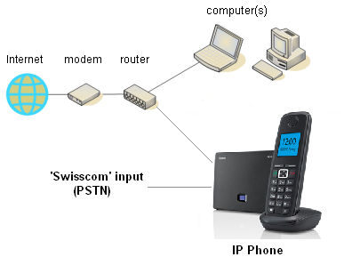

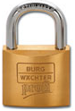 Feedback

* * *
Copyright © 2012 Switzernet

