Siemens Gigaset C470IP

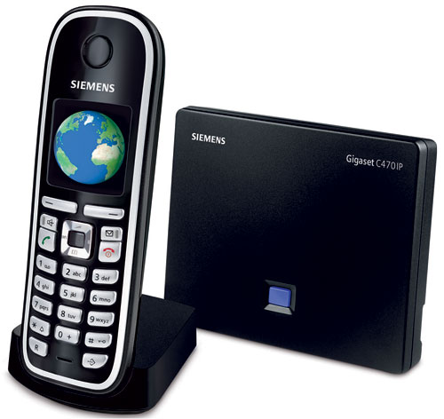 | CHF139.00 statt CHF 165  bis zum 28 februar  Bestellen Sie jetzt! | AUCTION

Description:
This telephone is hybrid and portable. You need to connect the C470IP base to ADSL/Cable modem via Ethernet/RJ45 cable, and you can make and receive calls, even if your computer is switched-off. This adapter has a PSTN pass through line for toggling operations between SIP and PSTN networks. So you can make and recive calls via classical (f.e. Swisscom) line or via VOIP using the analog telephone plugged into this adapter. New: ECO DECT – 60% less energy use and variable reduction of transmitting power
Developper website

With subscription:
- Access to contractual discount rates: see the rates.
- Swiss fixnet line number
- No roaming (the rates are the same if you use your Switzernet account abroad)
- Free destinations (Switzerland fixnet, Germany fixnet, United Kingdom fixnet, USA fixnet and mobiles, Hawaii fixnet and mobiles, Singapore fixnet and mobiles) for private customers
- Monthly fee: 9 CHF
- The invoice is sent on every 1st day of the month, payment receiption deadline is 25 days
Abonnement is avalable only for Swiss residents; for foreign residents please open a prepaid account.
> General conditions

Plugin scheme:
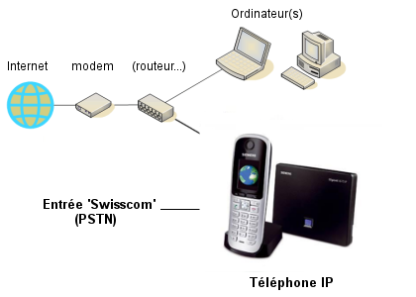

Feedback

* * *

Copyright © 2009 Switzernet

