Siemens Gigaset C610IP

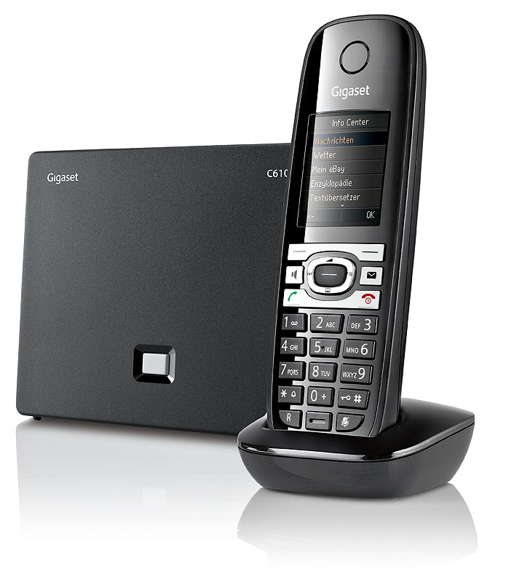 | CHF 129.00  Order now!

Description:
The C610IP is an hybrid and portable phone. After having connected the C610IP base to ADSL/Cable modem via Ethernet/RJ45 cable, make and receive calls, even with your computer switched-off. This phone has a PSTN pass through line for toggling operations between SIP and PSTN networks. So you can make and receive calls via classical (f.e. Swisscom) line or via VOIP. New: ECO DECT – 80% less energy use and variable reduction of transmitting power
Developper website
With subscription:
- Access to contractual discount rates: see the rates.
- Swiss fixnet line number
- No roaming (the rates are the same if you use your Switzernet account abroad).
- Free destinations to landlines of 18 countries: AT, BE, CH, DE, DK, ES, FR, GR, IT, IE, LI, LU, NL, PT, SE, UK, MA, TR ; and to mobiles and landlines of 5 countries: CN, US, CA, SG, HK.
- Monthly fee: 9 CHF
- The invoice is sent on every 1st day of the month, payment receiption deadline is 25 days
Abonnement is avalable only for Swiss residents; for foreign residents please open a prepaid account.
> Conditions générales
Plugin scheme:
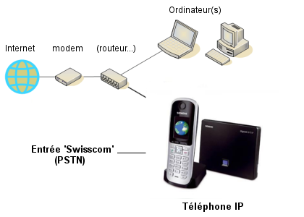

* * *
Copyright © 2011 Switzernet

