Grandstream DP715

|  |  |
| --- | --- |
| C:\Users\Nicolas Bondier\Desktop\HT715-5-2.jpg | CHF 69.-  [C:\Users\Nicolas Bondier\Desktop\140228-dp715-description-web\files\button_files\image002.png](http://switzernet.com/public/070608-subscribe/index.php?modele=DP715) |

# Description:

DP715/710 is the next generation of powerful, affordable, high quality and simple to configure VoIP DECT phones for small business and residential users. Their compact size, superb voice quality, rich feature set, market leading price-performance and wide range radio coverage enable consumers to maximize the power of IP voice application and mobility for a minimum investment. DP715/710 is SIP and DECT compliant and field proven for flexible deployment.

[Official Grandstream DP715 page](https://www.grandstream.com/index.php/products/ip-voice-telephony/enterprise-ip-phones/dp715_710)

# With the subscription plan:

* A Swiss fix net line number.
* No roaming. The rates are the same if you use your Switzernet account abroad.
* Exceptional rates to Switzerland and in the whole world with per second billing.
* Free calls to fix landlines of 23 countries (Switzerland included):

at be ca ch cn de dk es fr gr ie it li lu nl pt se sg uk us ma tr hk

* Free calls to mobiles for destinations: USA, Canada, China, Hong Kong and Singapore.
* The possibility to receive calls on many SIP devices in the same time.
* Monthly fees: 9 CHF.
* The invoice is sent on every 1st day of the month, payment reception deadline is 25 days.
* The subscription is only available with a billing address in Switzerland. For ordering from other countries, choose a [prepaid account](http://switzernet.com/public/070608-subscribe/produit.php).

See the [general terms and conditions](http://switzernet.com/public/090506-general-conditions/en.pdf).

# Plugin scheme:

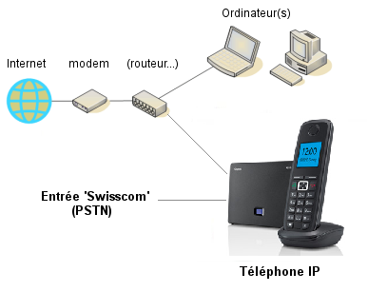

\* \* \*

Switzernet logo

Copyright © 2014 Switzernet