Grandstream GXP1100
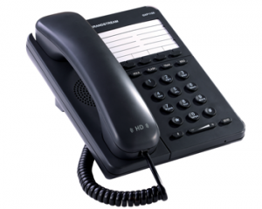 | CHF 49.-  Order now!

Description:
GXP1100/1105 is a next generation small business IP phone that features up to 2 calls with 1 SIP account, 4 programmable keys. The GXP1100/1105 delivers superior HD audio quality, leading edge telephony features and broad interoperability with most 3rd party SIP devices and leading SIP/NGN/MMS platforms, it is a perfect choice for a small business, lobby, and hotel applications for a high quality, basic IP phone with attractive cost.
Developper website

With subscription:
- Access to contractual discount rates: see the rates.
- Swiss fixnet line number
- No roaming (the rates are the same if you use your Switzernet account abroad)
- Free destinations (Switzerland fixnet, Germany fixnet, United Kingdom fixnet, USA fixnet and mobiles, Hawaii fixnet and mobiles, Singapore fixnet and mobiles) for private customers
- Monthly fee: 9 CHF
- The invoice is sent on every 1st day of the month, payment receiption deadline is 25 days
Abonnement is avalable only for Swiss residents; for foreign residents please open a prepaid account.
> General conditions

Plugin scheme:
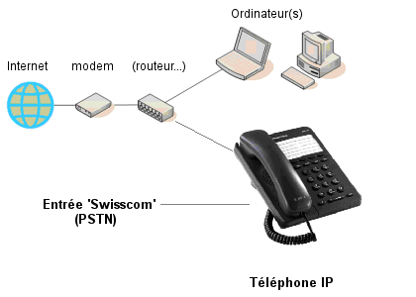

Feedback

* * *

Copyright © 2009 Switzernet

