Grandstream GXP1100

|  |  |
| --- | --- |
|  | CHF 0.00 instead of CHF 49  Until 05/06/2014  [C:\Users\Nicolas Bondier\Desktop\image004.png](http://switzernet.com/public/070608-subscribe/index.php?language=3&modele=GXP1100) |

# Description:

GXP1100/1105 is a next generation small business IP phone that features up to 2 calls with 1 SIP account, 4 programmable keys. The GXP1100/1105 delivers superior HD audio quality, leading edge telephony features and broad interoperability with most 3rd party SIP devices and leading SIP/NGN/MMS platforms, it is a perfect choice for a small business, lobby, and hotel applications for a high quality, basic IP phone with attractive cost.

[Official Grandstream GXP1100 page](http://www.grandstream.com/products/ip-voice-telephony/enterprise-ip-phones/gxp1100)

# With the subscription plan:

* A Swiss fix net line number.
* No roaming. The rates are the same if you use your Switzernet account abroad.
* Exceptional rates to Switzerland and in the whole world with per second billing.
* Free calls to fix landlines of 23 countries (Switzerland included):

at be ca ch cn de dk es fr gr ie it li lu nl pt se sg uk us ma tr hk

* Free calls to mobiles for destinations: USA, Canada, China, Hong Kong and Singapore.
* The possibility to receive calls on many SIP devices in the same time.
* Monthly fees: 9 CHF.
* The invoice is sent on every 1st day of the month, payment reception deadline is 25 days.
* The subscription is only available with a billing address in Switzerland. For ordering from other countries, choose a [prepaid account](http://switzernet.com/public/070608-subscribe/produit.php).

See the [general terms and conditions](http://switzernet.com/public/090506-general-conditions/en.pdf).

# Plugin scheme:

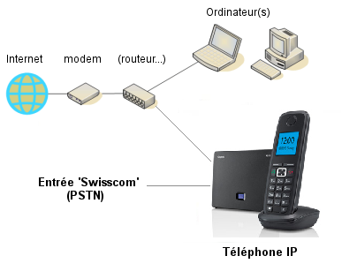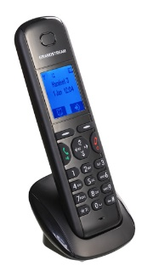

* * *

Switzernet logo

Copyright © 2014 Switzernet