Grandstream GXP1400

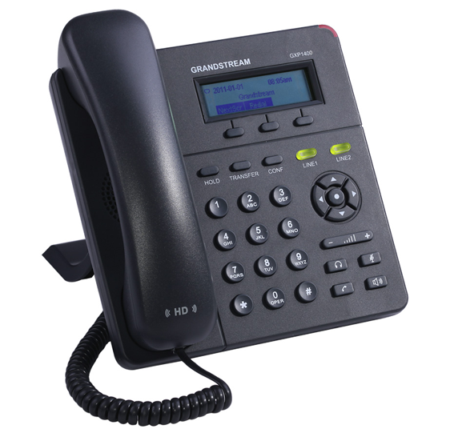 | CHF 59.-  

Description:
GXP1400/1405 is a next generation small-to-medium business IP phone that features 2 lines with 2 SIP account, a 128x40 graphical LCD, 3 XML programmable context-sensitive soft keys. The GXP1400/1405 delivers superior HD audio quality, rich and leading edge telephony features, personalized information and customizable application service, automated provisioning for easy deployment, advanced security protection for privacy, and broad interoperability with most 3rd party SIP devices and leading SIP/NGN/IMS platforms. It is a perfect choice for small-to-medium businesses looking for a high quality, feature rich IP phone with affordable cost.

Official Granstream GXP1400 page

With the subscription plan:
- A Swiss fix net line number.
- No roaming. The rates are the same if you use your Switzernet account abroad.
- Exceptional rates to Switzerland and in the whole world with per second billing.
- Free calls to fix landlines of 23 countries (Switzerland included):

- Free calls to mobiles for destinations: USA, Canada, China, Hong Kong and Singapore.
- The possibility to receive calls on many SIP devices in the same time.
- Monthly fees: 9 CHF.
- The invoice is sent on every 1st day of the month, payment reception deadline is 25 days.
- The subscription is only available with a billing address in Switzerland. For ordering from other countries, choose a prepaid account.
See the general terms and conditions.

Plugin scheme:
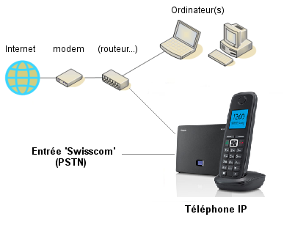
* * *
Copyright © 2014 Switzernet

