Grandstream GXP1400
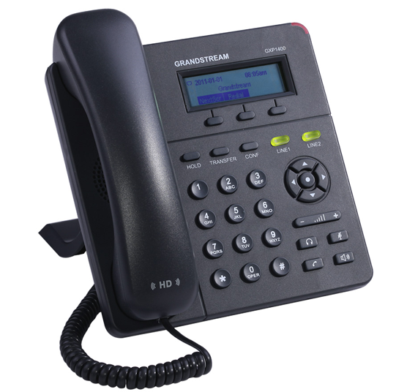 |   CHF 29.00 instead of CHF 59.00  Until 30 November 2012  Order now!

Description:
GXP1400/1405 is a next generation small-to-medium business IP phone that features 2 lines with 2 SIP account, a 128x40 graphical LCD, 3 XML programmable context-sensitive soft keys. The GXP1400/1405 delivers superior HD audio quality, rich and leading edge telephony features, personalized information and customizable application service, automated provisioning for easy deployment, advanced security protection for privacy, and broad interoperability with most 3rd party SIP devices and leading SIP/NGN/IMS platforms. It is a perfect choice for small-to-medium businesses looking for a high quality, feature rich IP phone with affordable cost.
Developper website

With subscription:
- Access to contractual discount rates: see the rates.
- Swiss fixnet line number
- No roaming: the rates are the same if you use your Switzernet account abroad.
- Free destinations (Switzerland included):


- Free mobile destinations for private customers: USA, Canada, Chine, Hong Kong, Singapore.
- Monthly fee: 9 CHF
- The invoice is sent on every 1st day of the month, payment reception deadline is 25 days
Subscription is available only for Swiss residents; for foreign residents please open a prepaid account.
> General conditions

Plugin scheme:
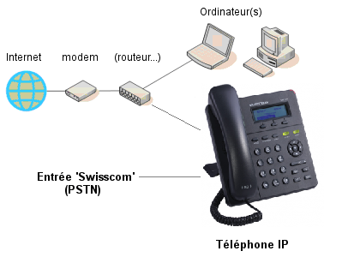

Feedback

* * *

Copyright © 2009 Switzernet

