Linksys PAP2T

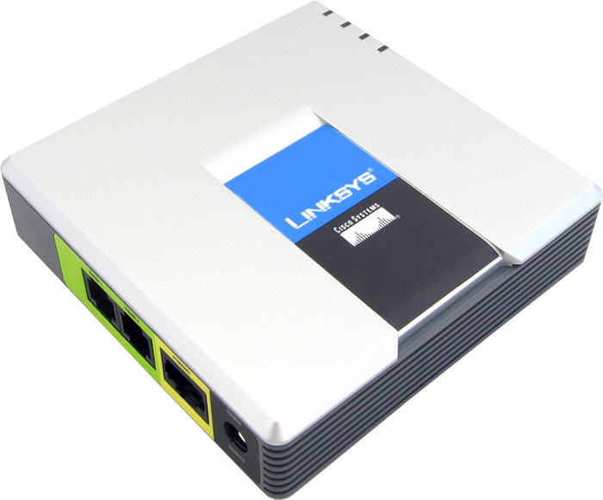 | CHF 88.00 instead of CHF117.00  since 10. June 2010  Order now !

Description :
This adapter allows the use of a traditional analog phone on IP telephone network (VOIP for Voice over IP). After plugging the PAP2T to the ADSL modem / cable via a cable Ethernet/RJ45, you can make and receive calls, even if the computer is off. It provides two voip accounts works independently, so you can ask for two separate phone numbers with this unit. Developper website

Avec l'abonnement :
- Access to contractual discount rates: see the rates.
- Swiss fixnet line number
- No roaming (the rates are the same if you use your Switzernet account abroad)
- Free destinations (Switzerland fixnet, Germany fixnet, United Kingdom fixnet, USA fixnet and mobiles, Hawaii fixnet and mobiles, Singapore fixnet and mobiles) for private customers
- Monthly fee: 9 CHF
- The invoice is sent on every 1st day of the month, payment reception deadline is 25 days

Abonnement is available only for Swiss residents; for foreign residents please open a prepaid account.

> General conditions

Plugin scheme :
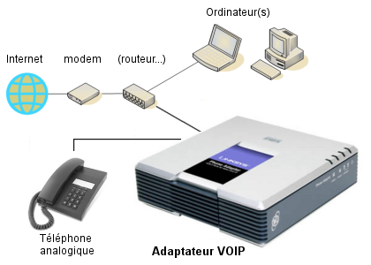

 Feedback

* * *
Copyright © 2009 Switzernet

