Linksys PAP2T

 |   CHF 19.00 instead of CHF 39.00  Until 30 November 2012  Order now!

Description :
This adapter allows the use of a traditional analog phone on IP telephone network (VOIP for Voice over IP). Après avoir connecté le PAP2T au modem ADSL/Câble via un câble Ethernet/RJ45, on peut passer et recevoir ses appels, même si l'ordinateur est éteint. After plugging the PAP2T to the ADSL modem / cable via a cable Ethernet/RJ45, you can make and receive calls, even if the computer is off. Il fournit deux prises téléphoniques qui fonctionnent indépendamment ; vous pouvez donc demander deux numéros de téléphone séparés avec cet appareil. It provides two voip accounts works independently, so you can ask for two separate phone numbers with this unit.

Developper website

With subscription:
- Access to contractual discount rates: see the rates.
- Swiss fixnet line number
- No roaming: the rates are the same if you use your Switzernet account abroad.
- Free destinations (Switzerland included):


- Free mobile destinations for private customers: USA, Canada, Chine, Hong Kong, Singapore.
- Monthly fee: 9 CHF
- The invoice is sent on every 1st day of the month, payment reception deadline is 25 days
Subscription is available only for Swiss residents; for foreign residents please open a prepaid account.

> General conditions

Plugin scheme :
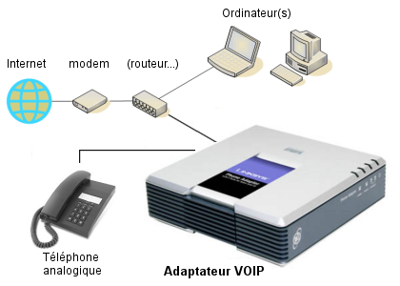

 Feedback

* * *
Copyright © 2009 Switzernet

