Linksys SPA3000

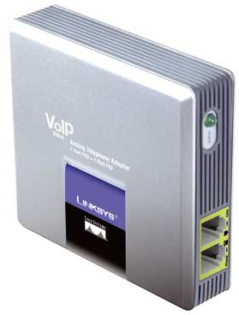 | CHF 49.00 instead of CHF 118.00  Since 2 January 2012  Order now!

Description:
This adapter let you use your existing analog telephone to make calls via Internet (or VOIP - Voice over IP). You need to connect SPA3000 to ADSL/Cable modem via Ethernet/RJ45 cable, and you can make and receive calls, even if your computer is switched-off. It has an integrated routeur and besides the PSTN pass-through line, it has one standard telephone jack for your phone.
Developper website

With subscription:
- Access to contractual discount rates: see the rates.
- Swiss fixnet line number
- No roaming (the rates are the same if you use your Switzernet account abroad)
- Free destinations (Switzerland fixnet, Germany fixnet, United Kingdom fixnet, USA fixnet and mobiles, Hawaii fixnet and mobiles, Singapore fixnet and mobiles) for private customers
- Monthly fee: 9 CHF
- The invoice is sent on every 1st day of the month, payment receiption deadline is 25 days
Abonnement is avalable only for Swiss residents; for foreign residents please open a prepaid account.
> General conditions

Plugin scheme:
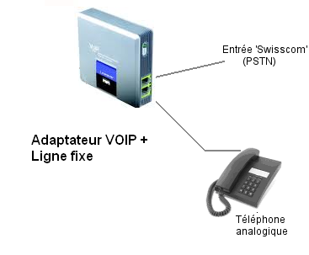

Feedback

* * *

Copyright © 2009 Switzernet

