Linksys SPA3000
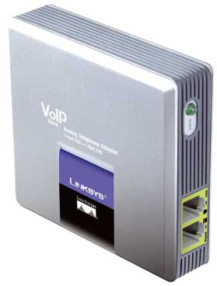 |   CHF 14.00 instead of CHF 49.00  until 20 September 2012  Order now!

Description:
This adapter let you use your existing analog telephone to make calls via Internet (or VOIP - Voice over IP). You need to connect SPA3000 to ADSL/Cable modem via Ethernet/RJ45 cable, and you can make and receive calls, even if your computer is switched-off. It has an integrated routeur and besides the PSTN pass-through line, it has one standard telephone jack for your phone.
Developper website

With subscription:
- Access to contractual discount rates: see the rates.
- Swiss fixnet line number
- No roaming: the rates are the same if you use your Switzernet account abroad.
- Free destinations (Switzerland included):


- Free mobile destinations for private customers: USA, Canada, Chine, Hong Kong, Singapore.
- Monthly fee: 9 CHF
- The invoice is sent on every 1st day of the month, payment reception deadline is 25 days
Subscription is available only for Swiss residents; for foreign residents please open a prepaid account.
> General conditions

Plugin scheme:
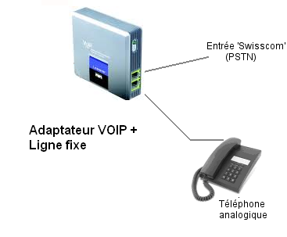

Feedback

* * *

Copyright © 2009 Switzernet

