Ultrative UTT-900B
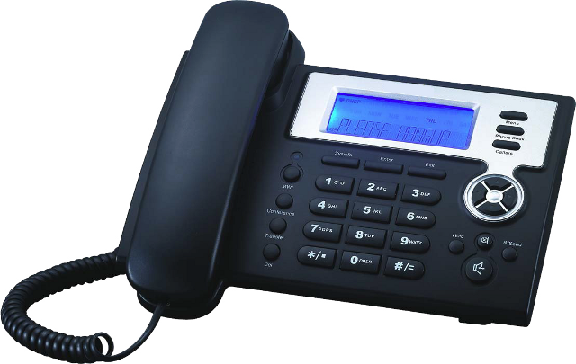 |   CHF 19.00 instead of CHF 39  Until 30 November 2012  Order now!

Description:
The IP phone UTT-900B allows configure 2 SIP lines at same time. It has a good voice quality and you can register up to 500 records in the phonebook. This device provides a LCD screen of 75 x 28 mm. It is designed as private clients as SME (Small and Medium Enterprises).

Developer website

With subscription:
- Access to contractual discount rates: see the rates.
- Swiss fixnet line number
- No roaming: the rates are the same if you use your Switzernet account abroad.
- Free destinations (Switzerland included):


- Free mobile destinations for private customers: USA, Canada, Chine, Hong Kong, Singapore.
- Monthly fee: 9 CHF
- The invoice is sent on every 1st day of the month, payment reception deadline is 25 days
Subscription is available only for Swiss residents; for foreign residents please open a prepaid account.
> General conditions

Plugin scheme:
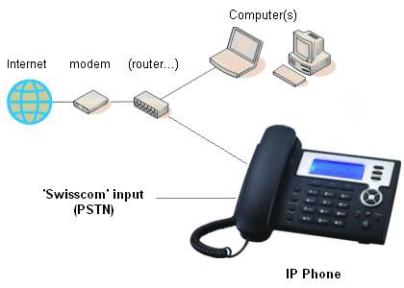

Feedback

* * *

Copyright © 2009 Switzernet

