Subscription without equipement

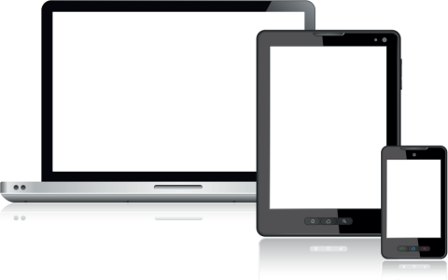

Description:
Switzernet invites you to use your phone from your computer using software such as X-Lite can be downloaded from our settings web page. You can also use any software or device IP telephony based on SIP protocol. In addition you can also use applications pour mobile and use your Switzernet number directly from your smartphone.
In this way, you stay reachable on your Switzernet numbers anywhere.
Consult the help documents for installing and configuring this page.

With the subscription plan:
- A Swiss fix net line number.
- No roaming. The rates are the same if you use your Switzernet account abroad.
- Exceptional rates to Switzerland and in the whole world with per second billing.
- Free calls to fix landlines of 23 countries (Switzerland included):

- Free calls to mobiles for destinations: USA, Canada, China, Hong Kong and Singapore.
- The possibility to receive calls on many SIP devices in the same time.
- Monthly fees: 9 CHF.
- The invoice is sent on every 1st day of the month, payment reception deadline is 25 days.
- The subscription is only available with a billing address in Switzerland. For ordering from other countries, choose a prepaid account.
See the general terms and conditions.

* * *
Copyright © 2014 Switzernet

