Linksys SPA1001

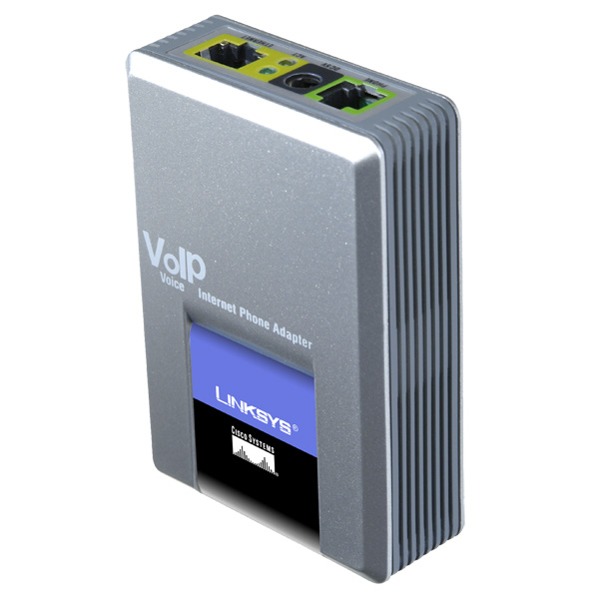 | CHF 49.00 instead of CHF 55  Since 23 October 2009  Order now!
Description :
- This adapter allows to use the traditional analog phone on IP telephone network (or VOIP for Voice over IP). After connecting the SPA1001 to the ADSL modem via the cable Ethernet/RJ45, you can make and receive calls even if the computer is turned off.

Wesite of adapter’s producer

With the subscription :
- IP Telephony at reduced contract price: see tariffs.
- Swiss landline number
- No roaming (the rates remain the same when you use your Switzernet line abroad)
- Free destinations (fixed lines in Switzerland, Portugal, Germany, France, UK, Austria, Sweden, Luxembourg, Liechtenstein; fixed and mobile lines in Singapore, USA, Canada for private subscribers
- Monthly cost: 9 CHF
- Invoice are sent on 1st day of each month, payable in 25 days
- Subscription is valid only with the billing address in Switzerland, to order from abroad please choose Prepaid account.
General Conditions

Order
Connection Schema:
You can use the device while the computer is turned off.

Your router
Internet
Votre
téléphone
analogique
Votre ordinateur
SPA 1001

If you have multiple Ethernet ports on your router

Document under the following link gives different instructions for configuring your device Linksys SPA1001:
http://switzernet.com/public/070723-config_UA/spa-1001.php

 Feedback

* * *
Copyright © 2009 Switzernet

More configurations :

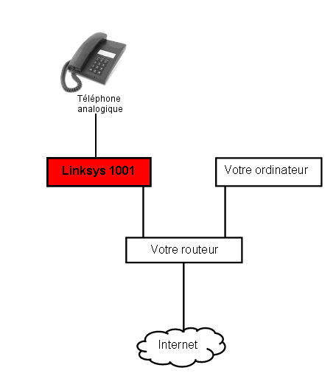 | 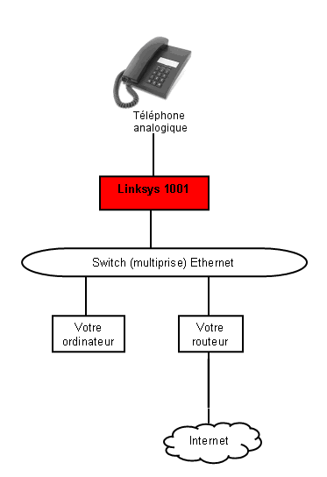
If you have multiple Ethernet port on your router | If you have one Ethernet port on your router

