Linksys SPA1001

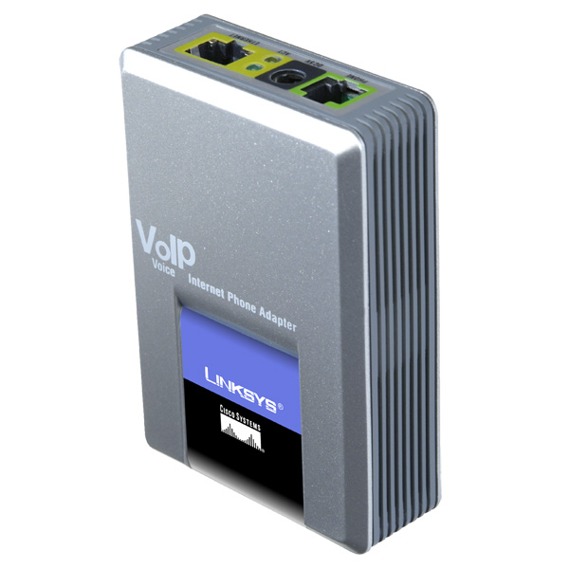 |   CHF 14.00 instead of CHF 29  Until 30 April 2012  Order now!
Description :
This adapter allows to use the traditional analog phone on IP telephone network (or VOIP for Voice over IP). After connecting the SPA1001 to the ADSL modem via the cable Ethernet/RJ45, you can make and receive calls even if the computer is turned off.

With subscription:
- Access to contractual discount rates: see the rates.
- Swiss fixnet line number
- No roaming: the rates are the same if you use your Switzernet account abroad.
- Free destinations (Switzerland included):


- Free mobile destinations for private customers: USA, Canada, Chine, Hong Kong, Singapore.
- Monthly fee: 9 CHF
- The invoice is sent on every 1st day of the month, payment reception deadline is 25 days
Subscription is available only for Swiss residents; for foreign residents please open a prepaid account.
General Conditions

Order
Connection Schema:
You can use the device while the computer is turned off.

Your router
Internet
Votre
téléphone
analogique
Votre ordinateur
SPA 1001

If you have multiple Ethernet ports on your router

Document under the following link gives different instructions for configuring your device Linksys SPA1001:
http://switzernet.com/public/070723-config_UA/spa-1001.php

More configurations :

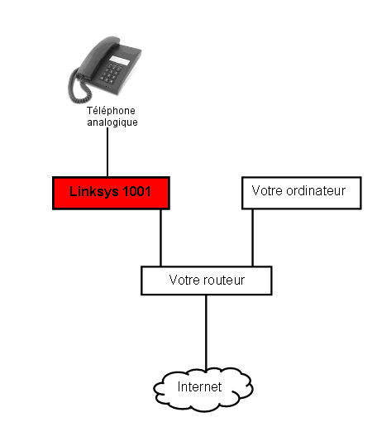 | 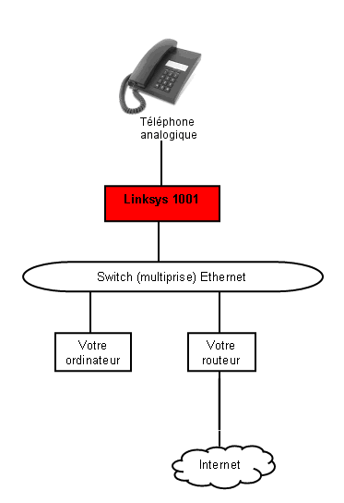
If you have multiple Ethernet ports on your router | If you have one Ethernet port on your router

 Feedback

* * *
Copyright © 2009 Switzernet

